**Course Description**

It's commonly said that data scientists spend 80% of their time cleaning and manipulating data and only 20% of their time analyzing it. The time spent cleaning is vital since analyzing dirty data can lead you to draw inaccurate conclusions. Data cleaning is an essential task in data science. Without properly cleaned data, the results of any data analysis or machine learning model could be inaccurate.

In this course, you will learn how to identify, diagnose, and treat a variety of data cleaning problems in Python, ranging from simple to advanced. You will deal with improper data types, check that your data is in the correct range, handle missing data, perform record linkage, and more!

**1. Common data problems**

In this chapter, you'll learn how to overcome some of the most common dirty data problems. You'll convert data types, apply range constraints to remove future data points, and remove duplicated data points to avoid double-counting.



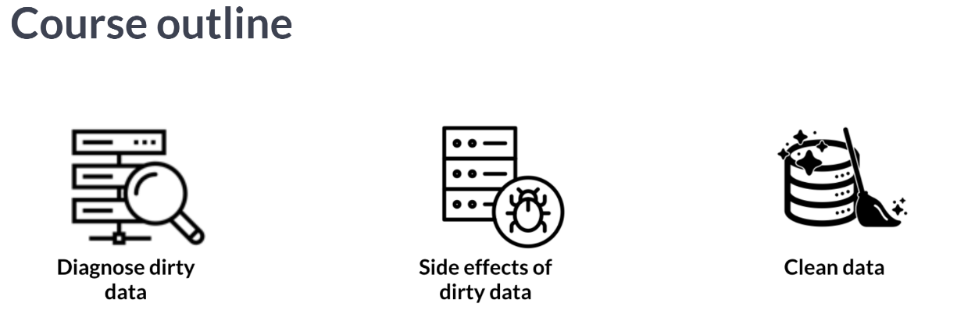  
In this chapter, we will discuss the most common data problems we may encounter and how to address them.

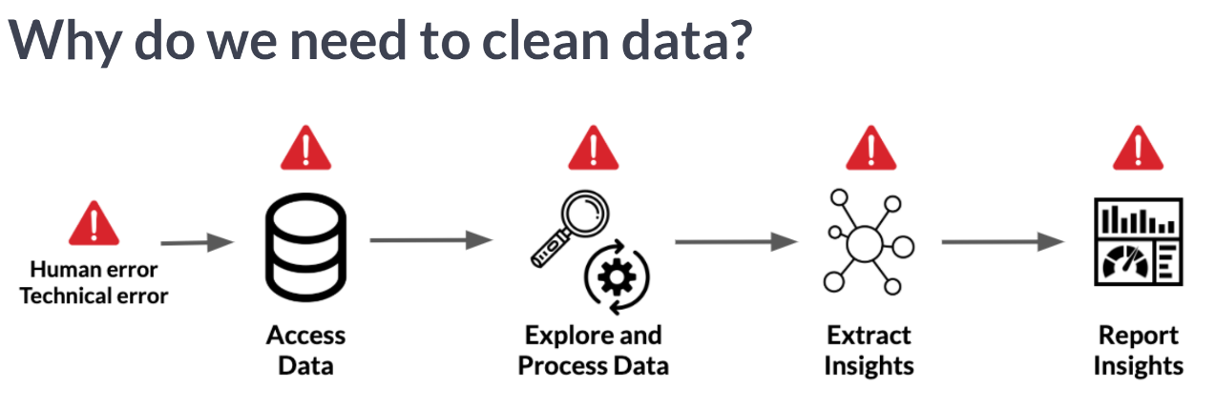  
Dirty data can appear because of duplicate values, misspellings, data type parsing errors and legacy systems. Without making sure that data is properly cleaned in the exploration and processing phase, we will surely compromise the insights and reports subsequently generated. As the old adage says, garbage in garbage out.

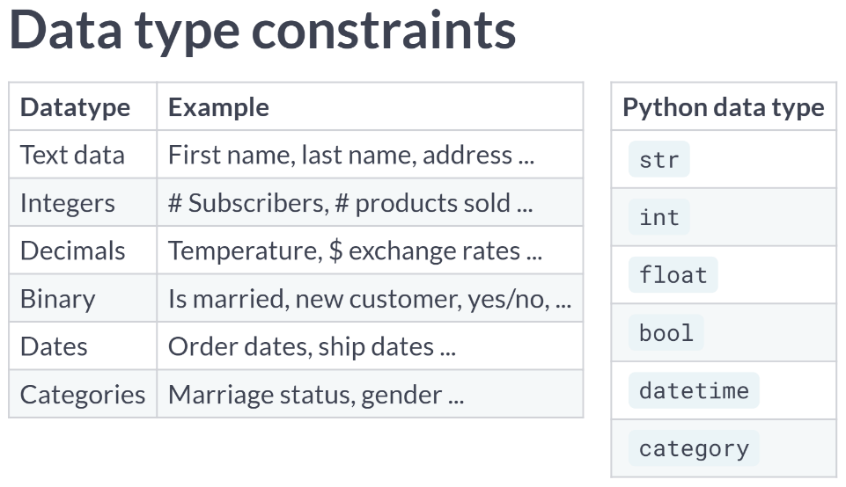  
When working with data, there are various types that we may encounter along the way. Luckily, Python has specific data type objects for various data types that you are probably familiar by now, and this makes it so much easier to manipulate these various data types in Python. As such, before preparing to analyze and extract insights from our data, we need to make sure our variables have the correct data types; otherwise, we risk compromising our analysis.

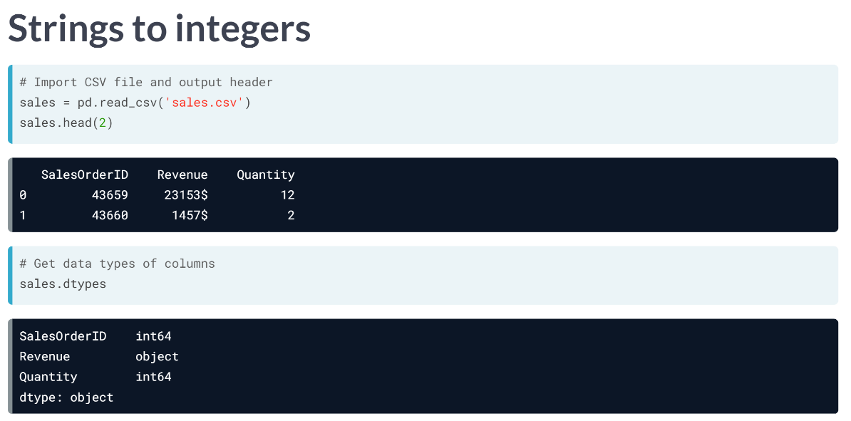  
A close inspection of the DataFrame column's data types using the **.dtypes** attribute returns object for the Revenue column, which is what pandas uses to store strings.  
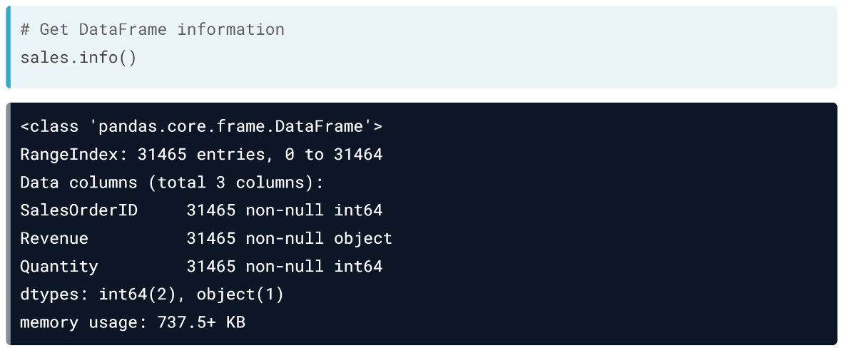  
We can also check the data types and the number of missing values per column in a DataFrame, by using the ***.info()*** method.

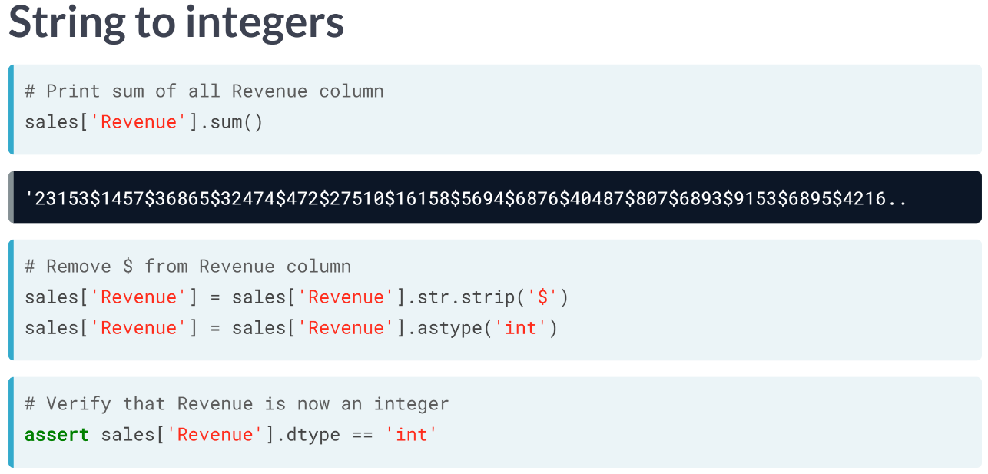  
Since the revenue column is a string, summing across all sales orders returns one large concatenated string containing each row's string. To fix this, we need to first remove the $ sign from the string so that pandas is able to convert the strings into numbers without error. We do this with the ***.str.strip()*** method, while specifying the string we want to strip as an argument, which is in this case the dollar sign.

Since our dollar values do not contain decimals, we then covert the Revenue column to an integer by using the ***.astype()*** method, specifying the desired data type as argument. Had our revenue values been decimal, we would have converted the Revenue column to float.

We can make sure that the Revenue column is now an integer by using the ***assert*** statement, which takes in a condition as input, as returns nothing if that condition is met, and an error if it is not.

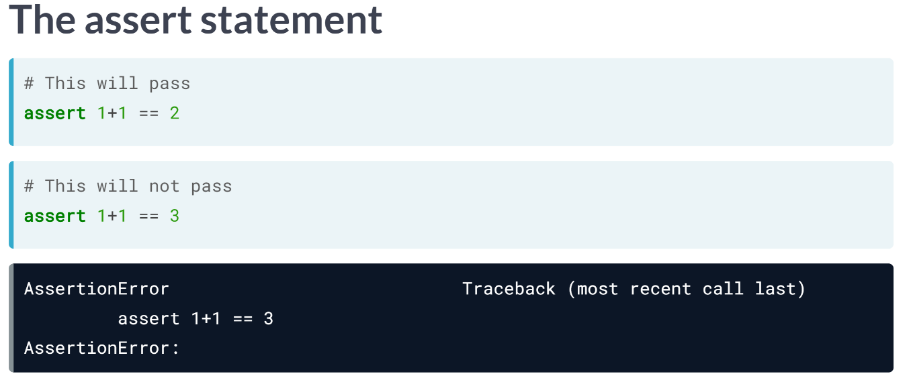  
The statement is true, in which case it will return nothing. However, when testing the false condition using assert statement, it will return *AssertionError*.

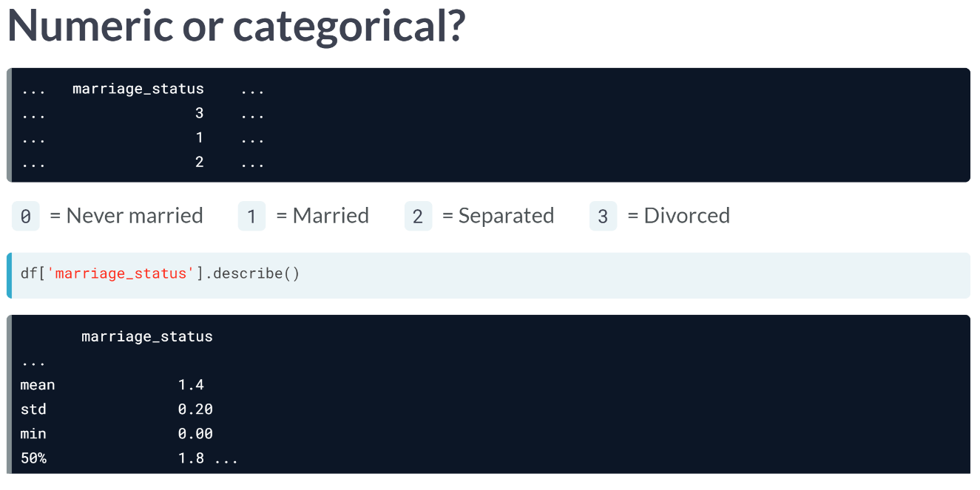  
This marriage status is intended to be a categorical data; however, it will be imported of type integer, which could lead to misleading results when trying to extract some statistical summaries.

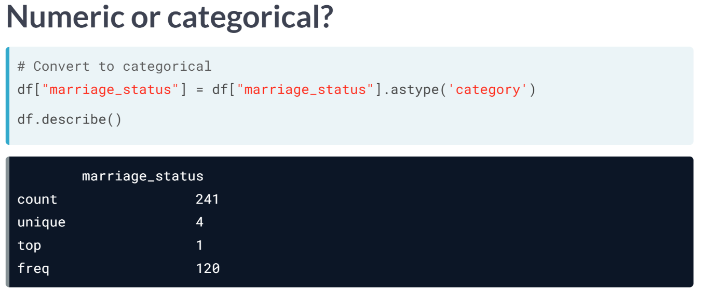  
We can solve this by using the ***same.astype()*** method seen earlier, but this time specifying the category data type as shown.

When applying the ***describe()*** again, we see that the summary statistics are much more aligned with that of a categorical variable, discussing the number of observations, number of unique values, most frequent category instead of mean and standard deviation. Yes, this is what we want!

# Common data types

Manipulating and analyzing data with incorrect data types could lead to compromised analysis as you go along the data science workflow.

When working with new data, you should always check the data types of your columns using the .dtypes attribute or the .info() method which you'll see in the next exercise. Often times, you'll run into columns that should be converted to different data types before starting any analysis.

In this exercise, you'll first identify different types of data and correctly map them to their respective types.

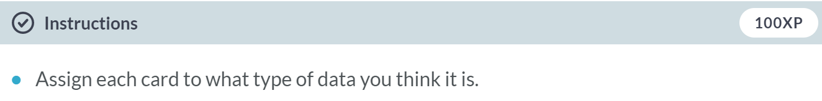  
  
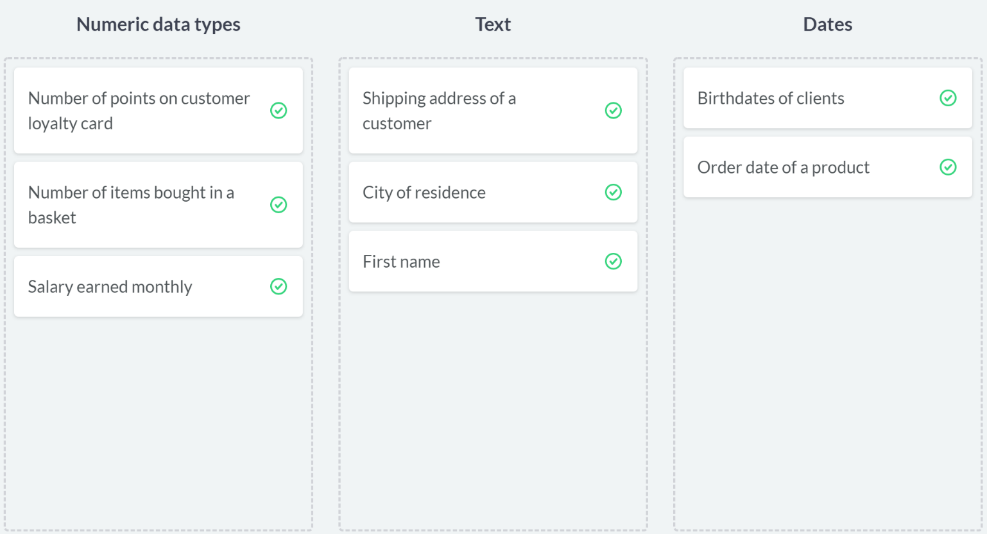  
Awesome! Correctly identifying what type your data is is one of the easiest ways to avoid hampering your analysis due to data type constraints in the long run.

# Numeric data or ... ?

In this exercise, and throughout this chapter, you'll be working with bicycle ride sharing data in San Francisco called ride_sharing. It contains information on the start and end stations, the trip duration, and some user information for a bike sharing service.

The user_type column contains information on whether a user is taking a free ride and takes on the following values:

* 1 for free riders.
* 2 for pay per ride.
* 3 for monthly subscribers.

In this instance, you will print the information of ride_sharing using .info() and see a firsthand example of how an incorrect data type can flaw your analysis of the dataset. The pandas package is imported as pd.

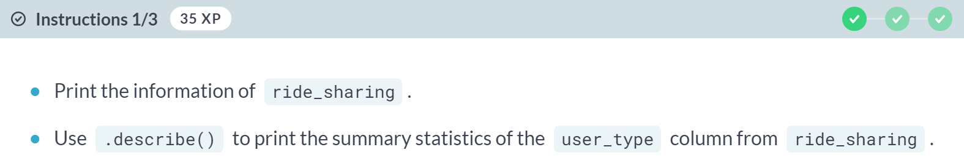  
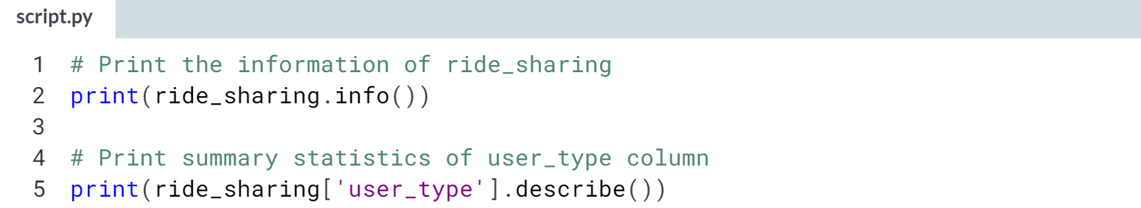  
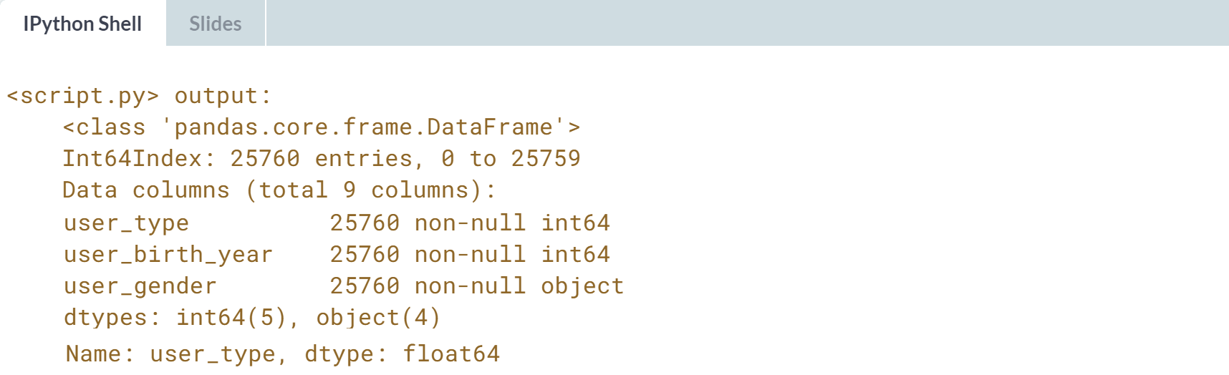

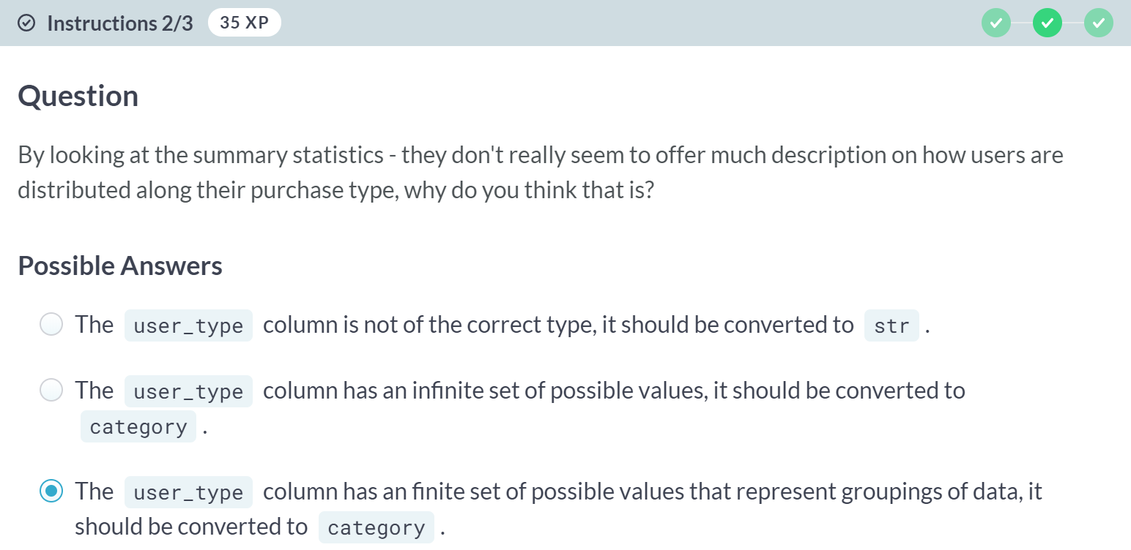  
  
A: Indeed *user_type* is of the wrong type, however converting it to *str* is probably not a good idea.

B: Yes, indeed *user_type* should be converted to a categorical variable, but is that the right reasoning?

C: This is a correct response.

(Exercise part 3 on the next page)

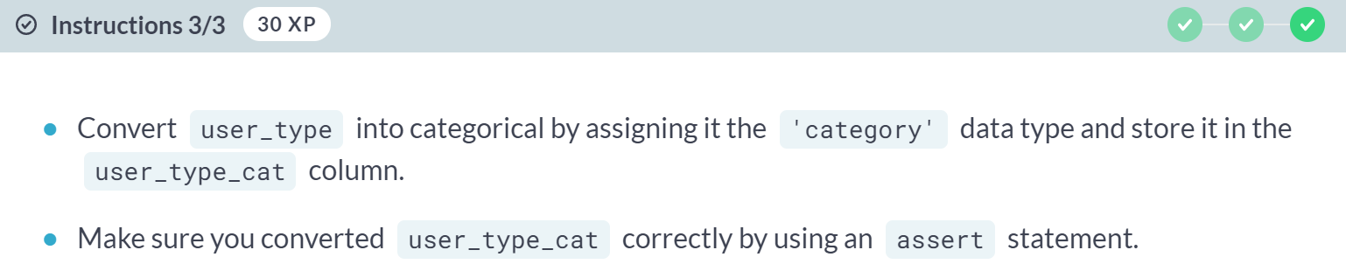  
  
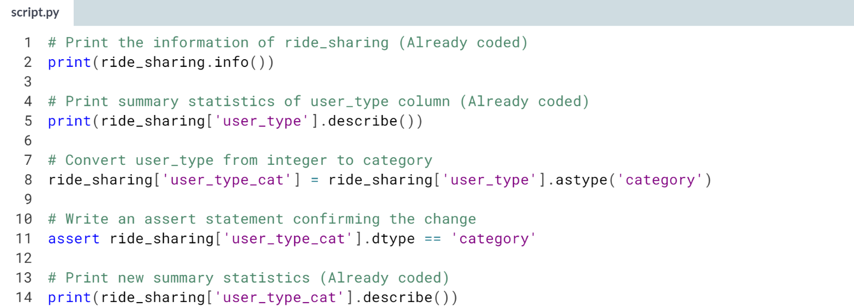  
  
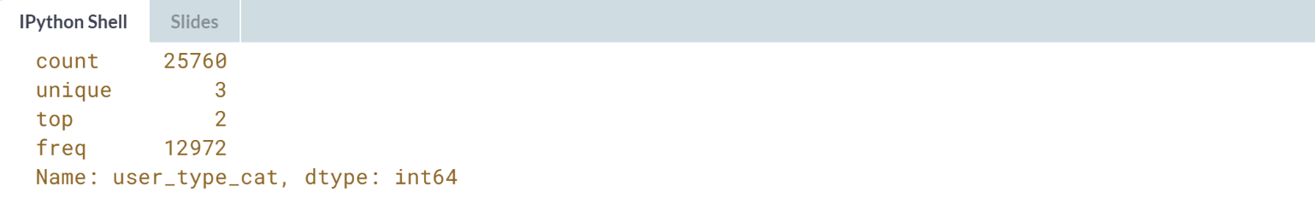  
Awesome work! Take a look at the new summary statistics, it seems that most users are pay per ride users!

# Summing strings and concatenating numbers

In the previous exercise, you were able to identify that category is the correct data type for user_type and convert it in order to extract relevant statistical summaries that shed light on the distribution of user_type.

Another common data type problem is importing what should be numerical values as strings, as mathematical operations such as summing and multiplication lead to string concatenation, not numerical outputs.

In this exercise, you'll be converting the string column duration to the type int. Before that however, you will need to make sure to strip "minutes" from the column in order to make sure pandas reads it as numerical. The pandas package has been imported as pd.

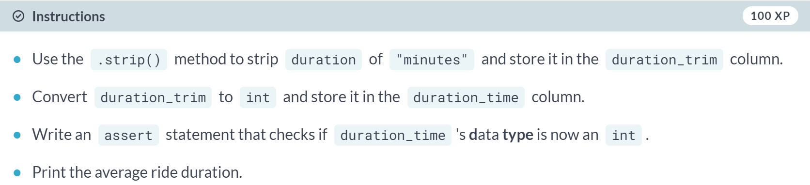

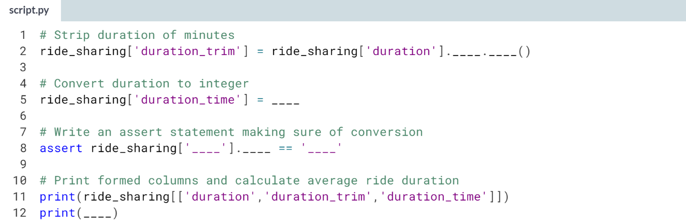  
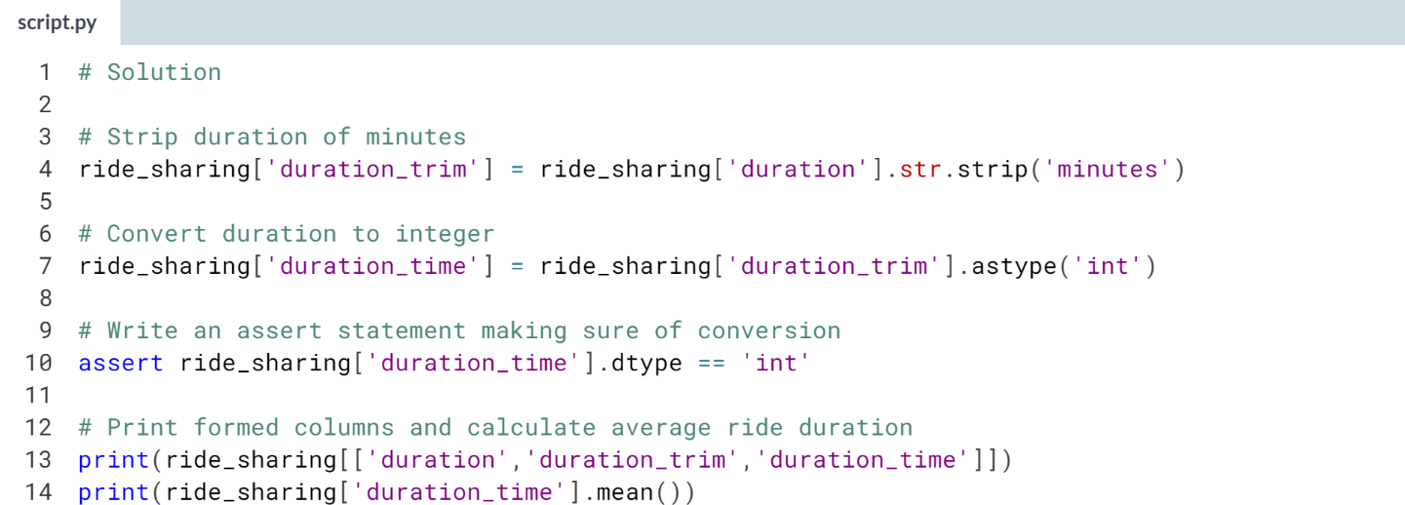

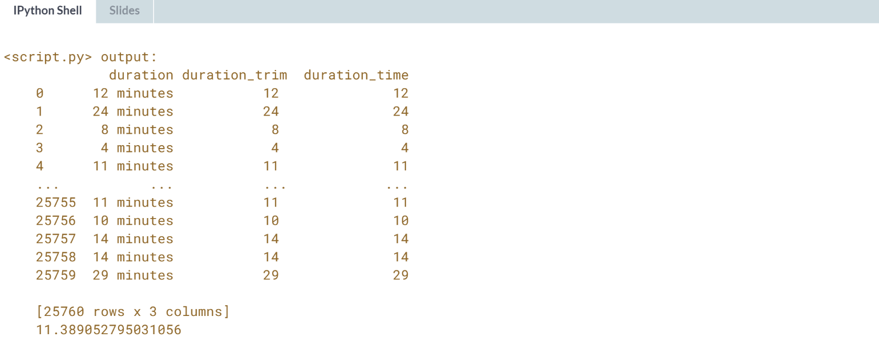  
Great work! 11 minutes is really not bad for an average ride duration in a city like San-Francisco. In the next lesson, you're going to jump right ahead into sanity checking the range of values in your data.



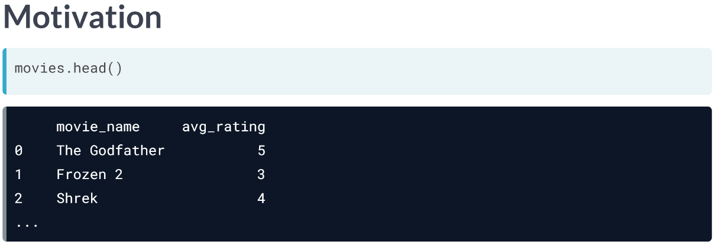  
This rating can be any integer between 1 and 5.

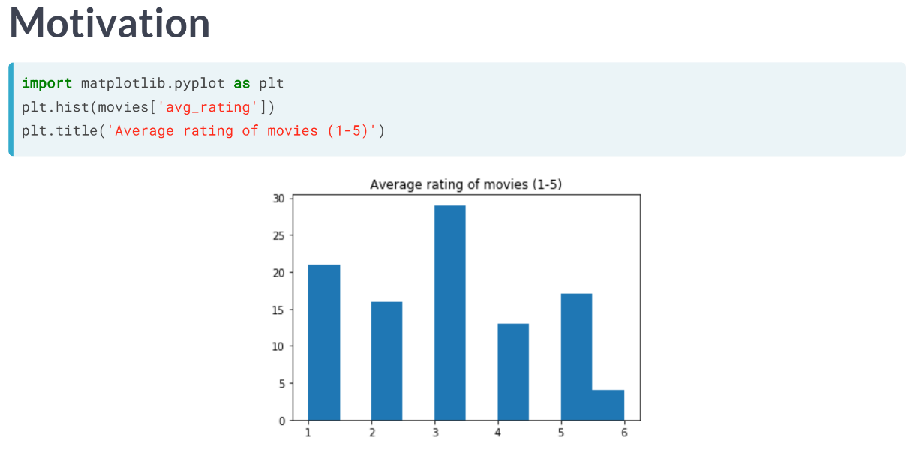  
After creating a histogram with matplotlib, we see that there are a few movies with an average rating of 6, which is well above the allowable range.

This is most likely an error in data collection or parsing, where a variable is well beyond its range and treating it is essential to have accurate analysis.

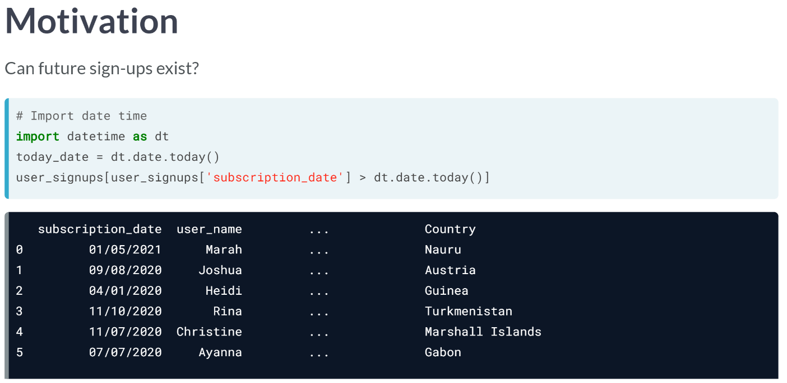  
Here's another example, where we see subscription dates in the future for a service. This doesn't make sense, as we cannot sign up for a service in the future, but these errors exist either due to technical or human error.

We use the datatime package's ***.date.today()*** function to get today's date, and we filter the dataset by any subscription date higher than today's date. We need to pay attention to the range of our data.

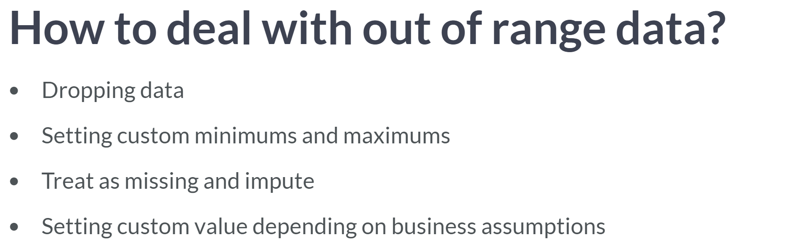  
  
As a rule of thumb, only drop data when a small proportion of your dataset is affected by out of range values; however, you really need to understand your dataset before deciding to drop values.

Another option would be setting custom minimums or maximums to your columns.

We could also set the data to missing and impute it.

We could also assign a custom value for any value of our data that go beyond a certain range.

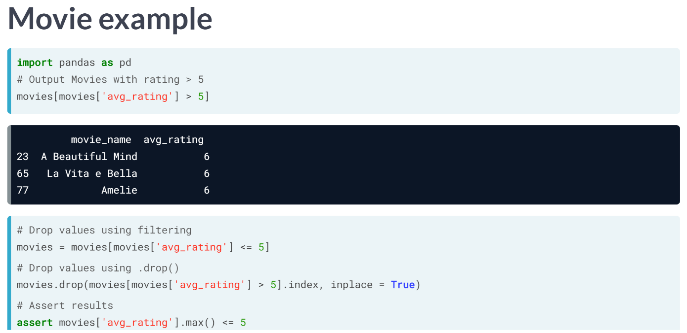  
Going back to the movie dataset, we first isolate the movies with ratings higher than 5. Now if these values affect a small set of our data, we can drop them. We can drop them in two ways:

1) We can either create a new filtered movies DataFrame where we only keep values of avg_rating lower or equal to 5.

2) Drop the values by using the drop method. The drop method takes in as argument the row indices of movies for which the avg_rating is higher than 5. We set the *inplace* argument to True so that values are dropped in place and we don't have to recreate a new column.

Finally, we can make sure this is set in place using an assert statement that checks if the maximum of avg_rating is lower or equal than to 5.

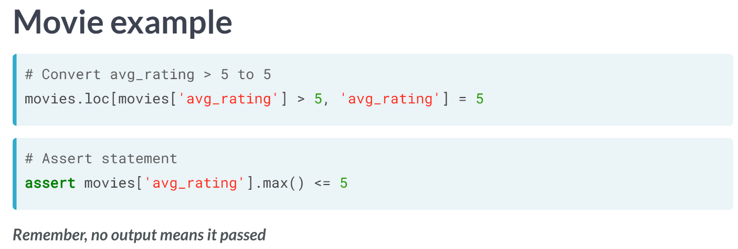  
Depending on the assumptions behind our data, we can also change the out of range values to a hard limit. For example, here we are setting any value of the *avg_rating* column in to 5 if it goes beyond it.

We can do this by using the dot-loc method, which returns all cells that fit a custom row and column index. It takes as first argument the row index, or here all instances of *avg_rating* above 5 and as second argument the column index, which is here the *avg_rating* column.

Again, we can make sure that this change was done using an assert statement.

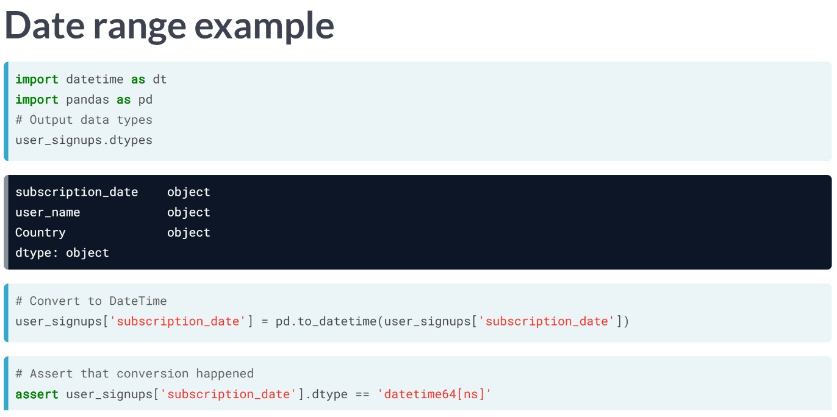  
Let's look at the date range example from earlier again. We first look at the datatypes of the column with the .dtypes attribute. We can confirm that the *subscription_date* column is an object and not a datetime object.

Datetime objects allow much easier manipulation of date data, so let's convert it to that. We do so with the ***to_datetime()*** function from pandas, which takes in as argument the column we want to convert. We can then test the data type conversion by asserting that the subscription's date's column is equal to *'datetime64[ns]'*, which is how the data type is represented in pandas.

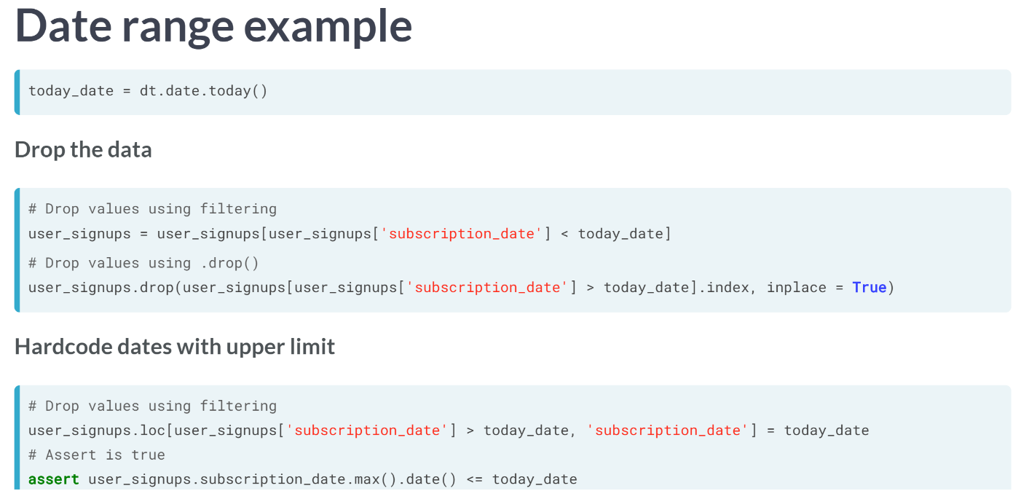  
Now that the column is in datetime, we can treat it in a variety of ways. We first create a today_date variable using the datetime function ***date.today()***, which allows us to store today's date. We can either drop the rows with exceeding dates similar to how we did in the average rating example or replace exceeding values with today's date. In both cases, we can use the assert statement to whether we verify our treatment, by comparing the maximum values in the *subscription_date* column. However, make sure to chain with the .date() method to return a datetime object instead of a timestamp.

# Tire size constraints

In this lesson, you're going to build on top of the work you've been doing with the ride_sharing DataFrame. You'll be working with the tire_sizes column which contains data on each bike's tire size.

Bicycle tire sizes could be either 26″, 27″ or 29″ and are here correctly stored as a categorical value. In an effort to cut maintenance costs, the ride sharing provider decided to set the maximum tire size to be 27″.

In this exercise, you will make sure the tire_sizes column has the correct range by first converting it to an integer, then setting and testing the new upper limit of 27″ for tire sizes.

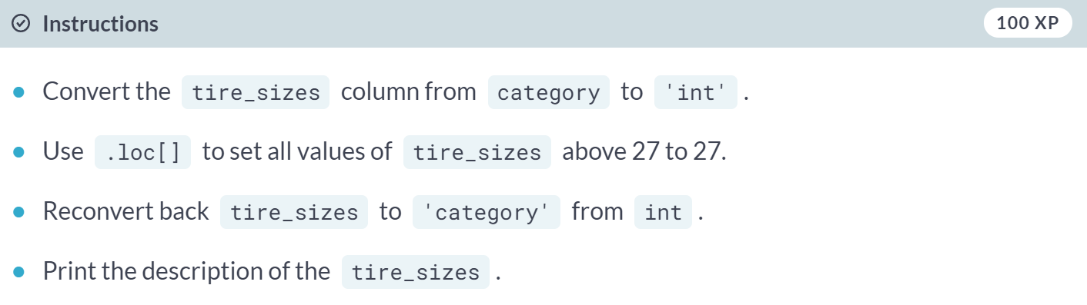

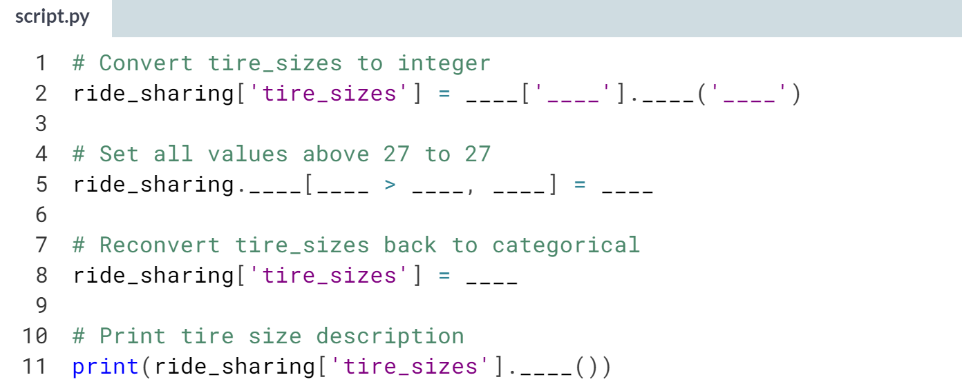

(Solutions on the next page)

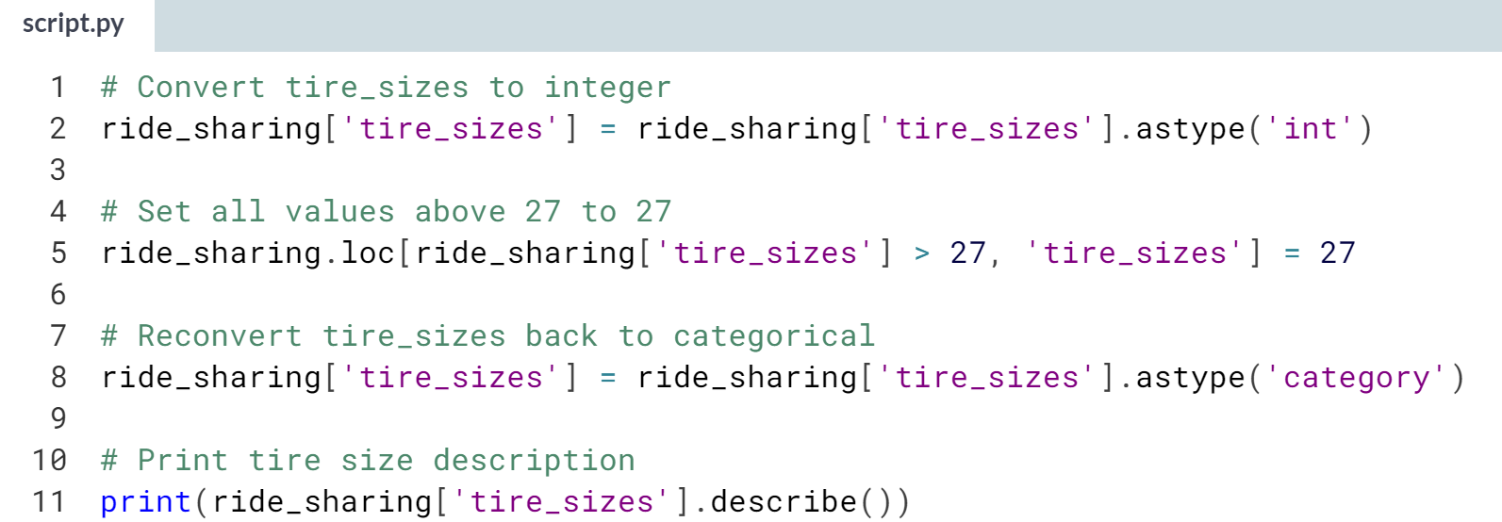

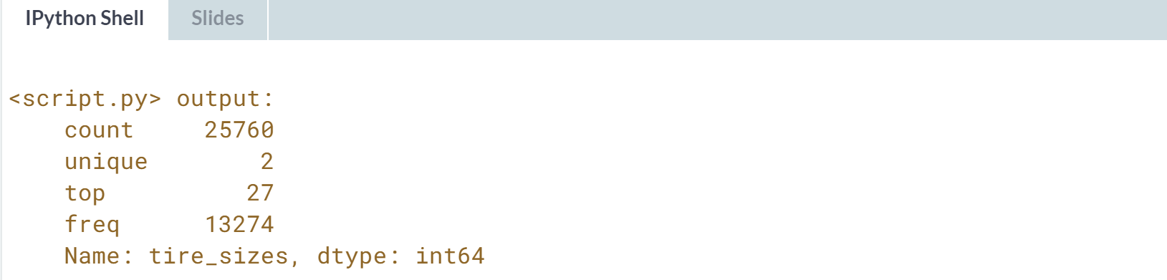  
Awesome work! You can look at the new maximum by looking at the top row in the description. Notice how essential it was to convert *tire_sizes* into integer before setting a new maximum.

# Back to the future

A new update to the data pipeline feeding into the ride_sharing DataFrame has been updated to register each ride's date. This information is stored in the ride_date column of the type object, which represents strings in pandas.

A bug was discovered which was relaying rides taken today as taken next year. To fix this, you will find all instances of the ride_date column that occur anytime in the future, and set the maximum possible value of this column to today's date. Before doing so, you would need to convert ride_date to a datetime object.

The datetime package has been imported as dt, alongside all the packages you've been using till now.

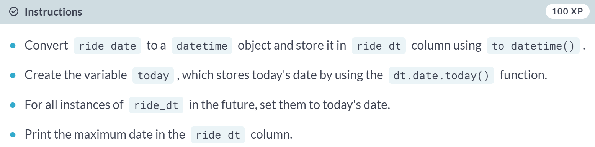

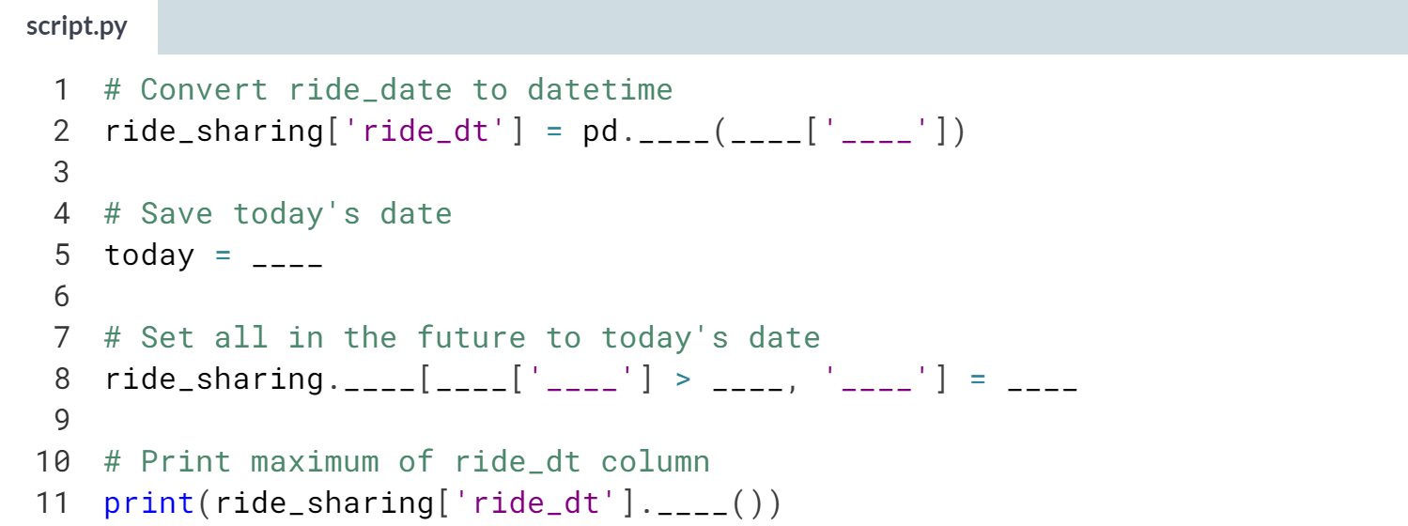

(Solution on the next page)

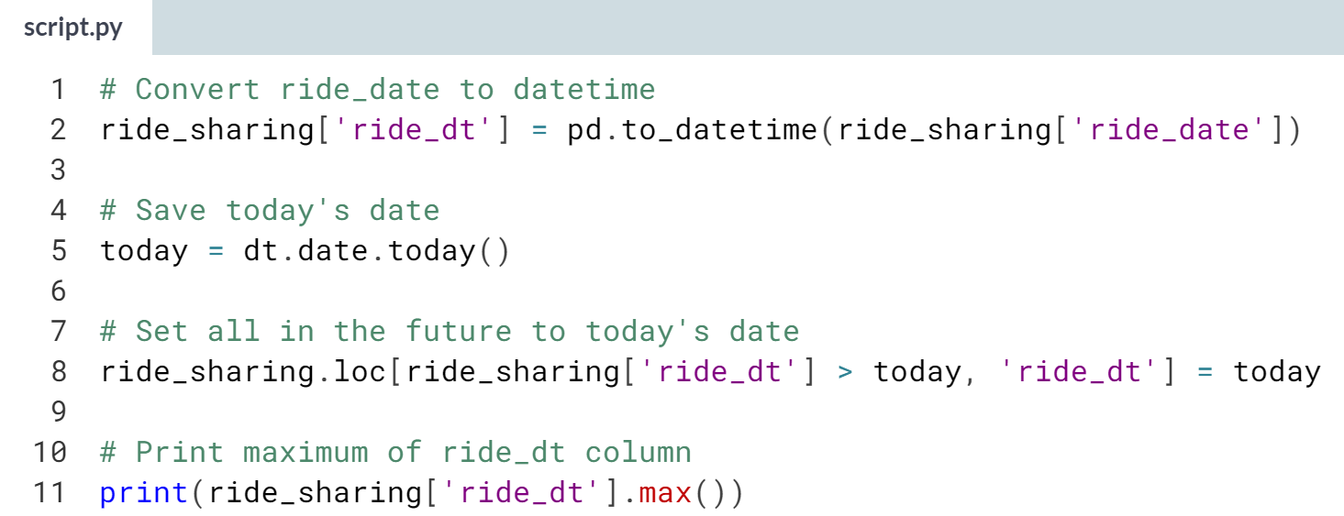

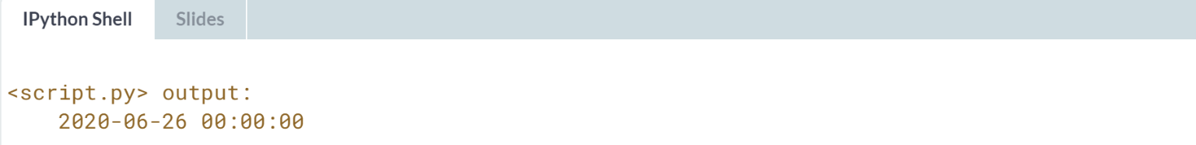

Great job! Imagine counting the number of rides taken today without having cleaned your ranges correctly. You would have wildly underreported your findings!



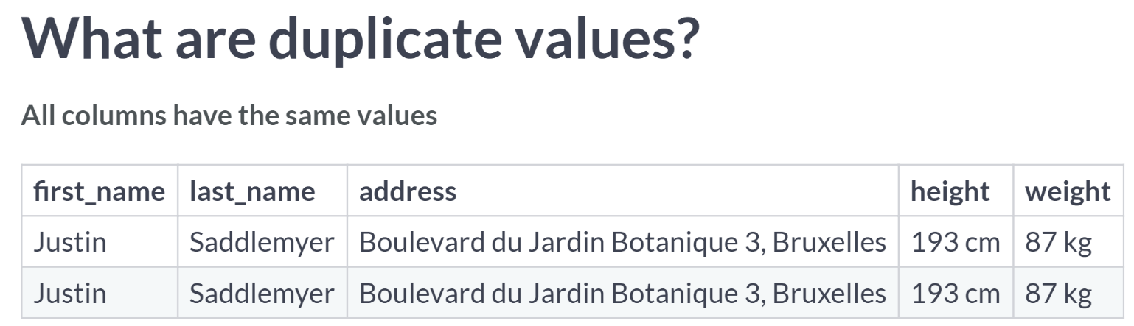

The rows presented have identical values across all columns.

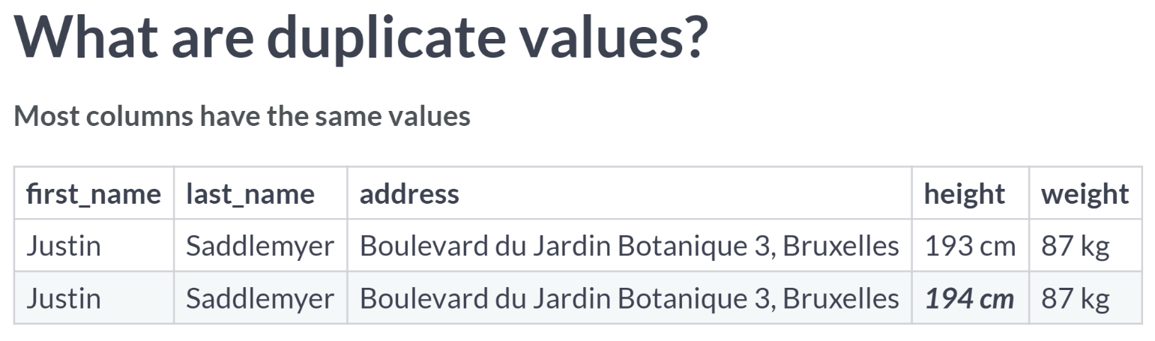  
In this one, there are duplicate values for all columns except the height column. This type of error makes us think that it's more likely a data entry error than an actual other person.

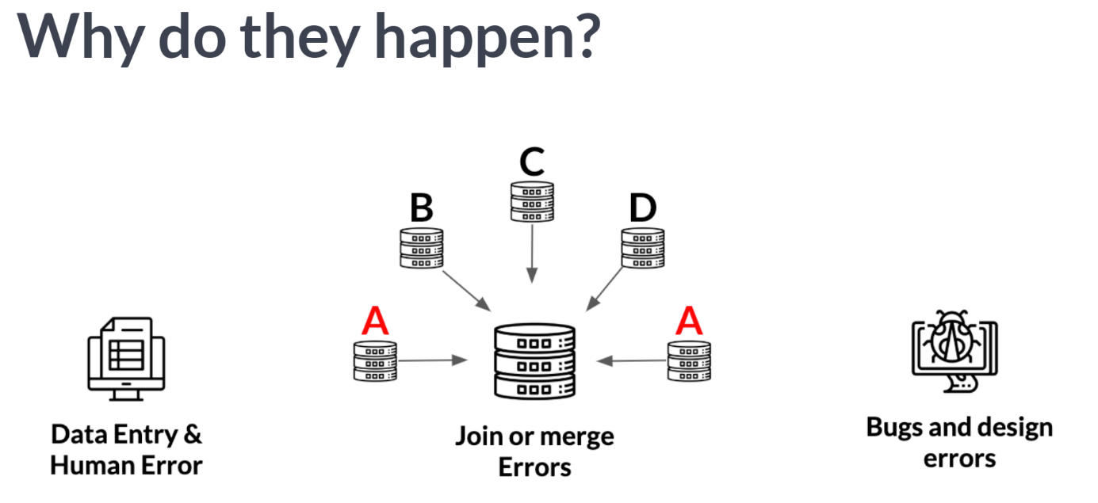  
This type of error most likely arises from the necessary act of joining and consolidating data from various resources, which could retain duplicate values.

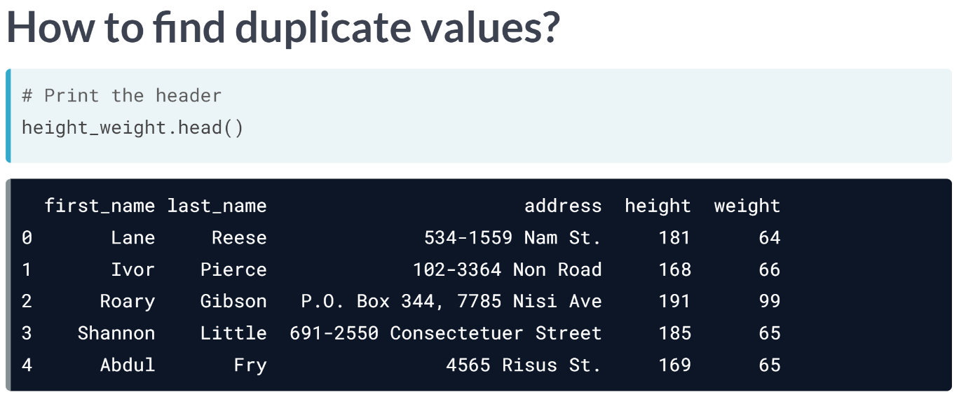  
We can find duplicates in a DataFrame by using the ***.duplicated()*** method. It returns a Series of Boolean values that are True for duplicate values, and False for non-duplicated values.  
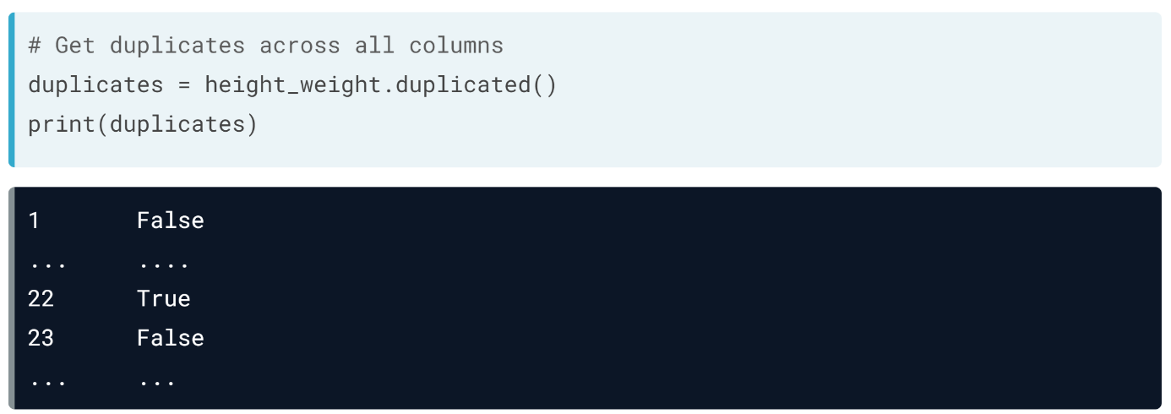  
We can see exactly which rows are affected by using brackets as such.  
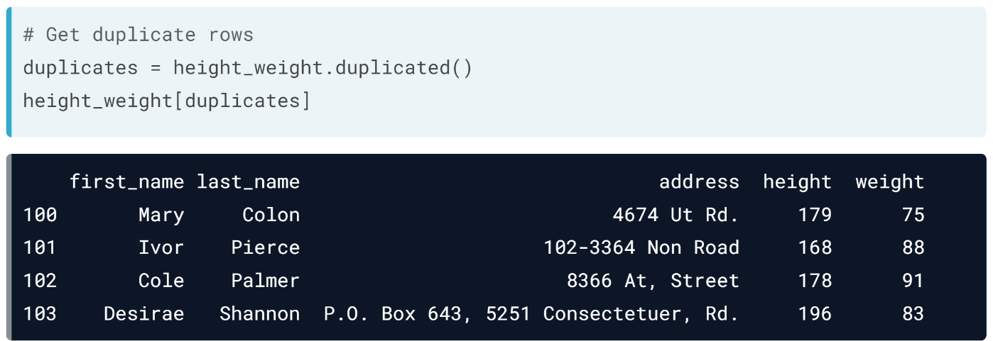  
However using ***.duplicated()*** without playing around with the arguments of the method can lead to misleading results, as all the columns are required to have duplicate values by default, with all duplicate values being marked as True except for the first occurrence.

This limits our ability to properly diagnose what type of duplication we have, and how to effectively treat it.

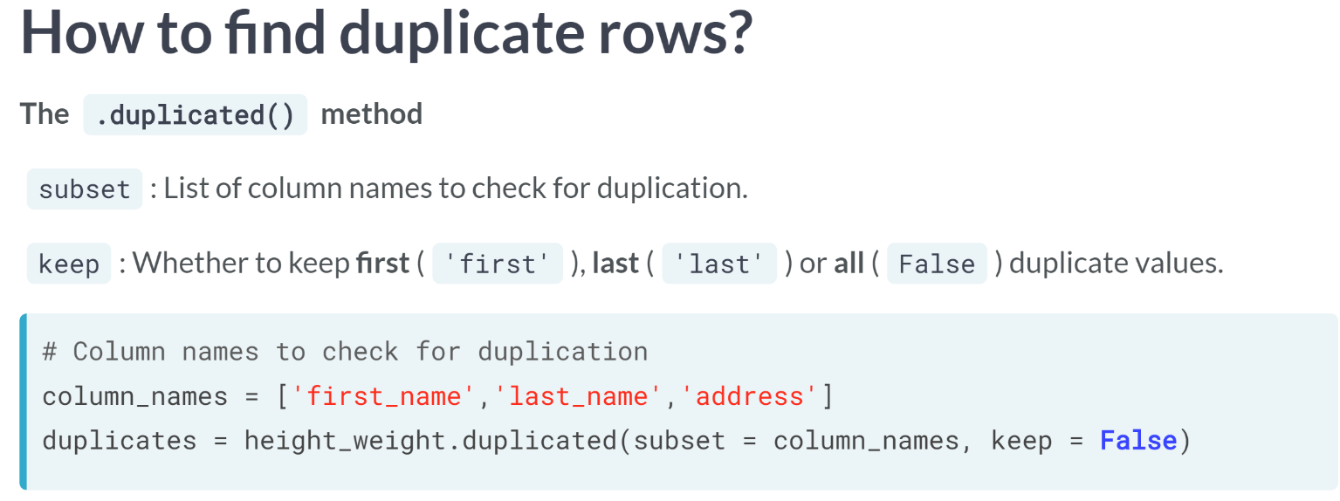  
To properly calibrate how we go about finding duplicates, we will use two arguments from the ***.duplicated()*** method.

The *subset* argument lets us set a list of column names to check for duplication. For example, it allows us to find duplicates for the first, last name, and address columns only.

The *keep* argument lets us keep the first occurrence of a duplicate value by setting it to the string first, the last occurrence of a duplicate value by setting it the string last, or we can keep all occurrences of duplicate values by setting it to False.

In this example, we are checking for duplicates across the first name, last name, and address variables, and we are going to keep all duplicates.

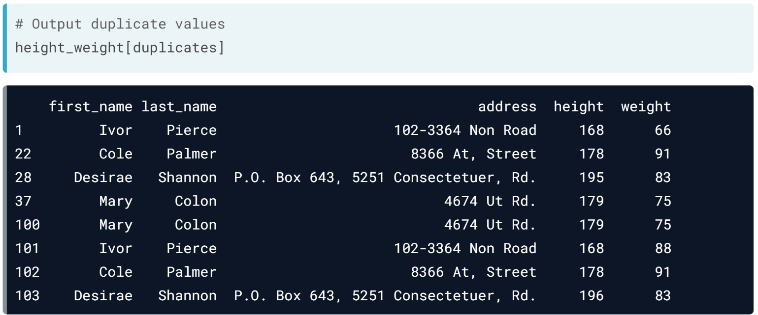  
We see the result, as shown above.

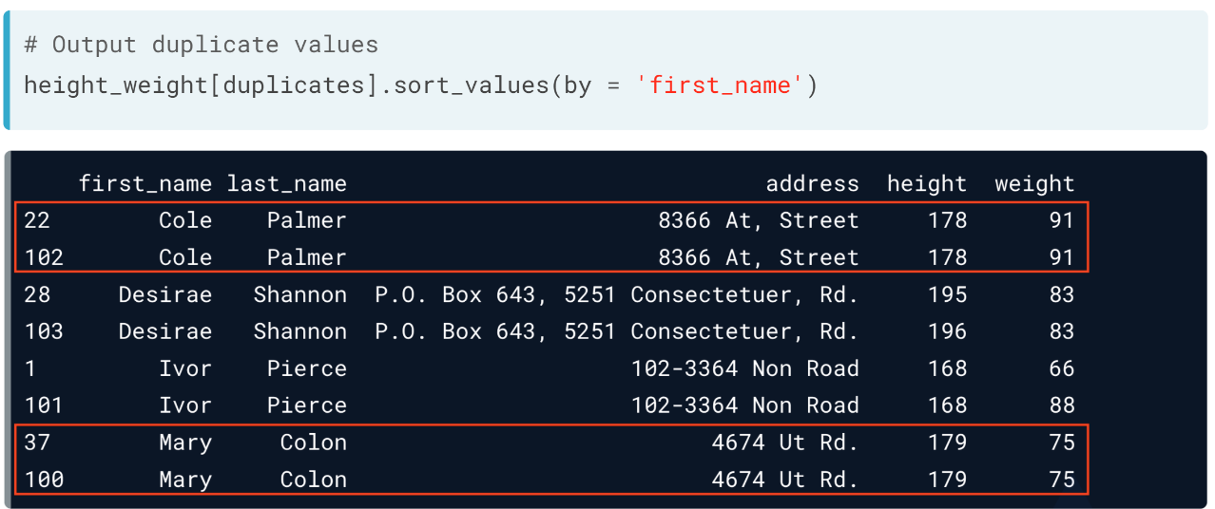  
Though, to get a better birds-eye view of the duplicates, we sort the duplicate rows using the .sort_values() method, choosing first_name to sort by. We find that there are four sets of duplicated rows, the first 2 being complete duplicates of each other across all columns, highlighted here in red.

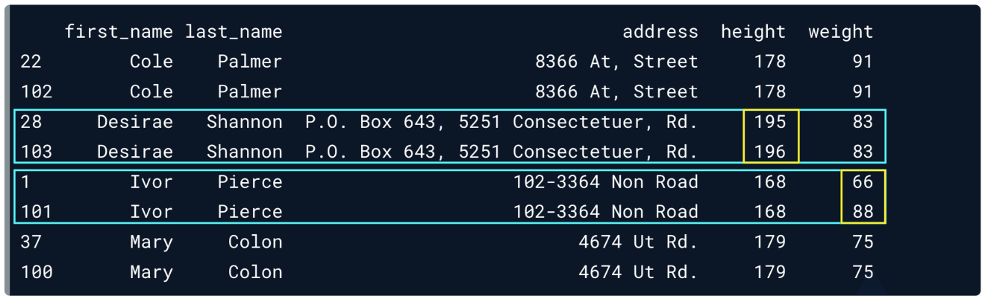  
The other 2 being incomplete duplicates of each other highlighted here in blue with discrepencies across height and weight, respectively.

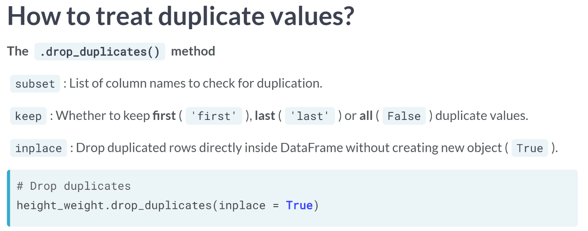  
The complete duplicates can be treated easily. All that is required is to keep one of them only and discard the others. This can be done with the ***.drop_duplicates()*** method, which also takes in the same *subset* and *keep* arguments as in the ***.duplicated()*** method, as well as the *inplace* argument, which drops the duplicated values directly inside the *height_weight* DataFrame. Here, we are dropping complete duplicates only, so it's not necessary nor advisable to set a subset, and since the keep argument takes in first as default, we can keep it as such. Note that we can also set it as last, but not as False as it would keep all the duplicates.

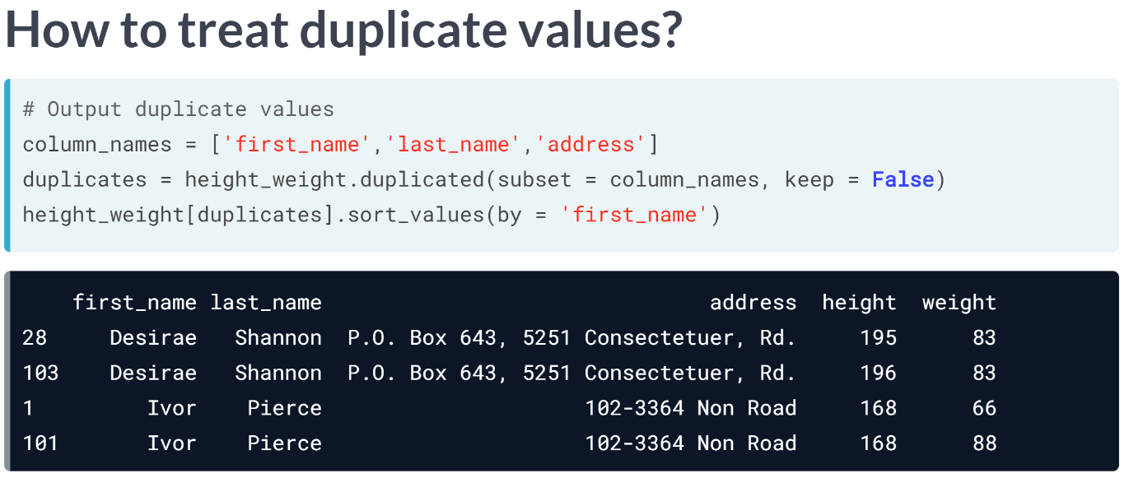  
This leaves us with the other 2 sets of duplicates discussed earlier, which are the same for first_name, last_name, and address, but contain discrepancies in height and weight.

Apart from dropping rows with really small discrepancies, we can use a statistical measure to combine each set of duplicated values.

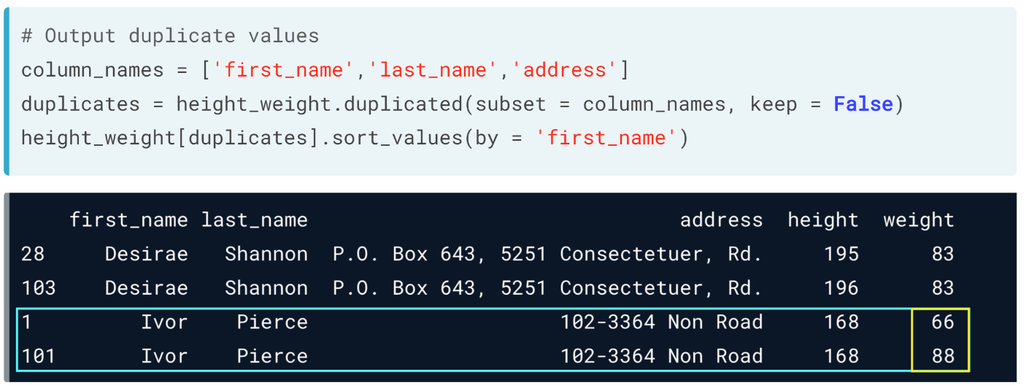  
For example, we can combine these two rows into one by computing the average mean between them, or the maximum, or other statistical measures, this is highly dependent on a common sense understanding of our data, and what type of data we have.

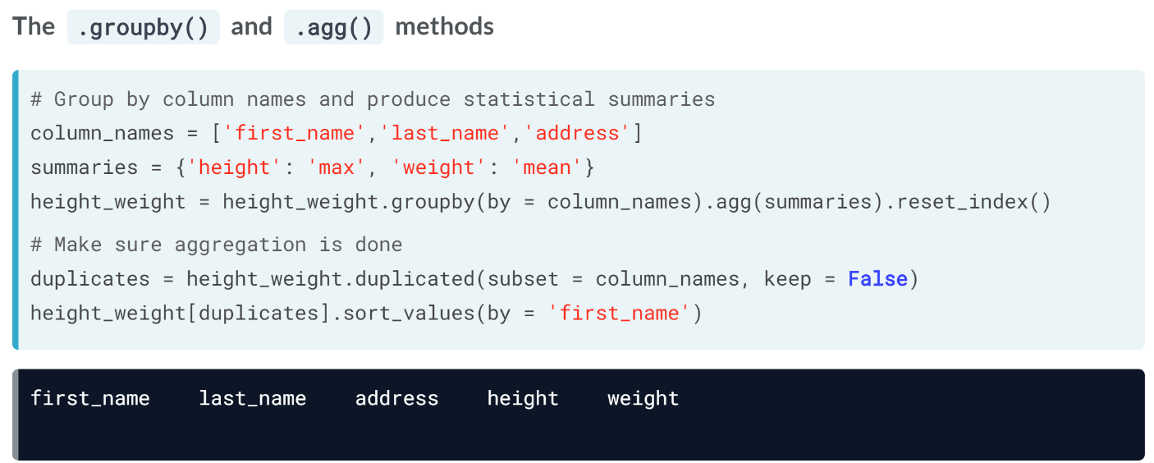  
We can do this easily using the ***groupby()*** method, which when chained with the ***.agg()*** method, allows you group by a set of common columns and return statistical values for specific columns when the aggregation is performed.

For example, we created a dictionary above called *summaries*, which instructs ***groupby()*** to return the maximum of duplicated rows for the height column, and the mean duplicated rows for the weight column.

We then group *height_weight* by the column names defined earlier, and chained it with the ***.agg()*** method, which takes in the summaries dictionary we created. We chain this entire line with the ***.reset_index()*** method, so that we can have numbered indices in the final output.

We can verify that there is no more duplicate value by running the ***duplicated()*** method again and use brackets to output duplicated row.

# How big is your subset?

You have the following loans DataFrame which contains loan and credit score data for consumers, and some metadata such as their first and last names. You want to find both complete and incomplete duplicates using .duplicated().

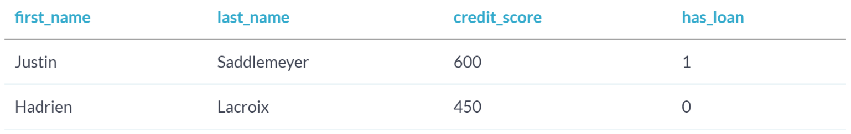

Choose the **correct** usage of .duplicated() below:

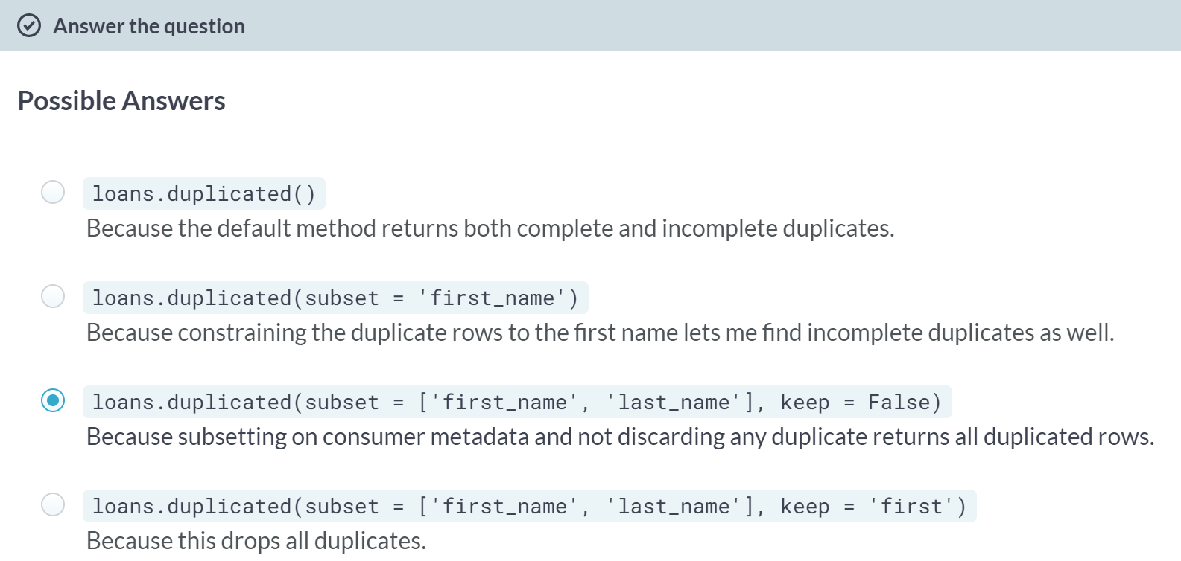  
C: Correct! Subsetting on metadata and keeping all duplicate records gives you a better bird-eye's view over your data and how to duplicate it! You can even subset the *loans* DataFrame using bracketing and sort the values so you can properly identify the duplicates.

A: That's not quite correct, using the default **.duplicated()** without tweaking some of the arguments returns only the non-first complete duplicates across all columns.

B: Are you sure about that? What if you have more than one consumer named Justin or Hadrien?

D: That's close! But the ***.duplicated()*** method returns duplicates but doesn't drop data.

# Finding duplicates

A new update to the data pipeline feeding into ride_sharing has added the ride_id column, which represents a unique identifier for each ride.

The update however coincided with radically shorter average ride duration times and irregular user birth dates set in the future. Most importantly, the number of rides taken has increased by 20% overnight, leading you to think there might be both complete and incomplete duplicates in the ride_sharing DataFrame.

In this exercise, you will confirm this suspicion by finding those duplicates. A sample of ride_sharing is in your environment, as well as all the packages you've been working with thus far.

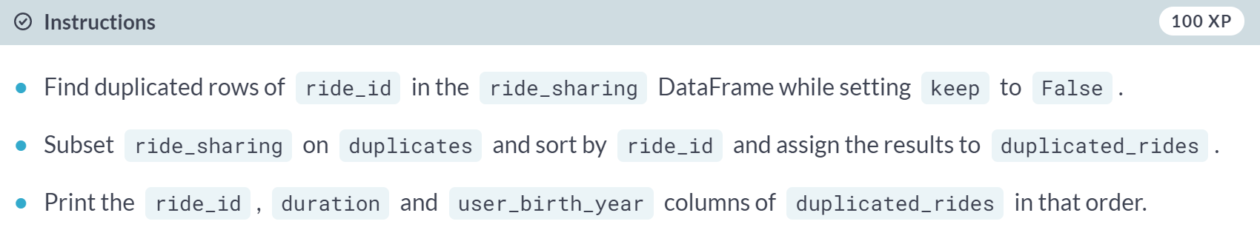

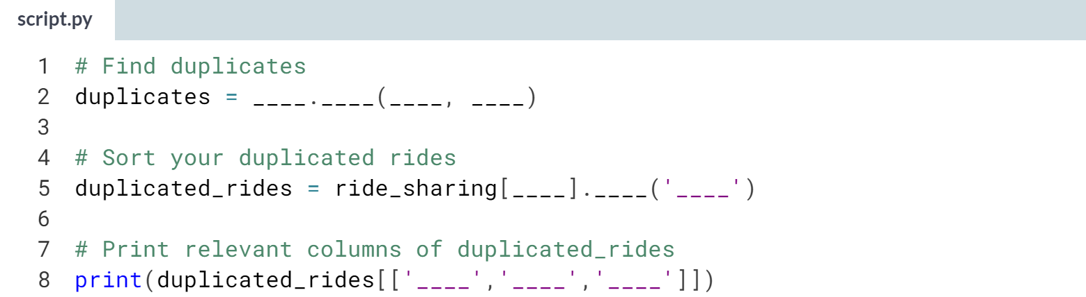  
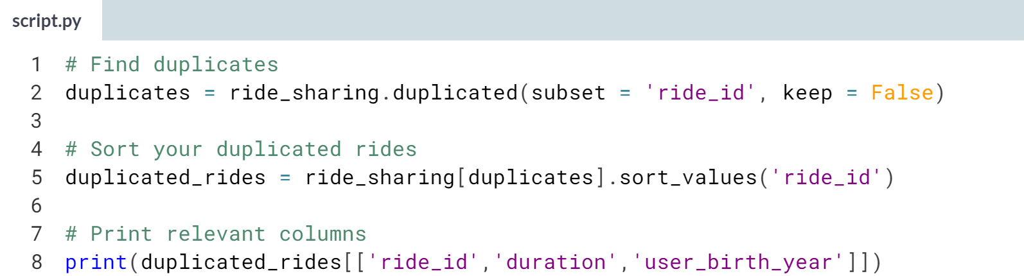

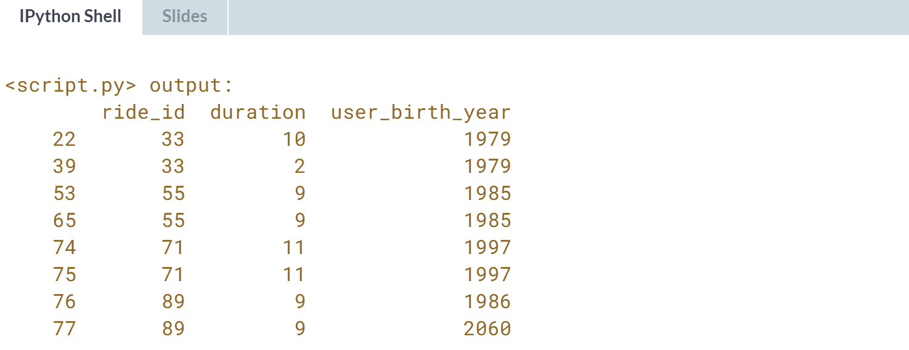

Great job! Notice that rides 33 and 89 are incomplete duplicates, whereas the remaining are complete. You'll learn how to treat them in the next exercise!

# Treating duplicates – **REVIEW**

In the last exercise, you were able to verify that the new update feeding into ride_sharing contains a bug generating both complete and incomplete duplicated rows for some values of the ride_id column, with occasional discrepant values for the user_birth_year and duration columns.

In this exercise, you will be treating those duplicated rows by first dropping complete duplicates, and then merging the incomplete duplicate rows into one while keeping the average duration, and the minimum user_birth_year for each set of incomplete duplicate rows.

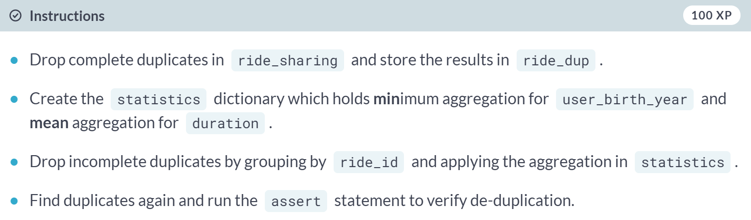

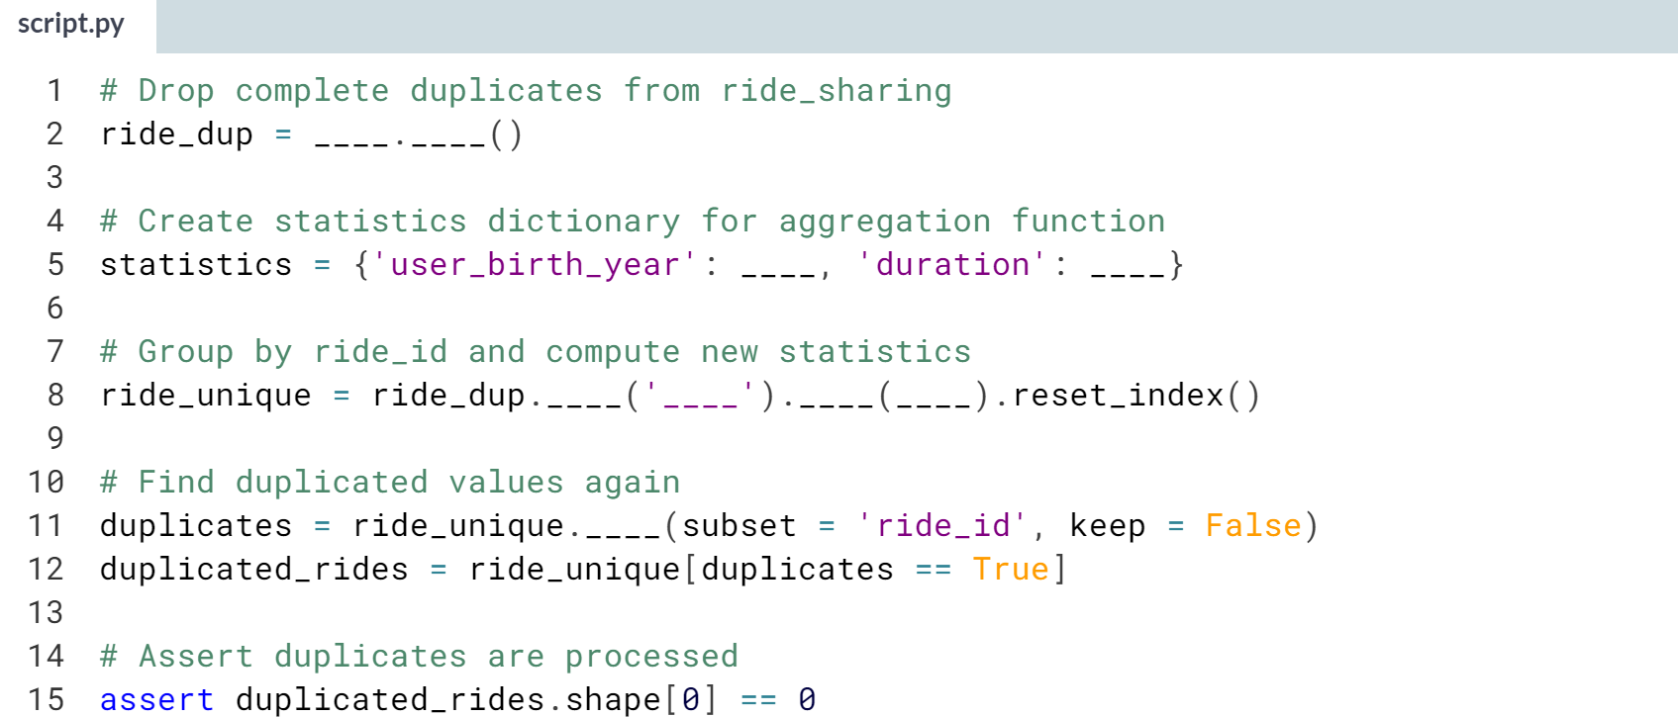

(Solution on the next page)

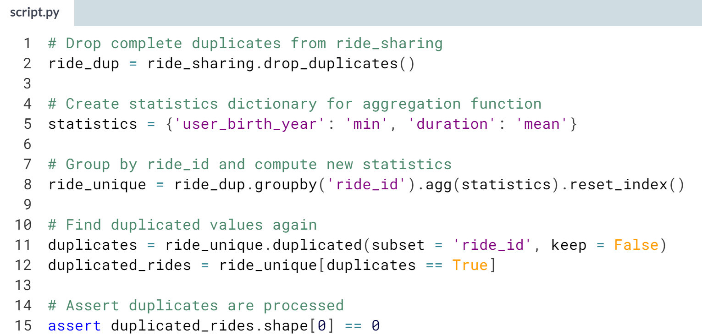  
Awesome work! You can bet after this fix that ride sharing KPIs will come back to normal.

**2. Text and categorical data problems**

Categorical and text data can often be some of the messiest parts of a dataset due to their unstructured nature. In this chapter, you’ll learn how to fix whitespace and capitalization inconsistencies in category labels, collapse multiple categories into one, and reformat strings for consistency.



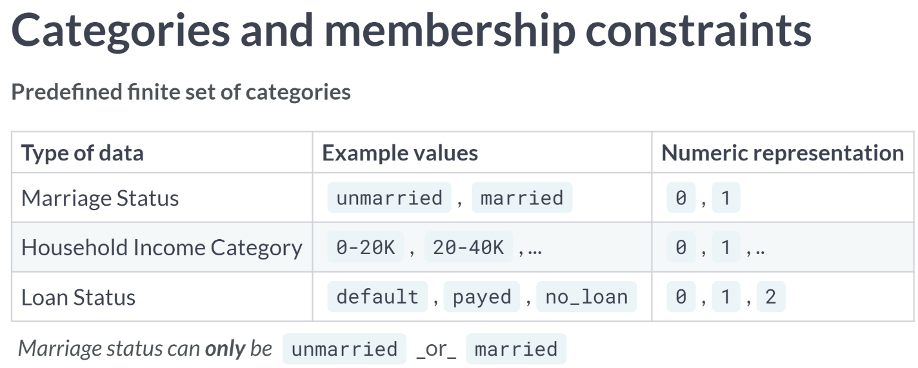

To run machine learning models on categorical data, they are often coded as numbers. Since categorical data represent a predefined set of categories, they can't have values that go beyond these predefined categories.

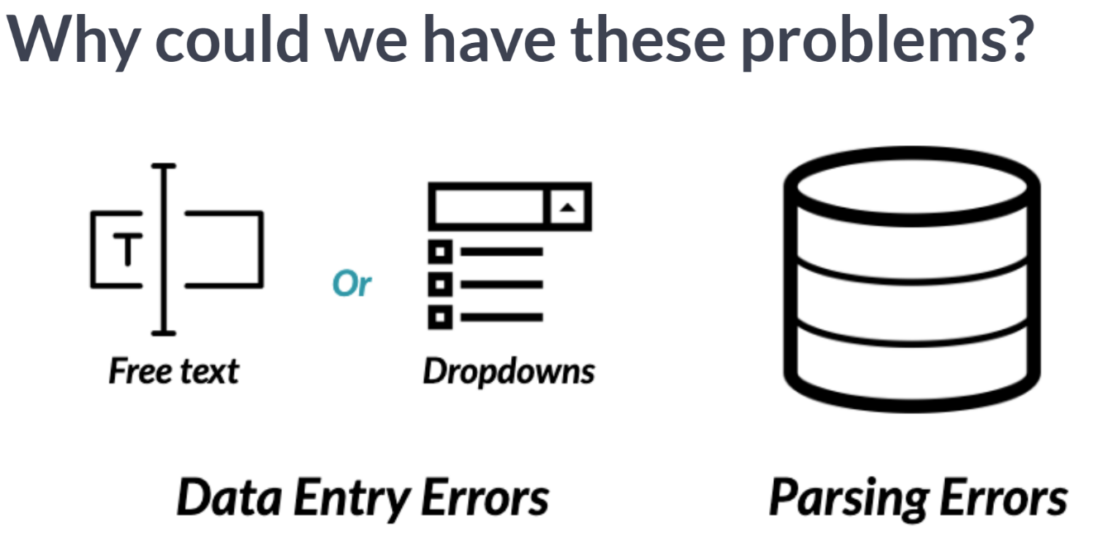

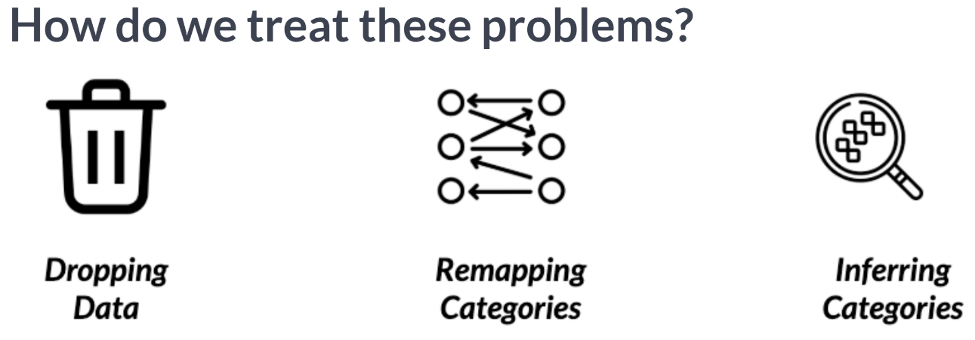  
There's a variety of ways we can treat these, with increasingly specific solutions for different types of inconsistencies.

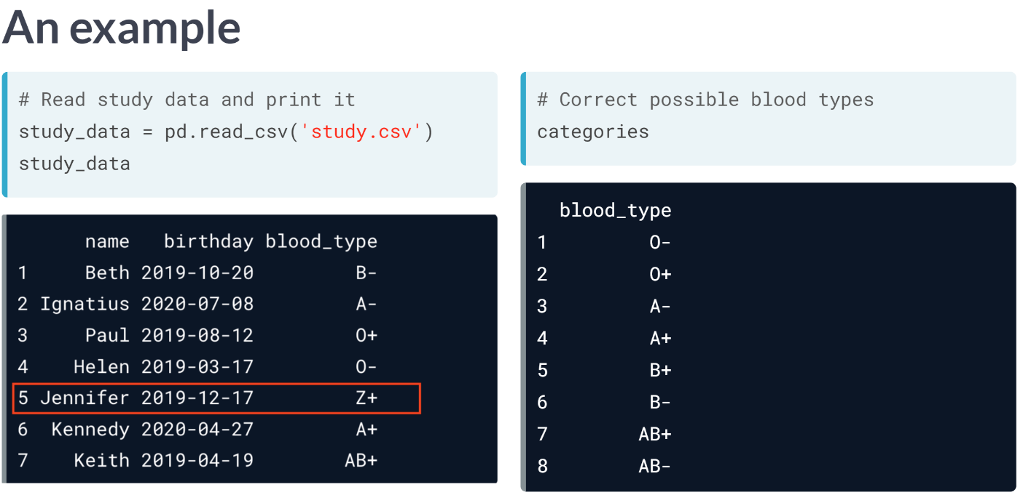  
Three's definitely no blood type named Z+. It's always good practice to keep a log of all possible values of your categorical data, as it will make dealing with these types of inconsistencies way easier.

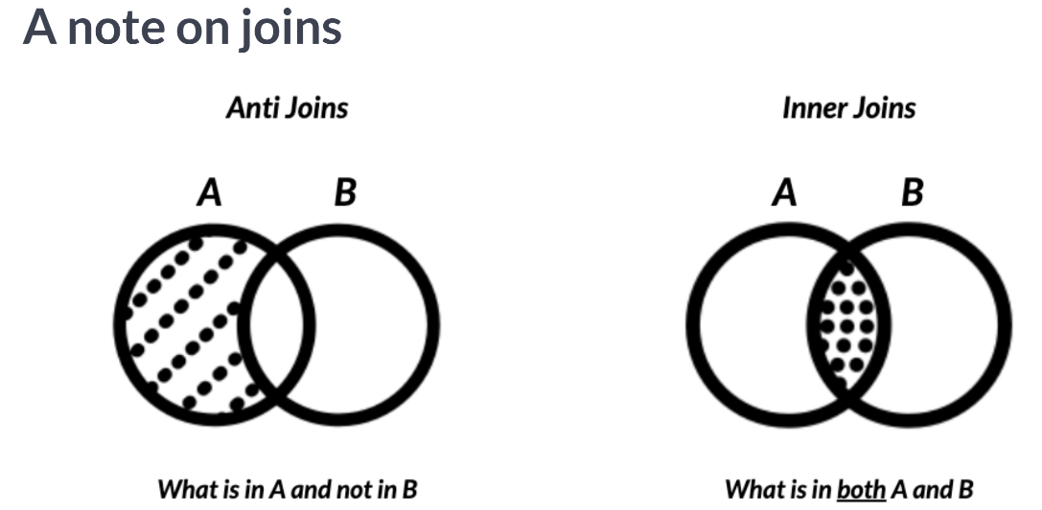  
Anti joins take in two DataFrames A and B, and return data from one DataFrame that is not contained in another. In this example, we are performing a left anti join of A and B and are returning the columns of DataFrames A and B for values only found in A of the common column between them being joined on.

Inner joins return only the data that is contained in both DataFrames. For example, an inner join of A and B, would return columns from both DataFrames, for values only found in A and B, of the common column between them being joined on.

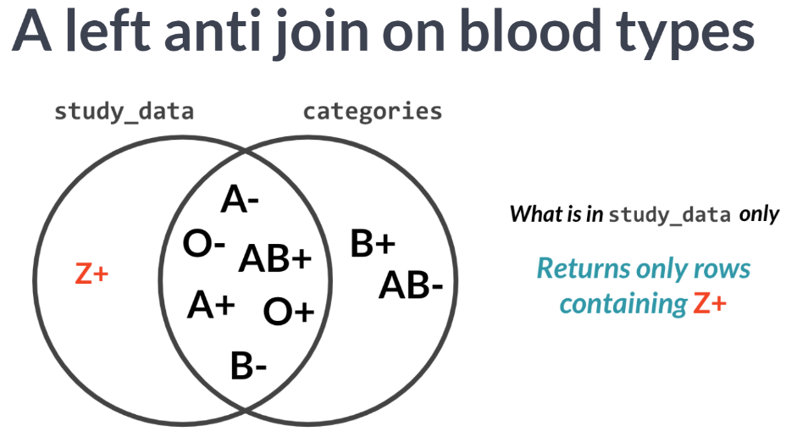  
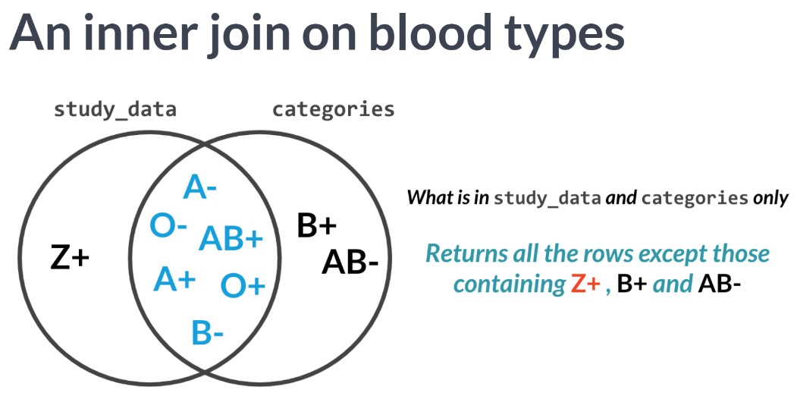

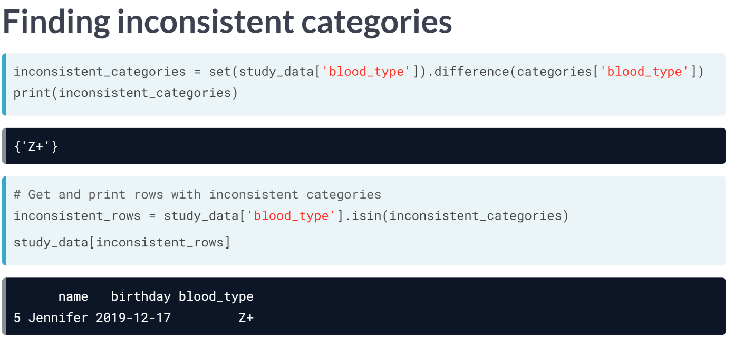  
Let's see how we can do this in Python. We first get all inconsistent categories in the *blood_type* column of the *study_data* DataFrame.

We do that by creating a set of out the *blood_type* column which stores its unique values and use the ***difference()*** method, which takes in as argument the *blood_type* column from the categories DataFrame. This returns all the categories in *blood_type* that are not in categories.

We then find the inconsistent rows by finding all the rows of the *blood_type* columns that are equal to inconsistent categories by using the ***isin()*** method, which returns a series of Boolean values that are True for inconsistent rows and False for consistent ones.

We then subset the *study_data* DataFrame based on these Boolean values, and we finally have our inconsistent data.

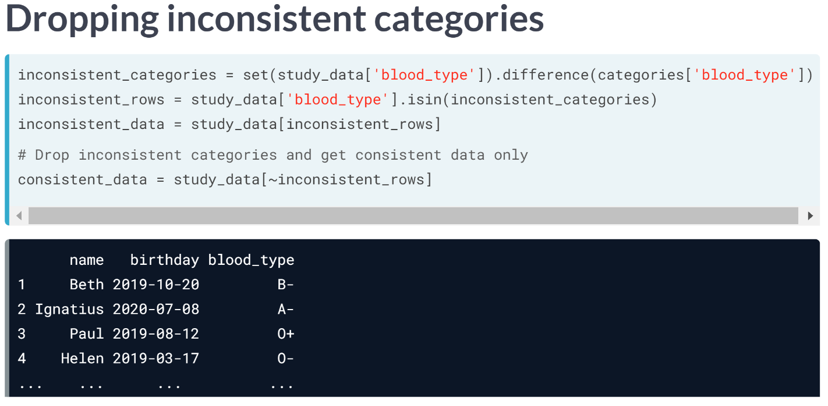  
To drop inconsistent rows and keep one that are only consistent, we just use the ***tilde(~)*** symbol while subsetting which returns everything except inconsistent rows.

#### Members only

Throughout the course so far, you've been exposed to some common problems that you may encounter with your data, from data type constraints, data range constrains, uniqueness constraints, and now membership constraints for categorical values.

In this exercise, you will map hypothetical problems to their respective categories.

  
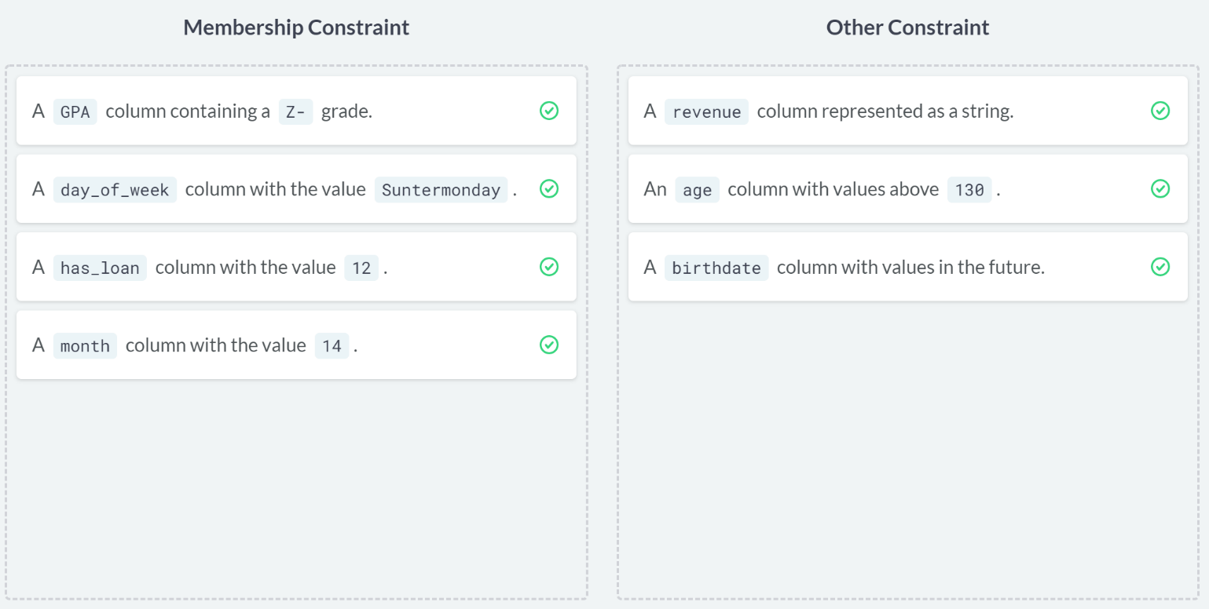  
Tremendous work. You're becoming an elite member of categorical variable experts!

# Finding consistency – **REVIEW**

In this exercise and throughout this chapter, you'll be working with the airlines DataFrame which contains survey responses on the San Francisco Airport from airline customers.

The DataFrame contains flight metadata such as the airline, the destination, waiting times as well as answers to key questions regarding cleanliness, safety, and satisfaction. Another DataFrame named categories was created, containing all correct possible values for the survey columns.

In this exercise, you will use both of these DataFrames to find survey answers with inconsistent values, and drop them, effectively performing an outer and inner join on both these DataFrames as seen in the video exercise. The pandas package has been imported as pd, and the airlines and categories DataFrames are in your environment.

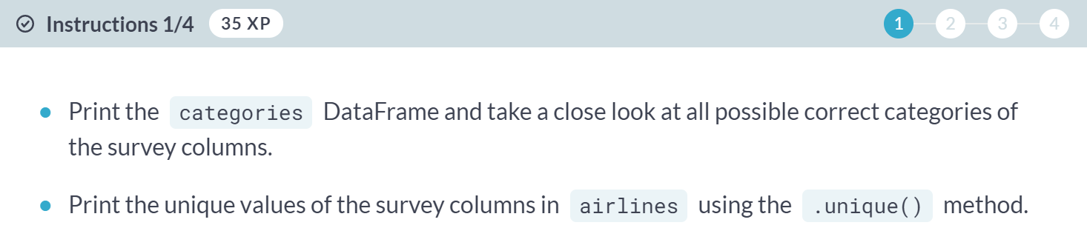  
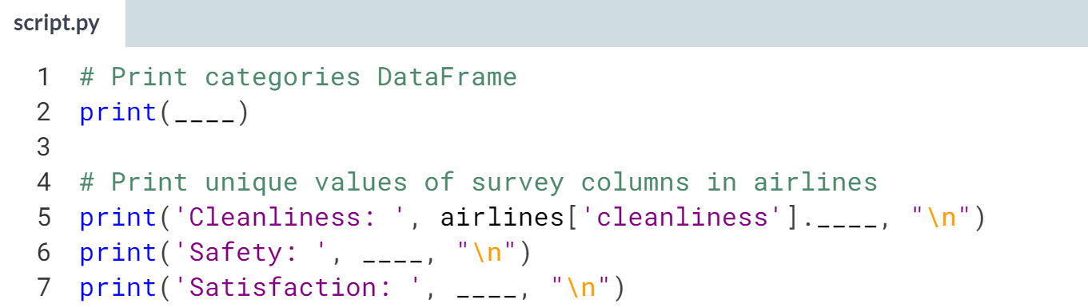  
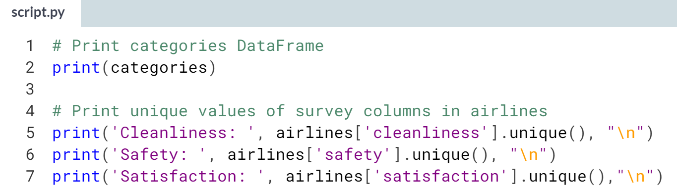  
(Result of the next page)

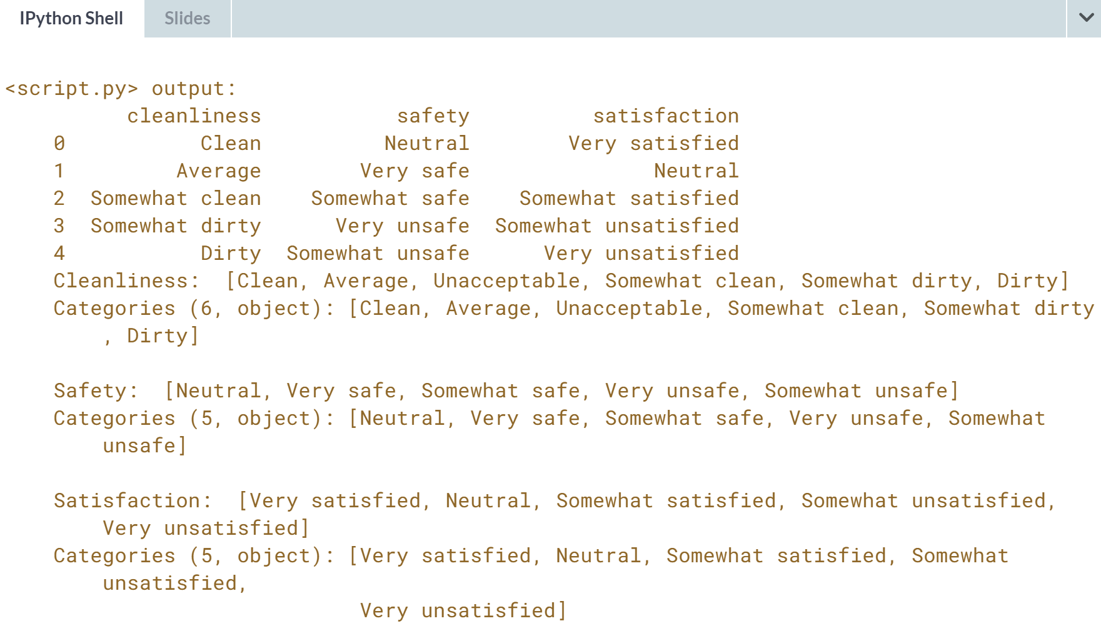

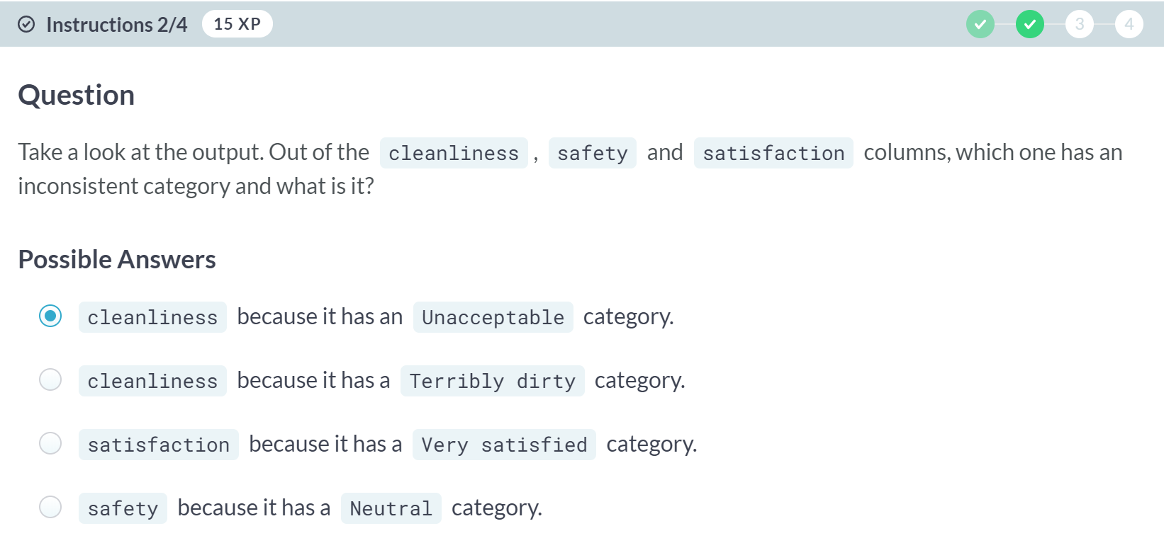

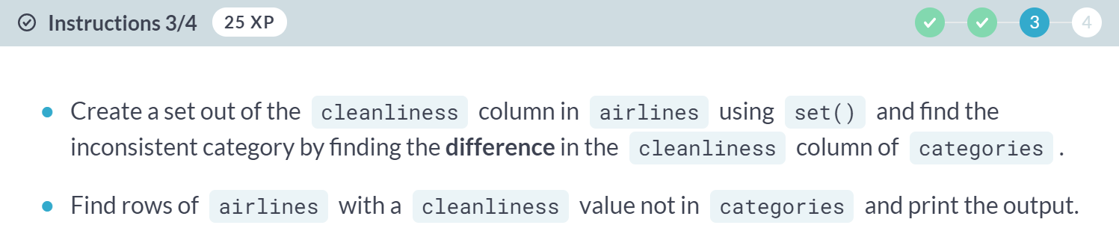

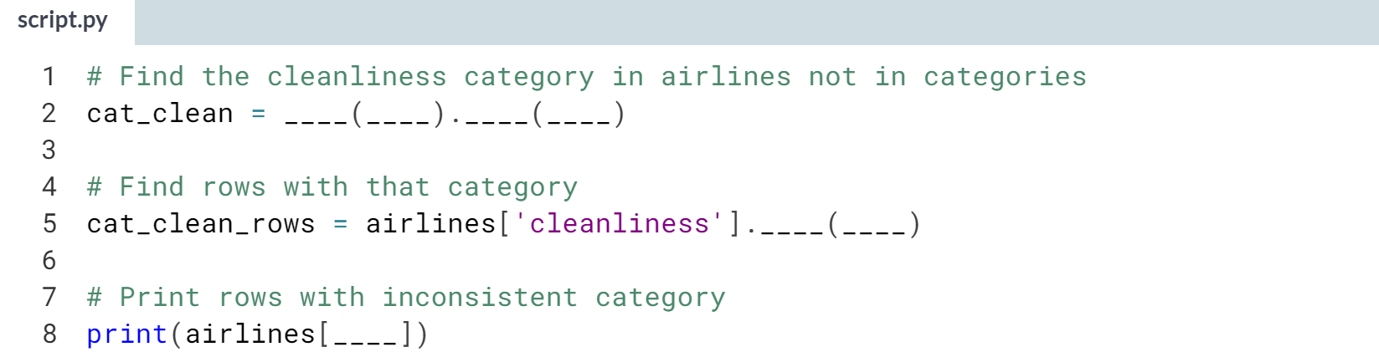

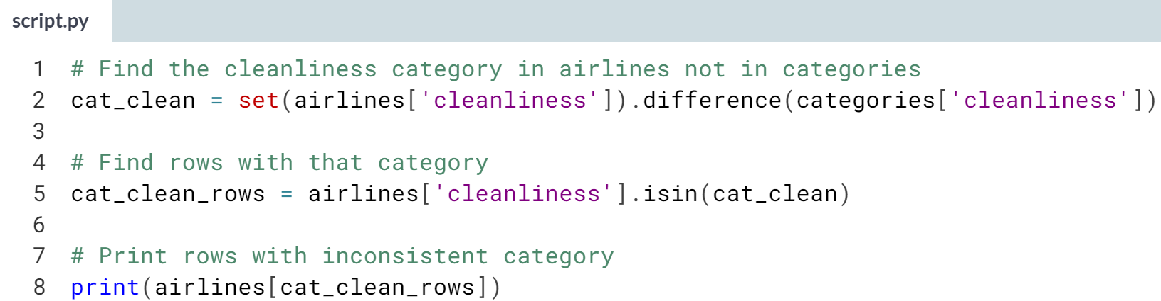

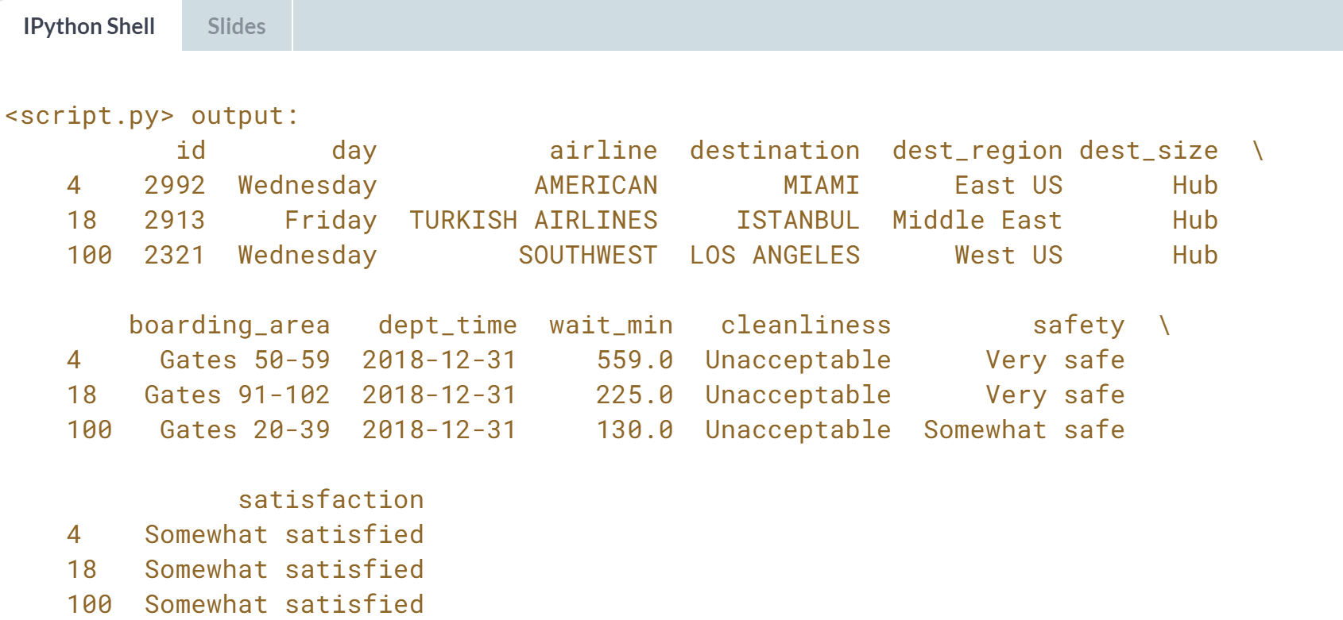

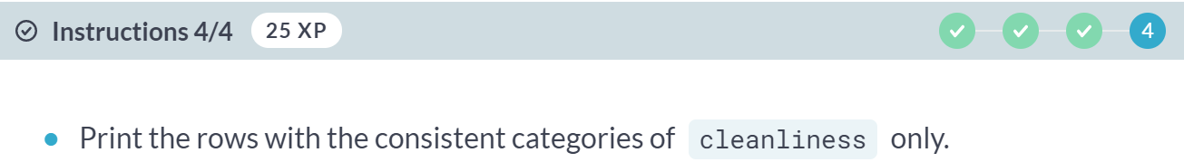

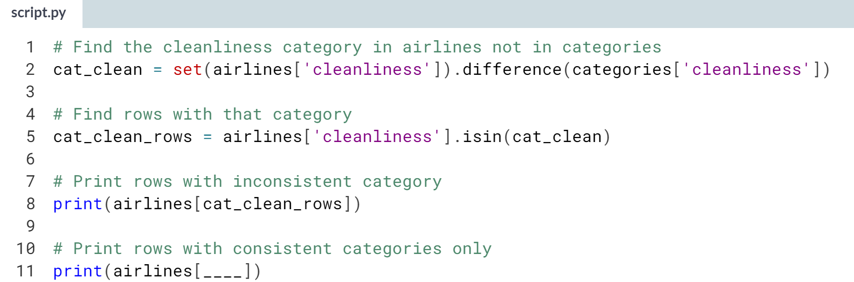

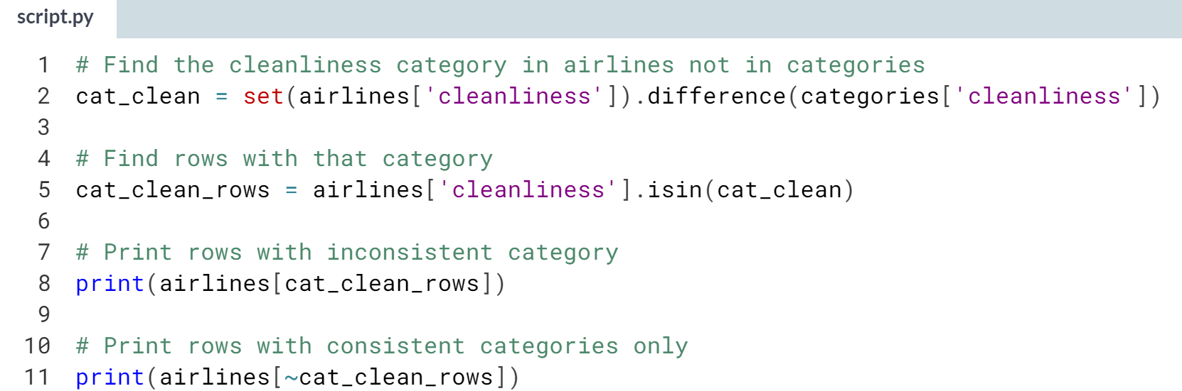  
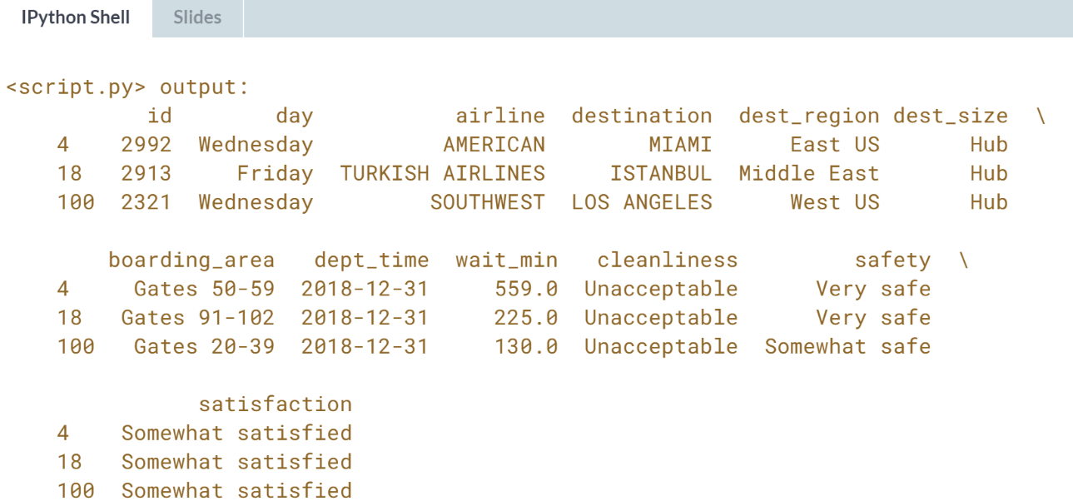  
Great consistent work! Keep it up! In the next lesson, we'll be looking at more in-depth solutions to dealing with dirty categorical data.



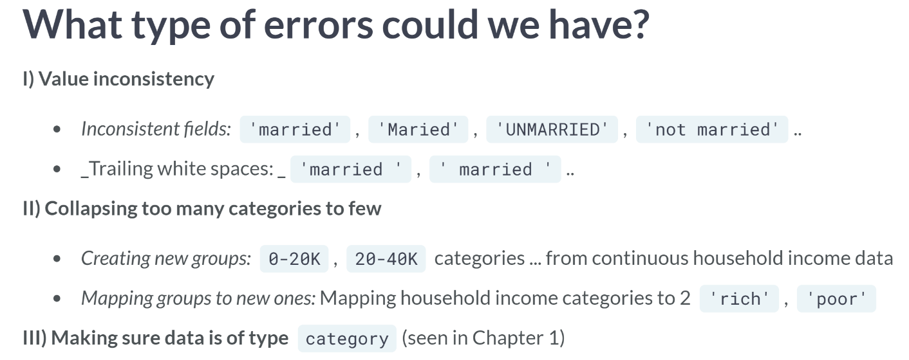  
These are some of the problems we may encounter while cleaning categorical data.

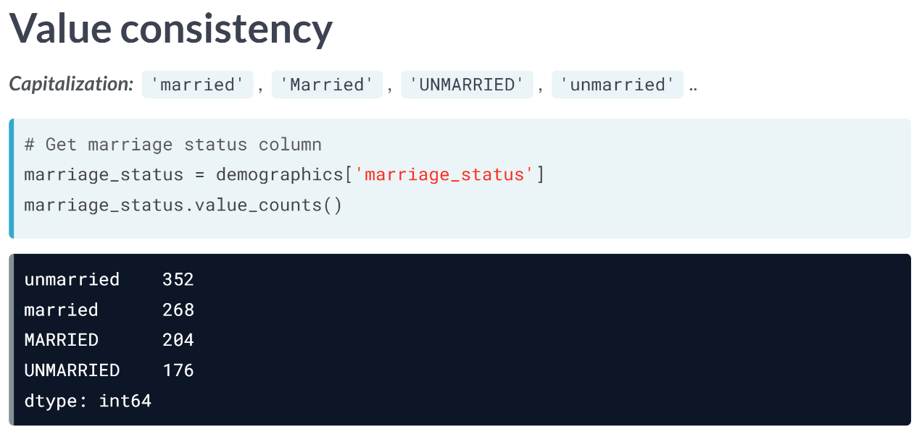  
Note that ***.value_counts()*** methods works only on Series.

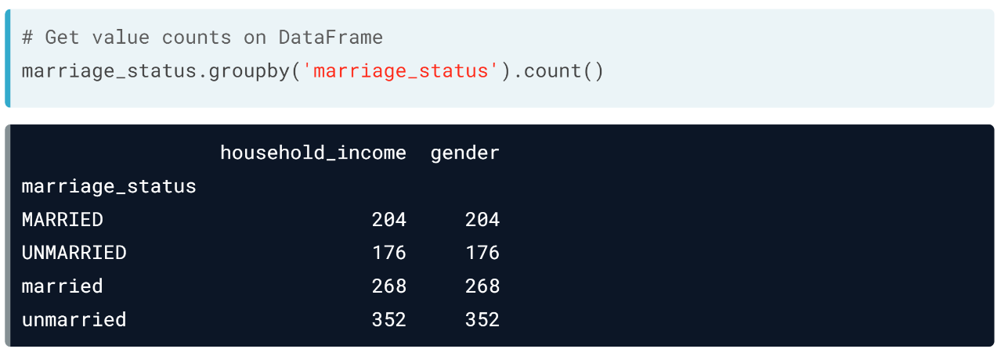  
For a DataFrame, we can ***groupby()*** the column and use the ***.count()*** method.

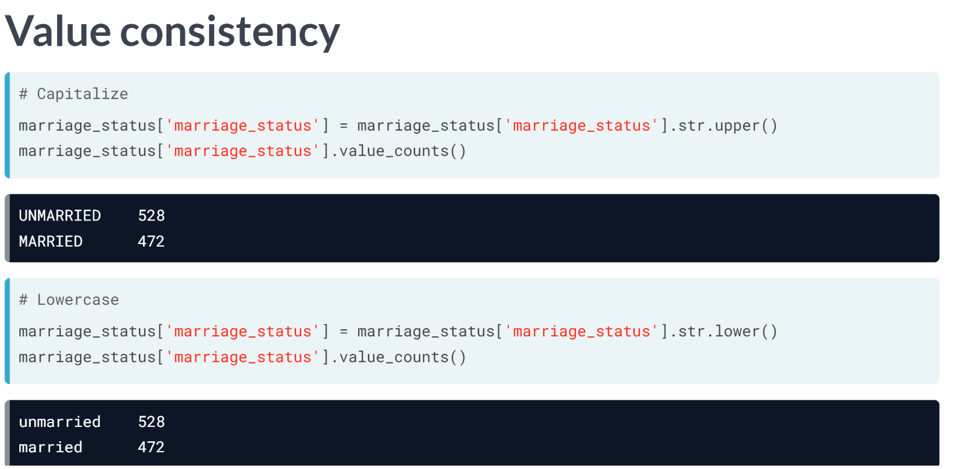  
To deal with these inconsistencies, we can either capitalize all the letters or make every letter into lowercase. Pay attention to the function, ***str.upper()*** and ***str.lower()***, respectively.

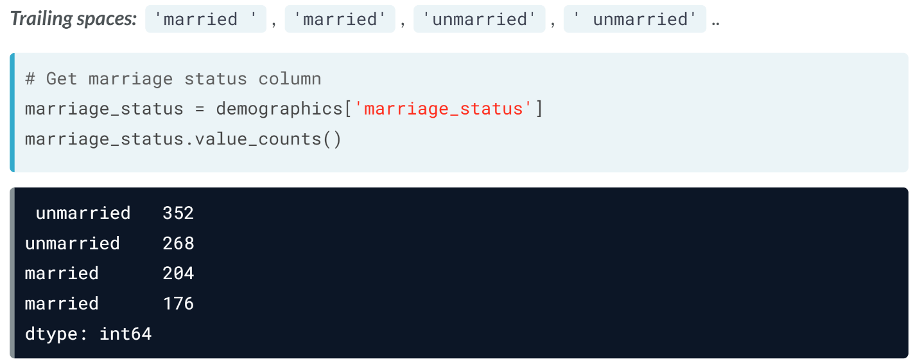  
Another common problem with categorical values is leading or trailing spaces. For example, imagine the same demographic DataFrame containing values with leading spaces. Note that there is a married category with a trailing space on the right, which makes it hard to spot on the output, as opposed to unmarried.

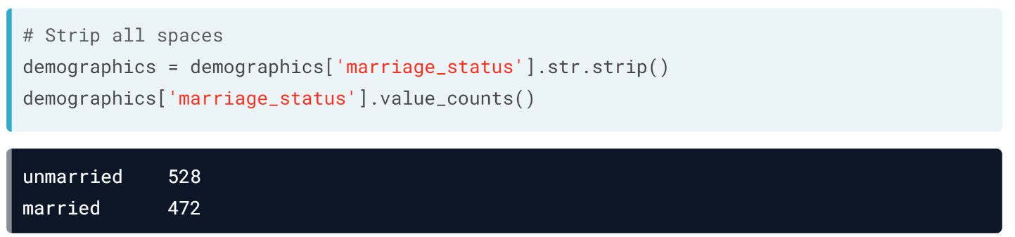  
We can use the ***str.strip()*** to remove leading spaces, which when given no input, strips all leading and trailing white spaces.

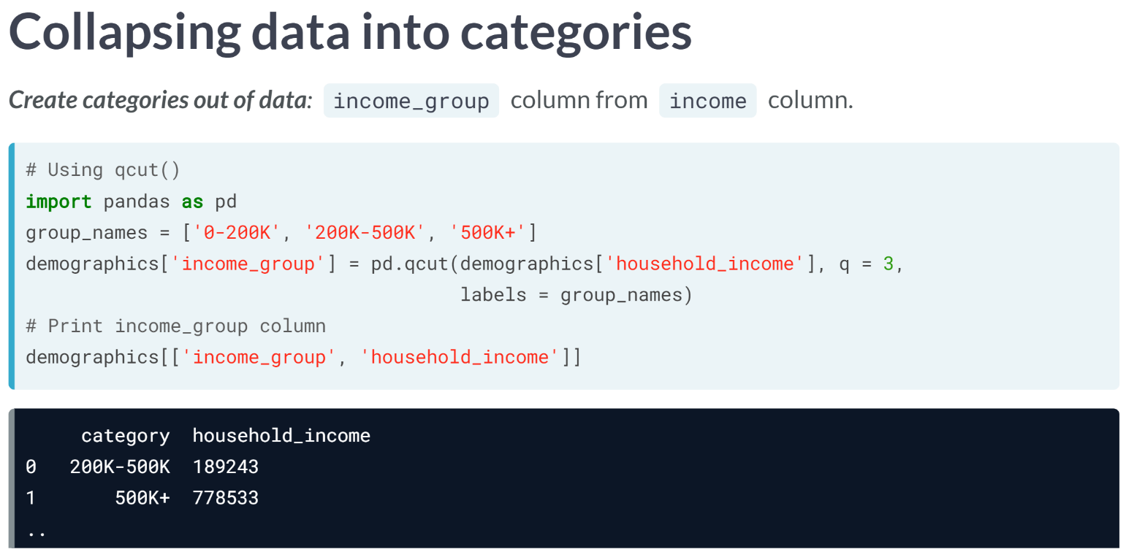We can create categories out of data in two ways.

The first method utilizes the ***qcut()*** function from pandas, which automatically divides our data based on its distribution into the number of categories we set in the *q* argument, we created the category names in the *group_names* list and fed it to the labels argument, returning the following.

Notice that the first row actually misrepresents the actual income of the income group, as we didn't instruct ***qcut()*** where our ranges actually lie.

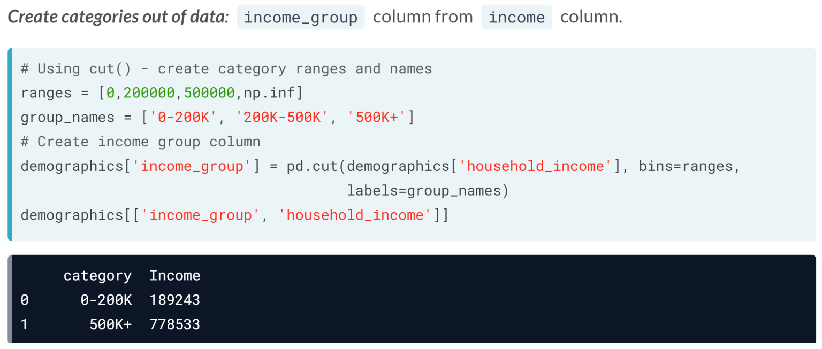  
We can do this with the ***cut()*** function instead, which lets us define category cutoff ranges with the bins argument.

It takes in a list of cutoff points for each category, with the final one being infinity represented with ***np.inf()*** from NumPy. From the output, we can see this is much more correct.

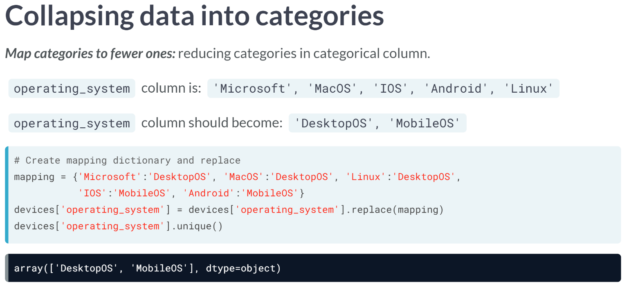  
Sometimes, we may want to reduce the number of categories we have in our data.

Let's move on to mapping categories to fewer ones. For example, assume we have a column containing the operating system of different devices, and contains these unique values.

Say we want to collapse these categories into two, as shown above. We can do this by using the ***replace()*** method.

It takes in a dictionary that maps each existing category to the category name you desire. A quick print of the unique value, so operating system shows the mapping has been complete.

# Categories of errors

In the video exercise, you saw how to address common problems affecting categorical variables in your data, including white spaces and inconsistencies in your categories, and the problem of creating new categories and mapping existing ones to new ones.

To get a better idea of the toolkit at your disposal, you will be mapping functions and methods from pandas and Python used to address each type of problem.

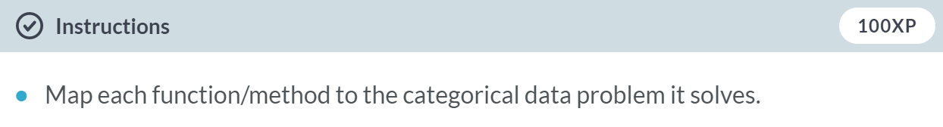

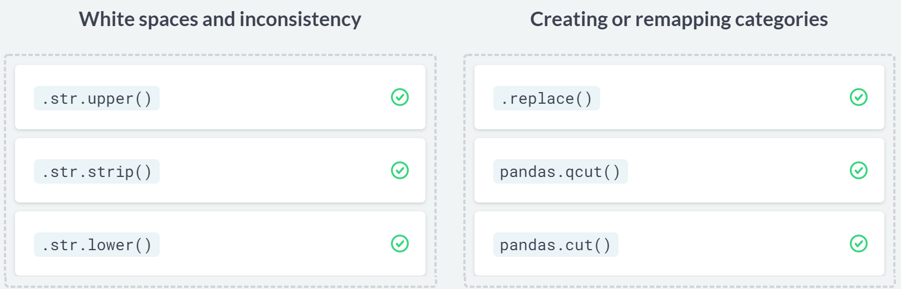

# Inconsistent categories

In this exercise, you'll be revisiting the airlines DataFrame from the previous lesson.

As a reminder, the DataFrame contains flight metadata such as the airline, the destination, waiting times as well as answers to key questions regarding cleanliness, safety, and satisfaction on the San Francisco Airport.

In this exercise, you will examine two categorical columns from this DataFrame, dest_region and dest_size respectively, assess how to address them and make sure that they are cleaned and ready for analysis.

The pandas package has been imported as pd, and the airlines DataFrame is in your environment.

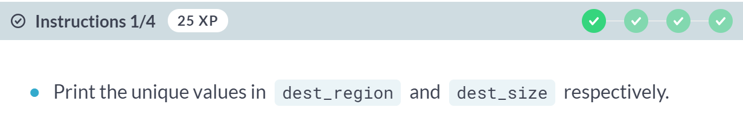  
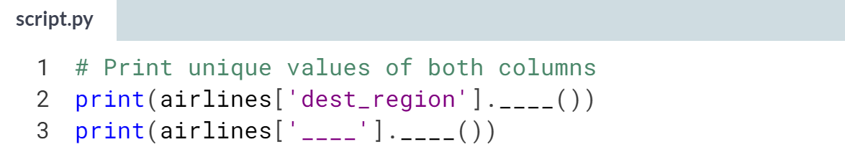

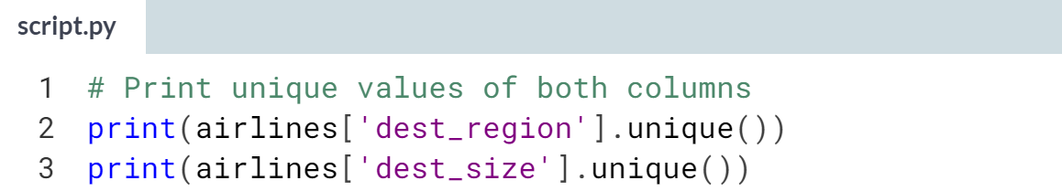

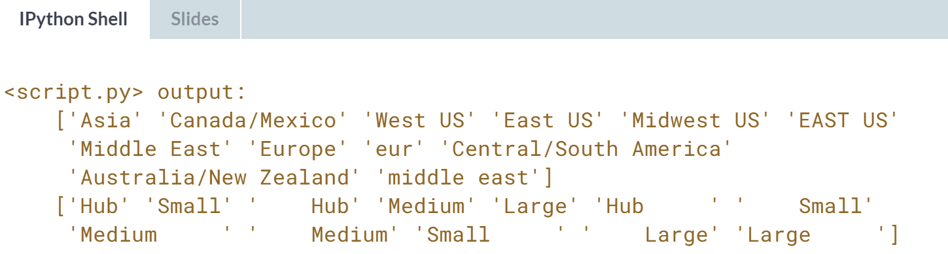

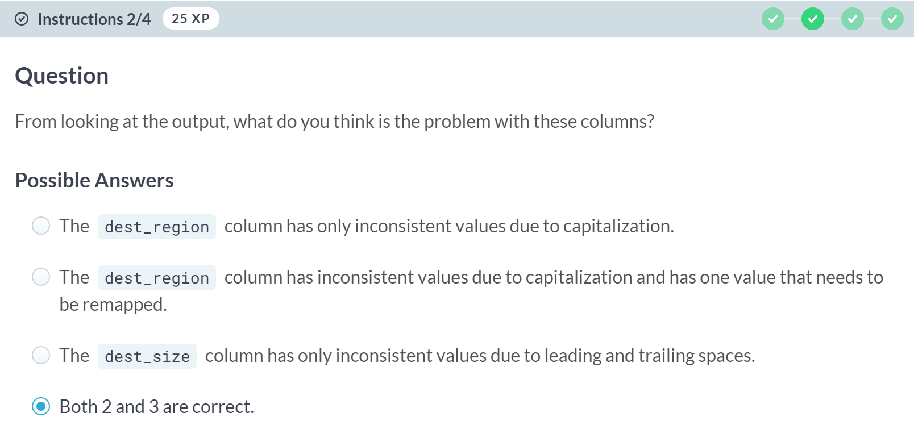

(Exercise continues on the next page)

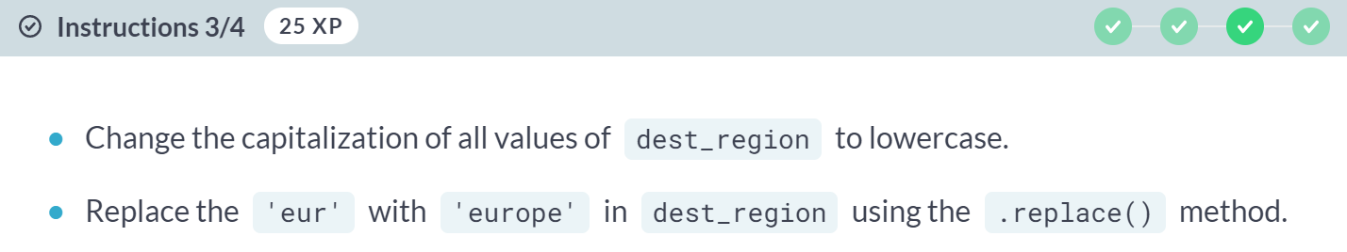  
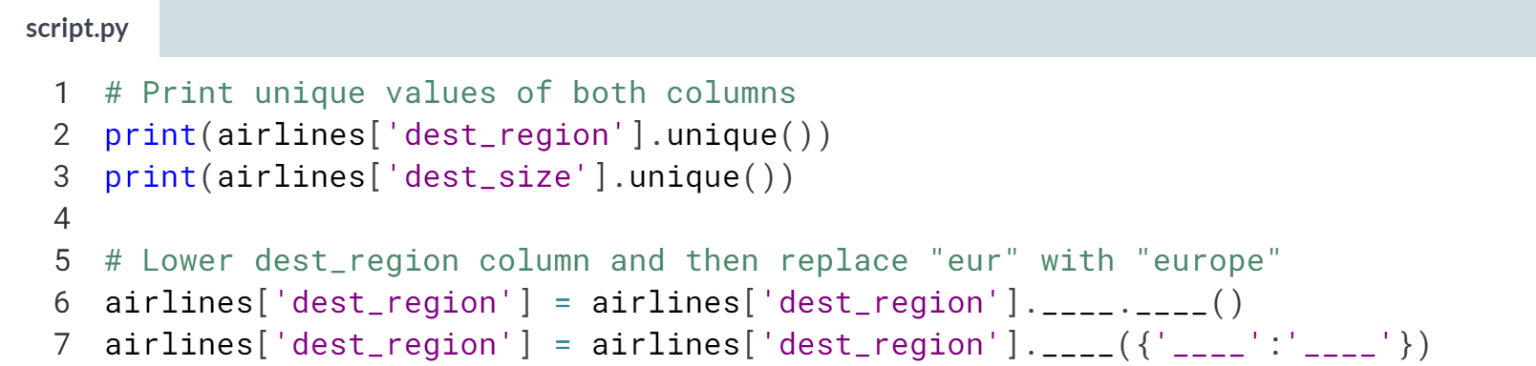

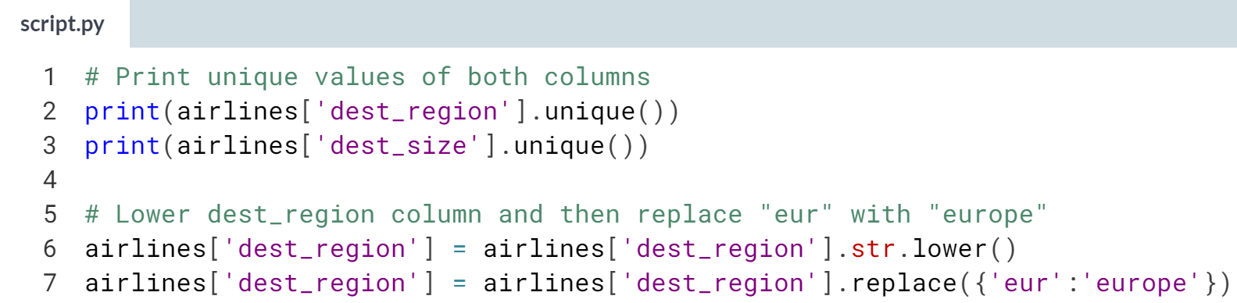

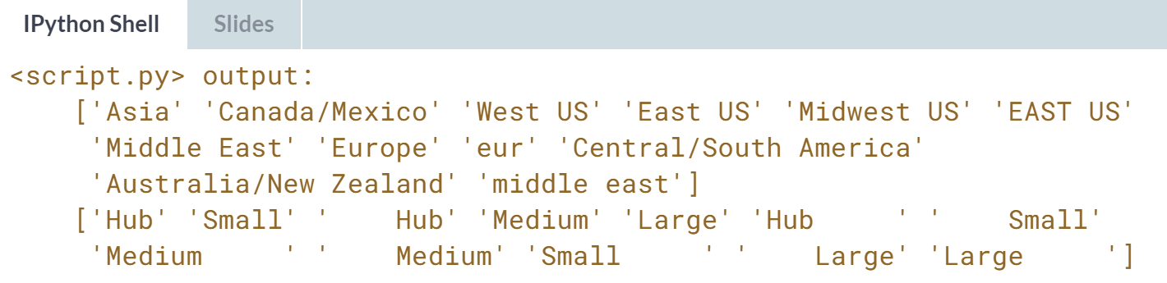

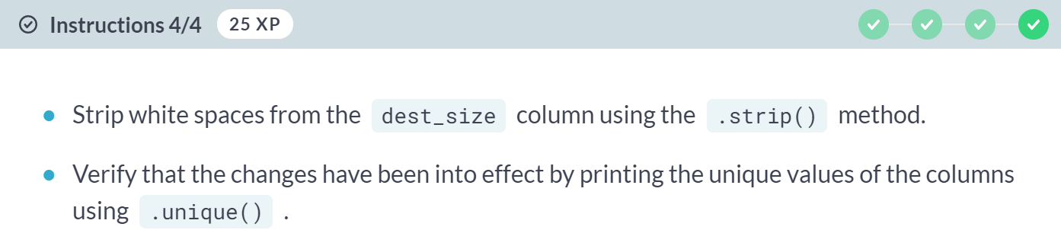

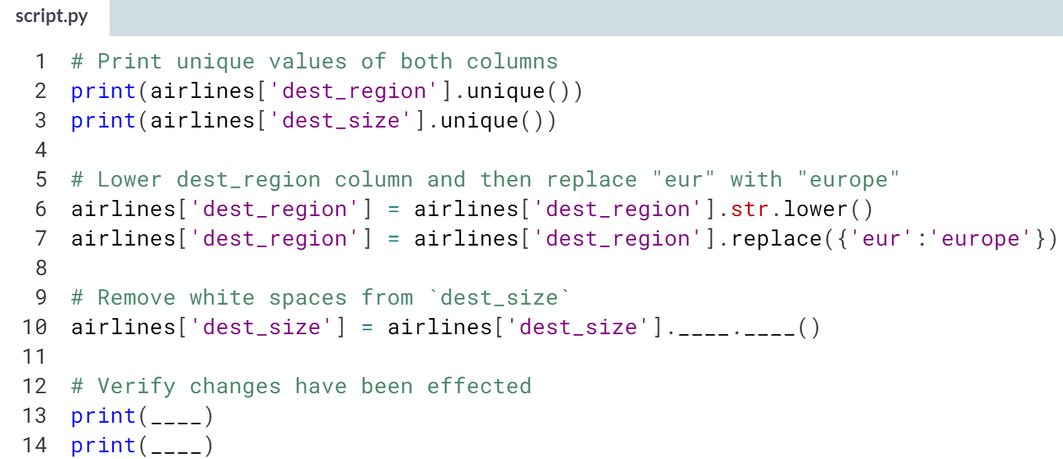

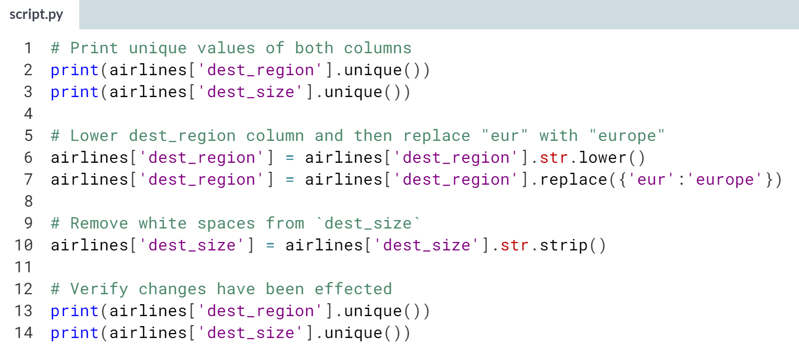  
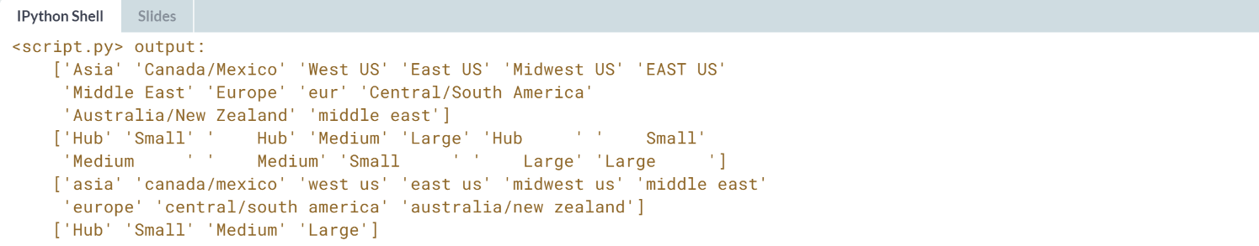  
Great work! Notice how all categories have been properly treated?

# Remapping categories

To better understand survey respondents from airlines, you want to find out if there is a relationship between certain responses and the day of the week and wait time at the gate.

The airlines DataFrame contains the day and wait_min columns, which are categorical and numerical, respectively. The day column contains the exact day a flight took place, and wait_min contains the amount of minutes it took travelers to wait at the gate. To make your analysis easier, you want to create two new categorical variables:

* wait_type: 'short' for 0-60 min, 'medium' for 60-180 and long for 180+
* day_week: 'weekday' if day is in the weekday, 'weekend' if day is in the weekend.

The pandas and numpy packages have been imported as pd and np. Let's create some new categorical data!

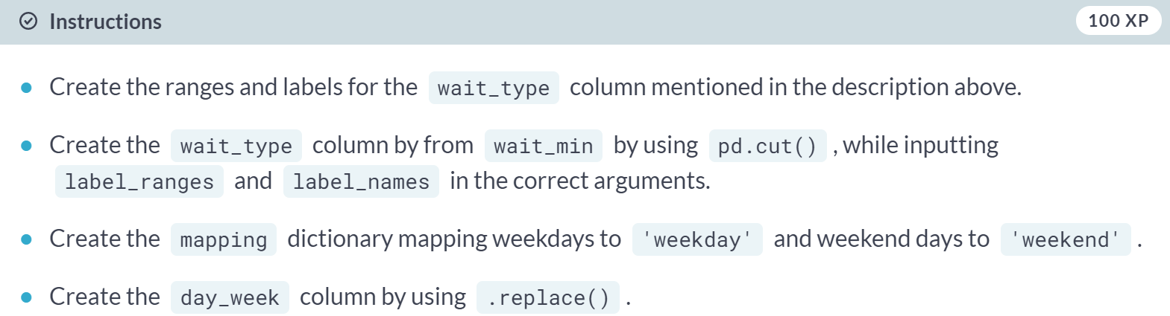

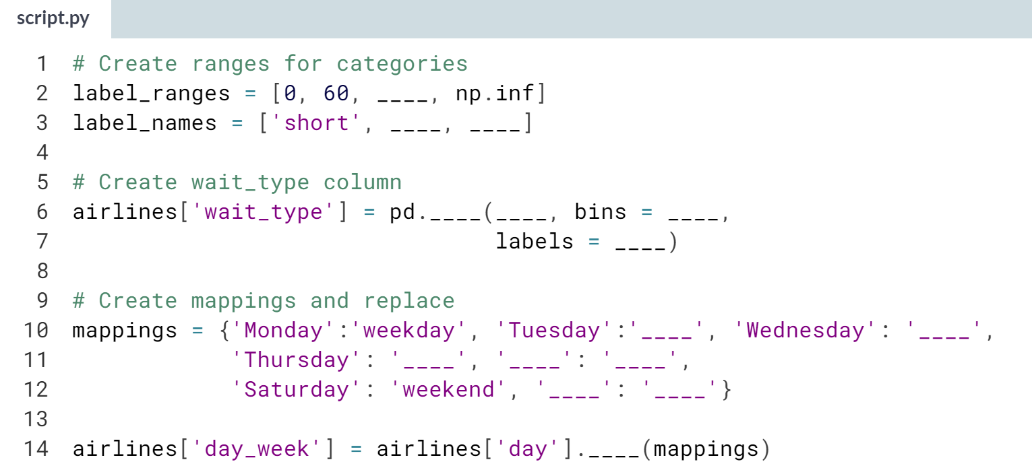

(Solution on the next page)

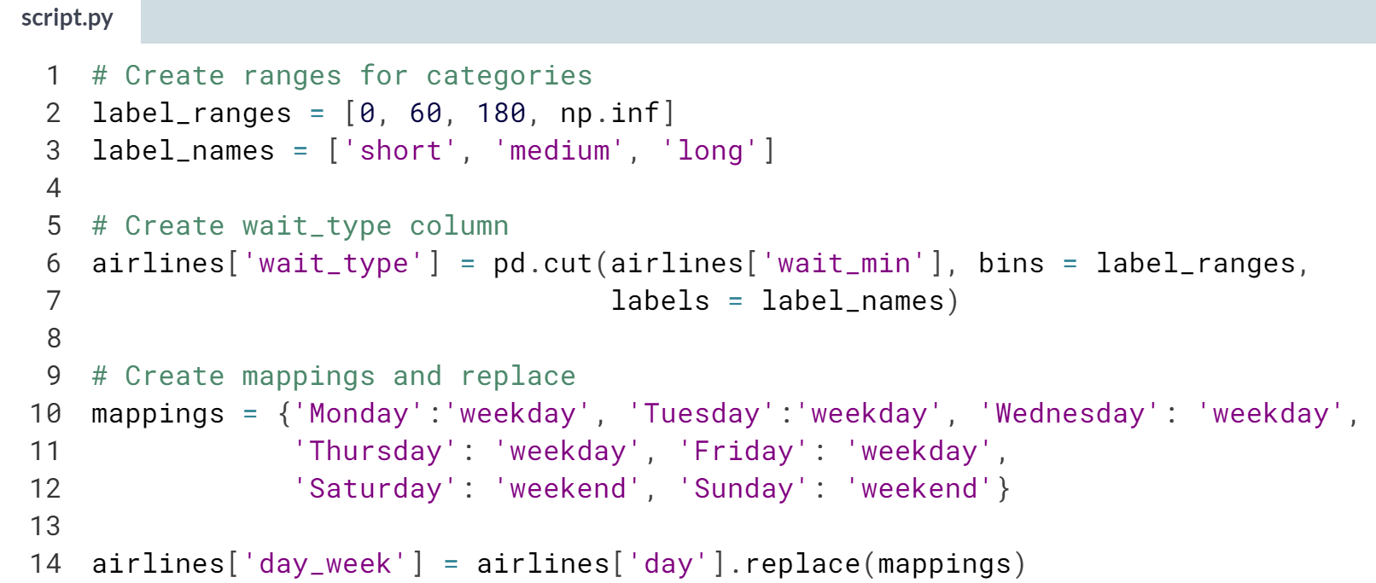  
Awesome work! You just created two new categorical variables, that when combined with other columns, could produce really interesting analysis. Don't forget, you can always use an *assert* statement to check your changes passed.



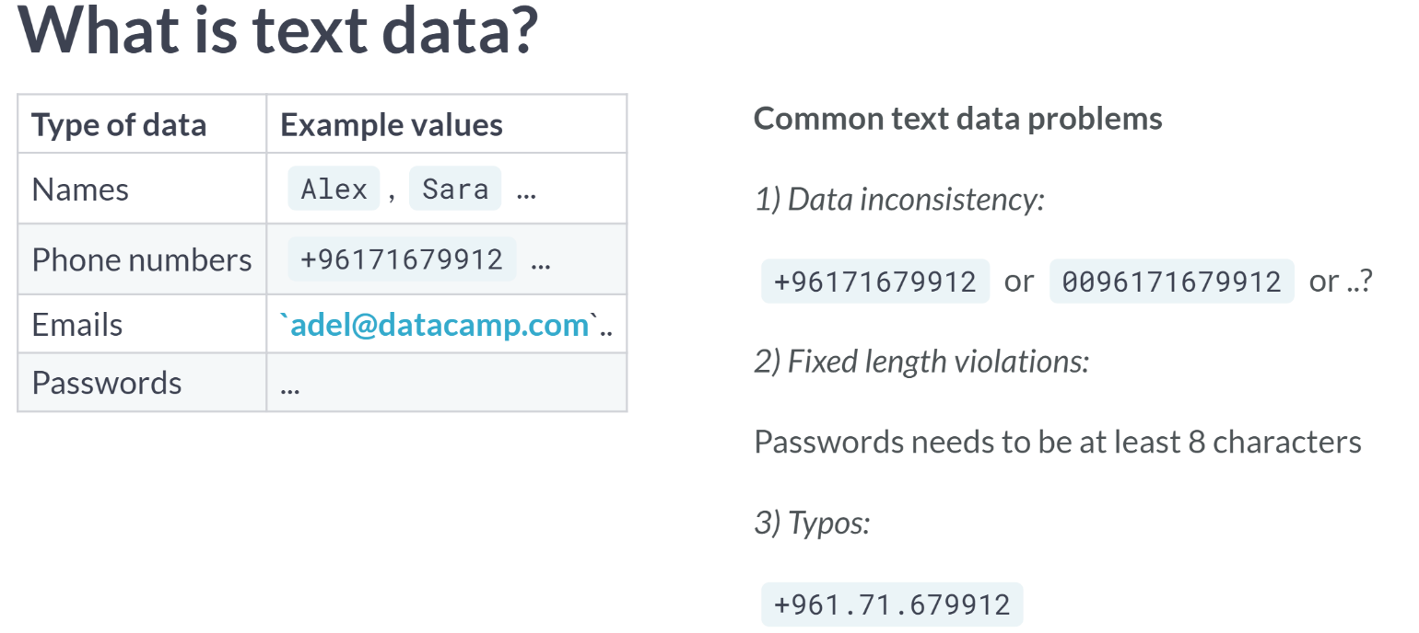

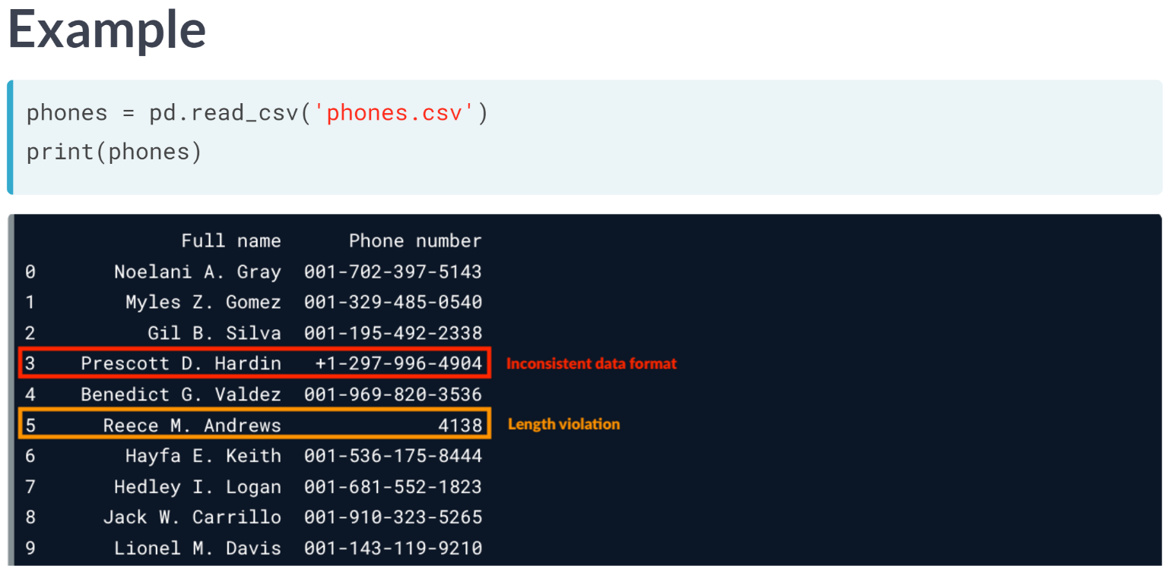  
If we wanted to feed these phone numbers into an automated call system or create a report discussing the distribution of users by area code, we couldn't really do so without uniform phone numbers.

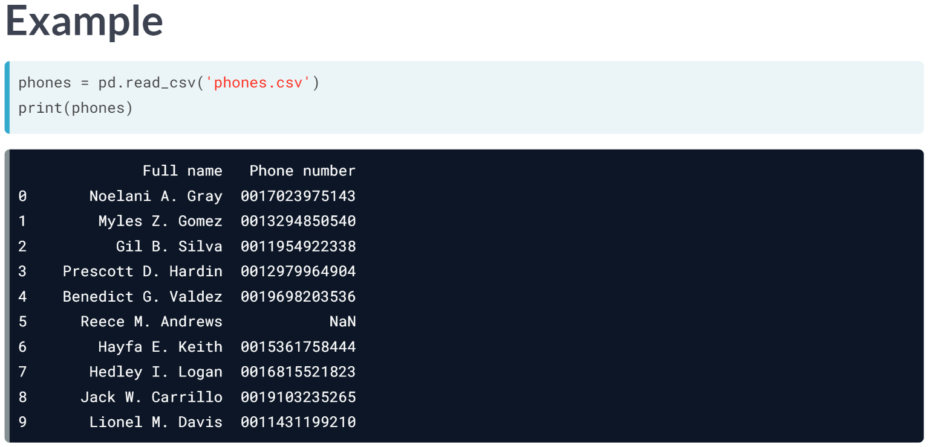  
Ideally, we want the DataFrame to look like this where all phone numbers are aligned to begin with 00, where any number below the 10-digit value is replaced with NaN to represent a missing value, and where all dashes have been removed.

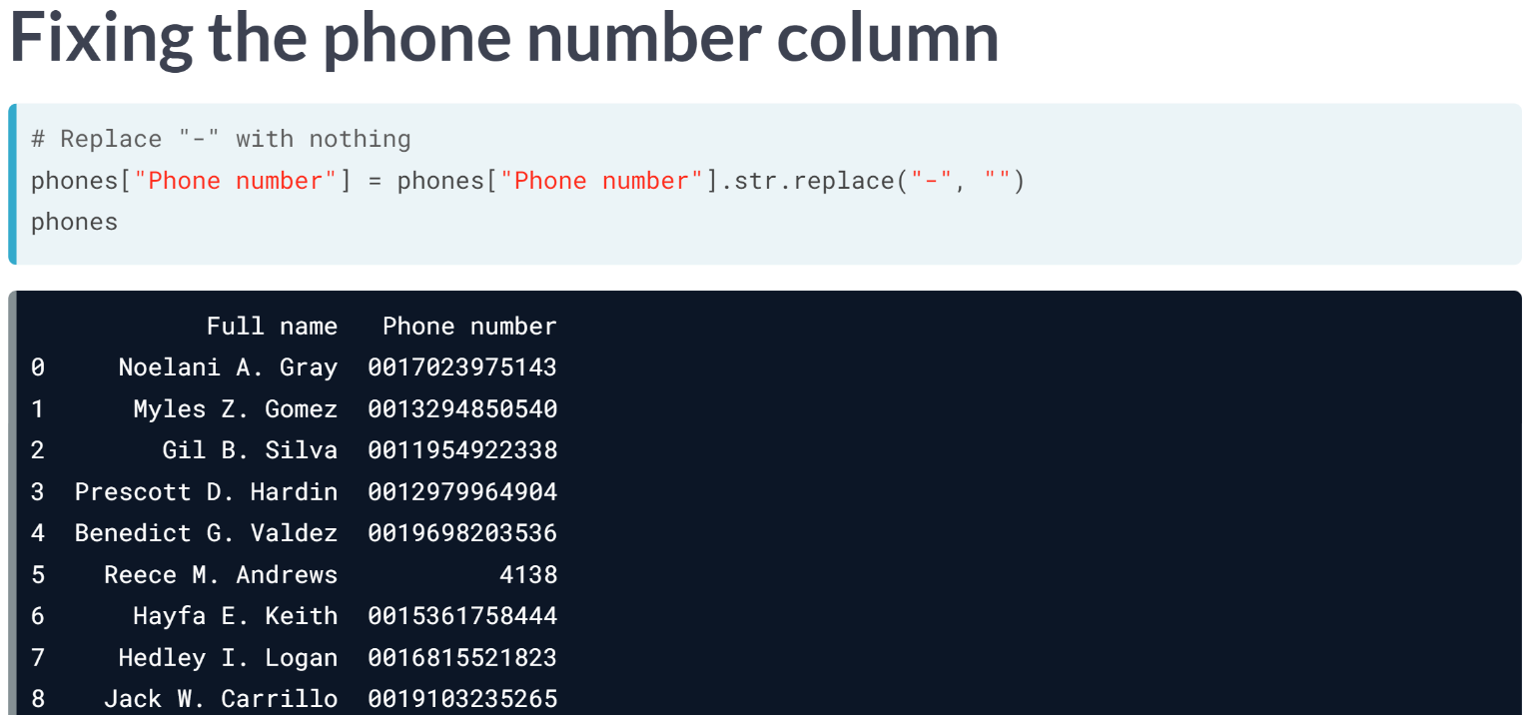  
To do this, let's first begin by replacing the plus sign with “00”, to do this, we use the ***.str()*** method, which takes in two values, the string being replaced, which is in this case the plus sign and the string to replace it with, which is in this case *“00”*. We can see that the column is updated after running this code.

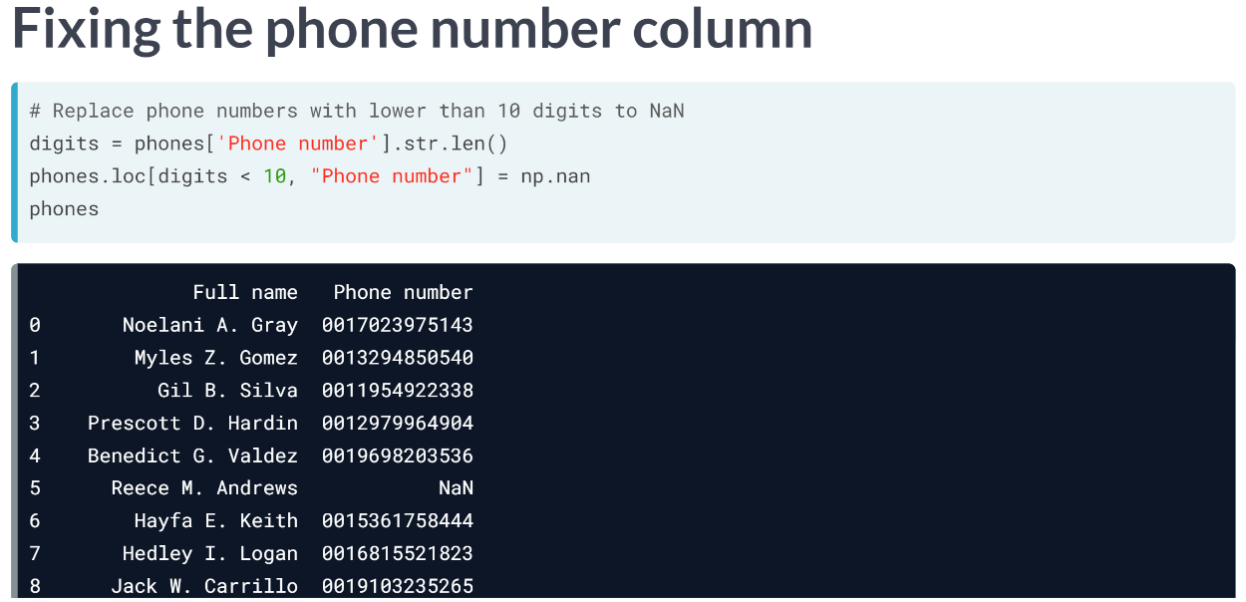  
We use the same exact technique to remove the dashes, by replacing the dash symbol with an empty string.

Also, we are going to replace all phone number s below 10 digits to NaN. We can do this by chaining the phone number column with the ***.str.len()*** method, which returns the string length of each row in the column.

We can then use the **.loc** method, to index rows where digits is below 10, and replace the value of Phone number with NumPy’s nan object, which is imported as *np*.

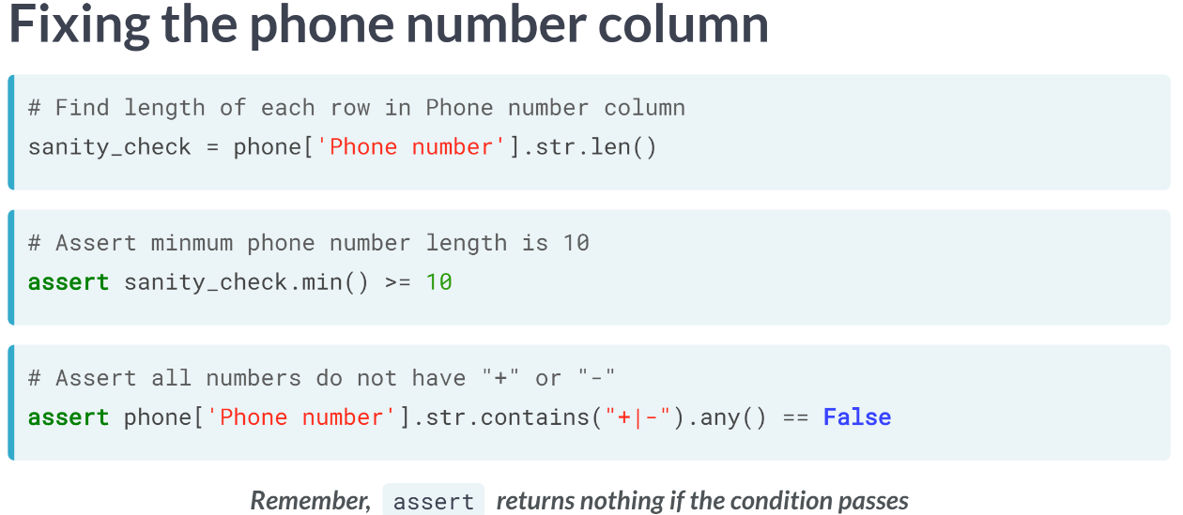  
We can also write assert statements to test whether the phone number column has a specific length, and whether it contains the symbols we removed.

The first assert statement tests that the minimum length of the strings in the phone number column, found through ***str.len()***, is bigger than or equal to 10.

In the second assert statement, we use the ***str.contains()*** method to test whether the phone number column contains a specific pattern. It returns a series of Booleans for that are True for matches and False for non-matches.

We set the pattern "+|-", and the bar pipe here is basically an or statement, so we are trying to find matches for either symbols. We chain it with the any method, which returns True if any element in the output of our ***.str.contains()*** is True, and test whether it returns False.

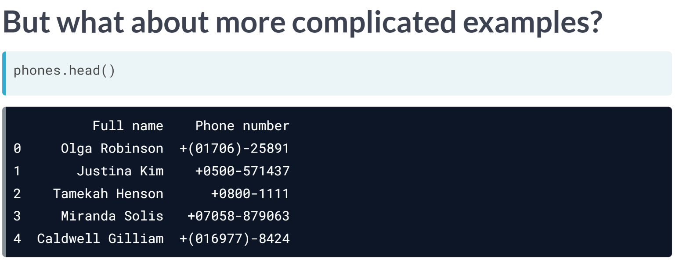  
How can we clean more complicated phone column that looks like the above, where phone numbers can contain a range of symbols from plus signs, dashes, parentheses, and maybe more?

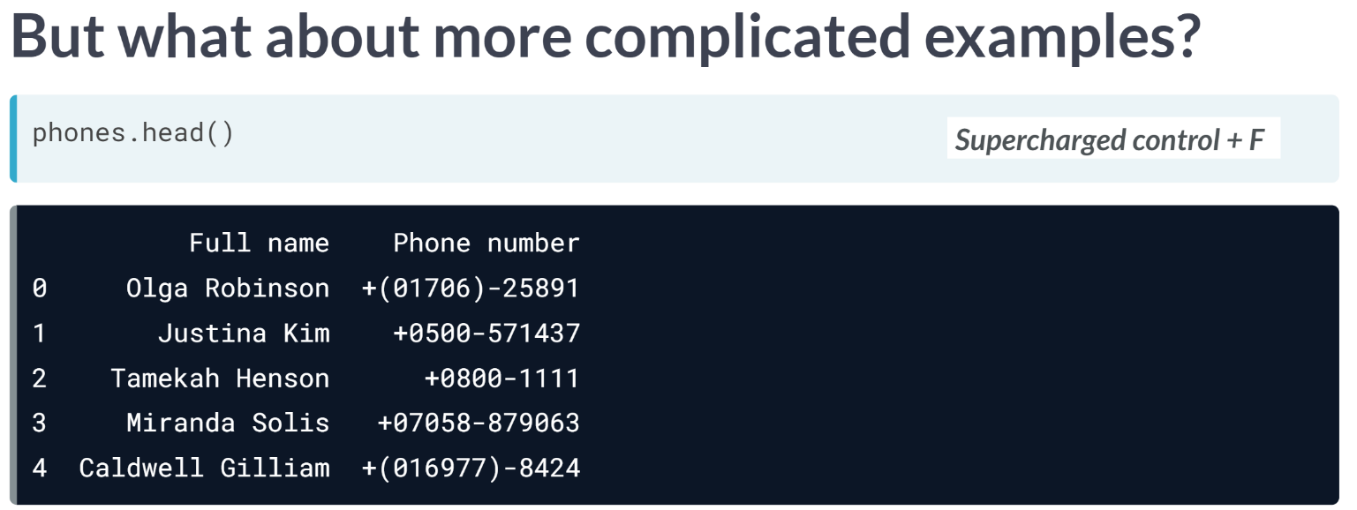  
This is where regular expressions come in. Regular expressions give us the ability to search for any pattern in text data, like only digits for example. They are like CTRL + F in your browser but way more powerful and robust.

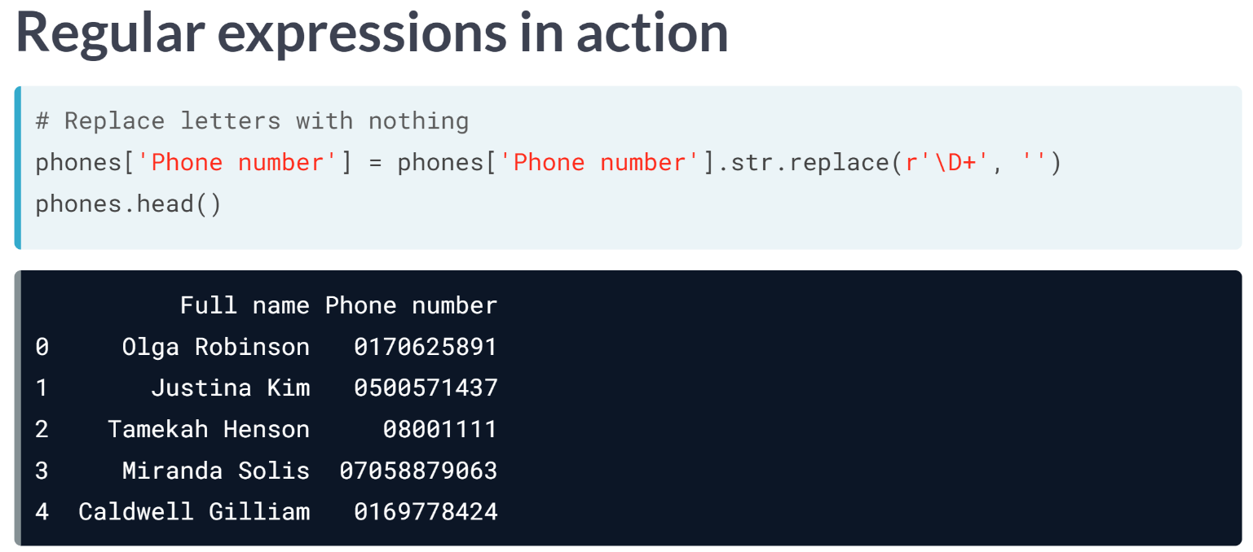  
Here we are only attempting to only extract digits from the phone number column.

To do this, we use the ***.str.replace()*** method with the pattern we want to replace with an empty string. Notice the pattern fed into the method.

This is essentially us telling pandas to replace anything that is not a digit with nothing. We won't get into specifics of regular expressions, and how to construct them, but they are immensely useful for difficult string cleaning tasks, so make sure to check out DataCamp's course on regular expressions

# Removing titles and taking names

While collecting survey respondent metadata in the airlines DataFrame, the full name of respondents was saved in the full_name column.

However, upon closer inspection, you found that a lot of the different names are prefixed by honorifics such as "Dr.", "Mr.", "Ms." and "Miss".

Your ultimate objective is to create two new columns named first_name and last_name, containing the first and last names of respondents, respectively.

Before doing so however, you need to remove honorifics.

The airlines DataFrame is in your environment, alongside pandas as pd.

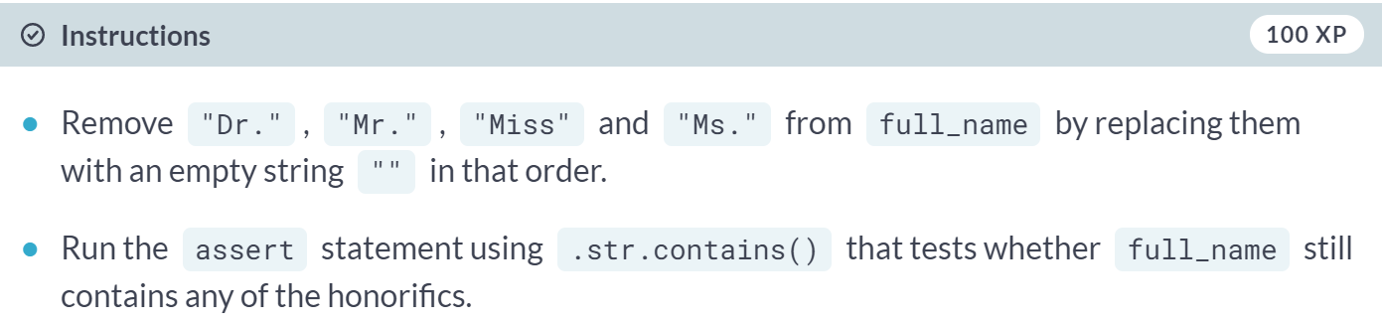

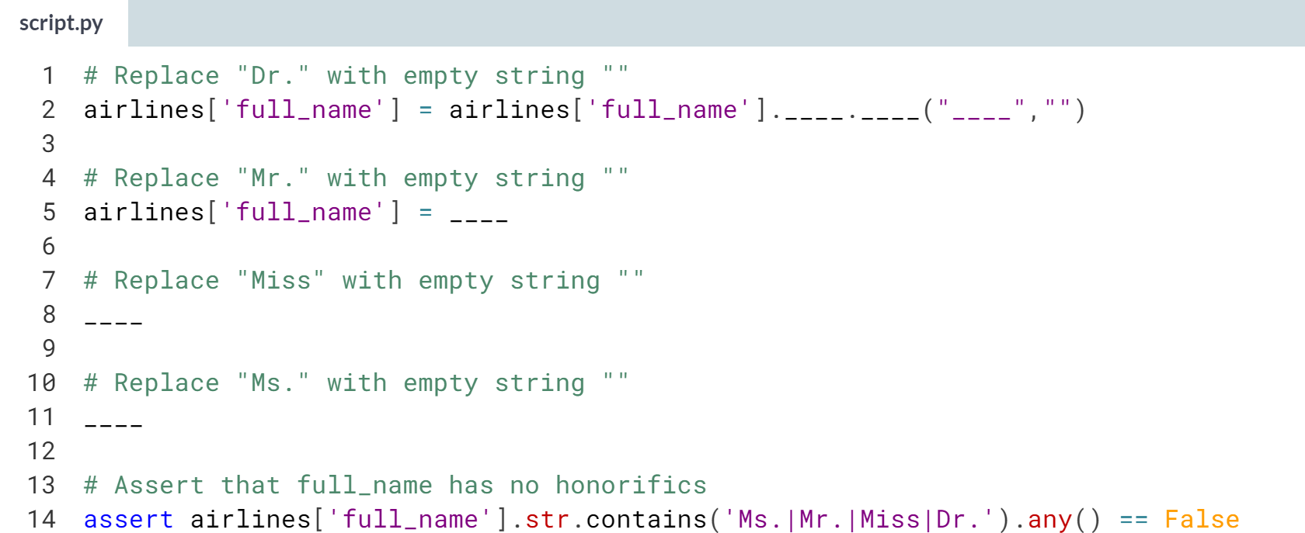

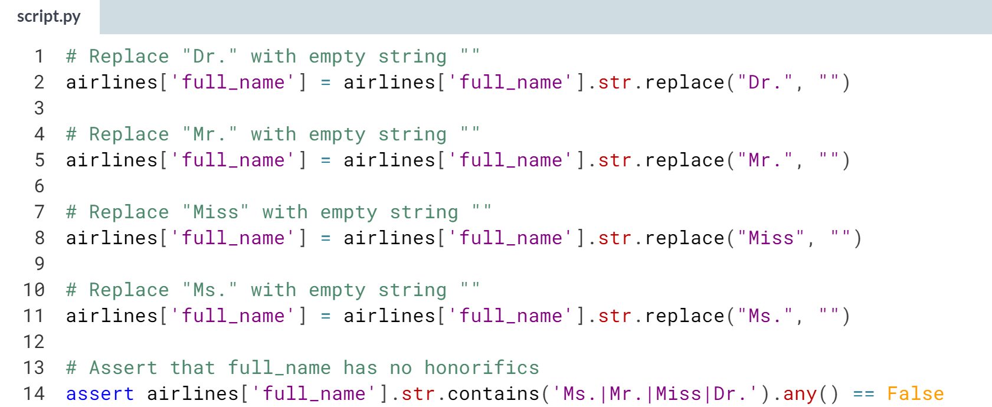

Great work! By normalizing full names this way, you can now easily split them into first names and last names!

# Keeping it descriptive

To further understand travelers' experiences in the San Francisco Airport, the quality assurance department sent out a qualitative questionnaire to all travelers who gave the airport the worst score on all possible categories.

The objective behind this questionnaire is to identify common patterns in what travelers are saying about the airport.

Their response is stored in the survey_response column. Upon a closer look, you realized a few of the answers gave the shortest possible character amount without much substance.

In this exercise, you will isolate the responses with a character count higher than **40** , and make sure your new DataFrame contains responses with **40** characters or more using an assert statement.

The airlines DataFrame is in your environment, and pandas is imported as pd.

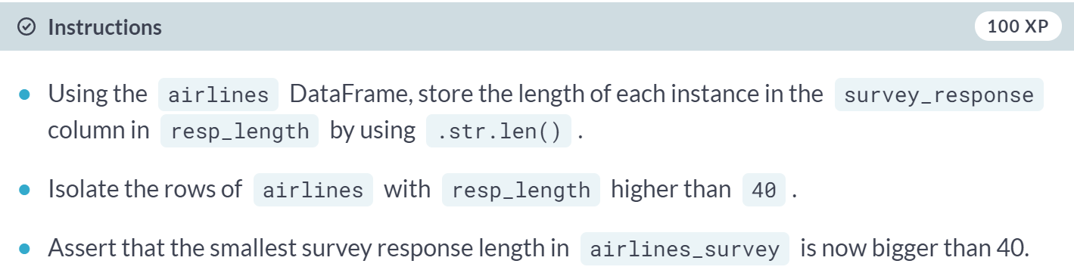

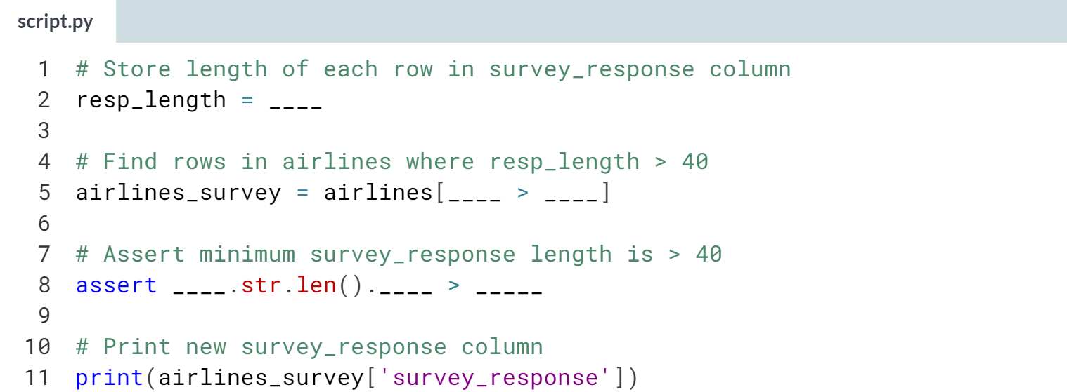

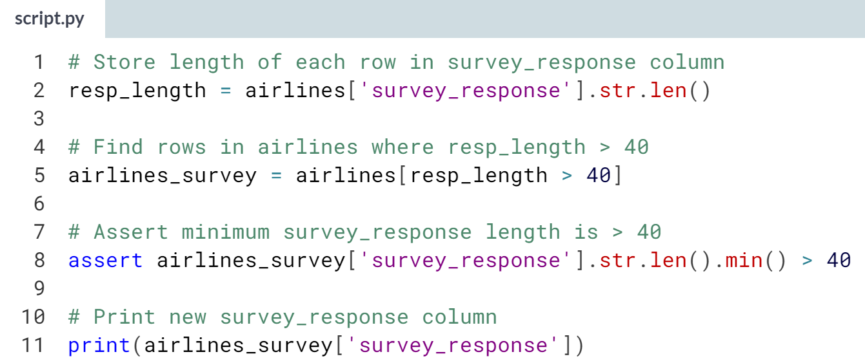

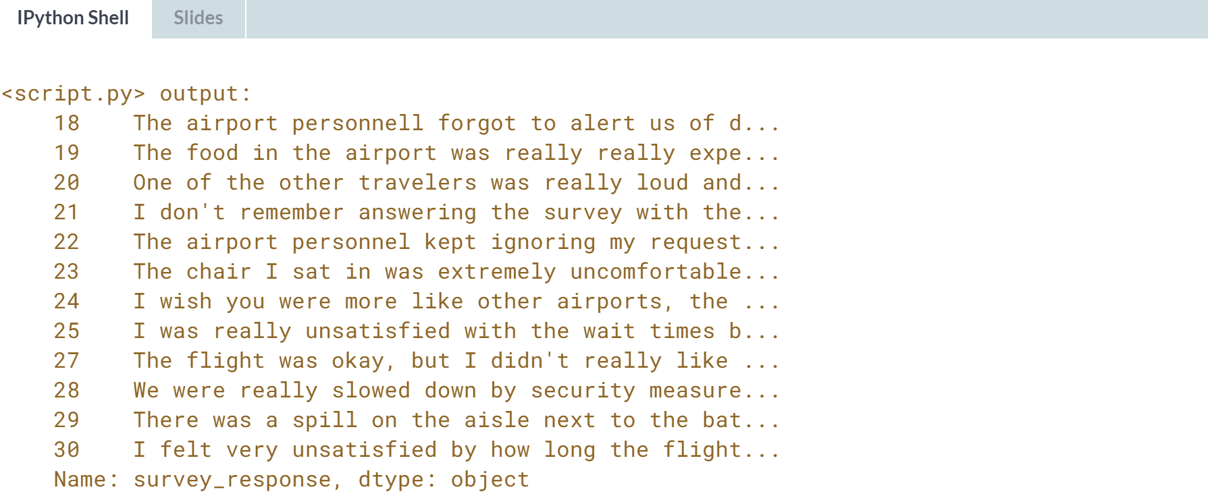

Phenomenal work! These types of feedbacks are essential to improving any service. Coupled with some wordcount analysis, you can find common patterns across all survey responses in no time!

**3. Advanced data problems**

In this chapter, you’ll dive into more advanced data cleaning problems, such as ensuring that weights are all written in kilograms instead of pounds. You’ll also gain invaluable skills that will help you verify that values have been added correctly and that missing values don’t negatively impact your analyses.



In this chapter, we will be looking at more advanced data problems, such as uniformity, cross-field validation and dealing with missing data.

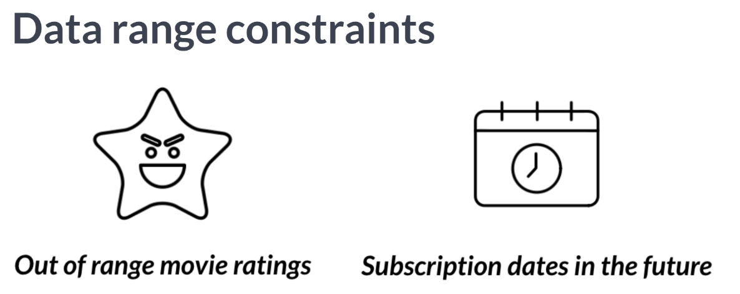  
We saw how out of range values are a common problem when cleaning data, and that when left untouched, can skew our analysis.

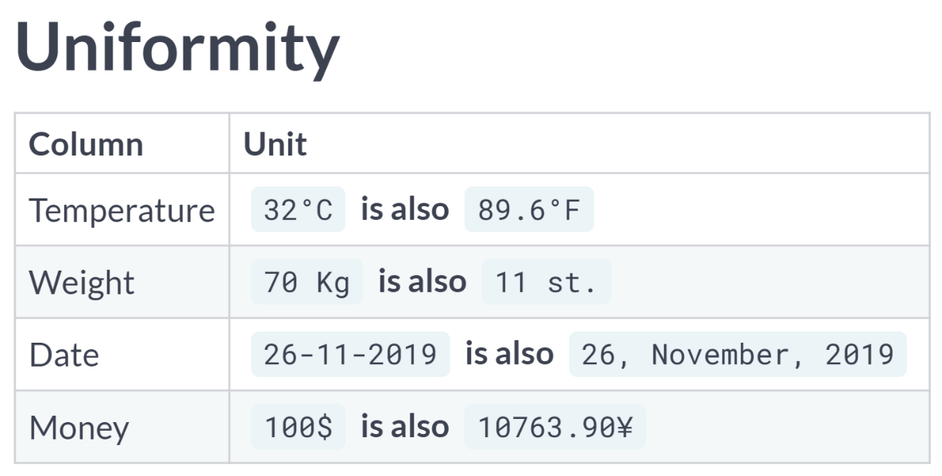  
In this lesson, we are going to tackle a problem that could similarly skew our data, which is unit uniformity. Verifying unit uniformity is imperative to having accurate analysis.

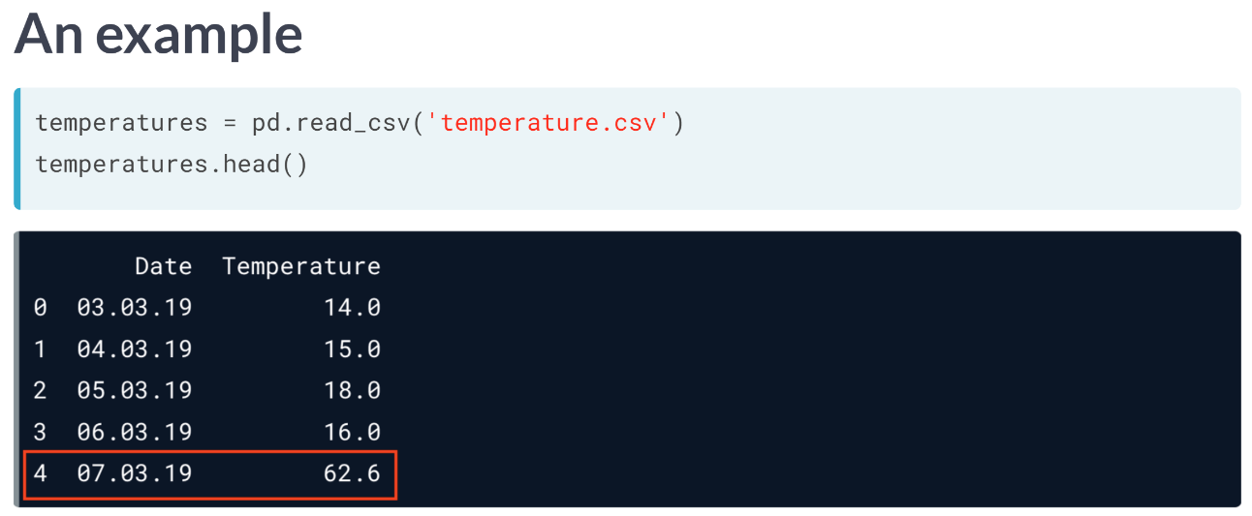  
Here's a dataset with average temperature data throughout the month of March in NYC. This dataset was collected with temperature data in Celsius and Fahrenheit merged together. We can see that unless a major climate event occurred, the value enclosed in red outlined rectangle is most likely in Fahrenheit, not in Celsius.

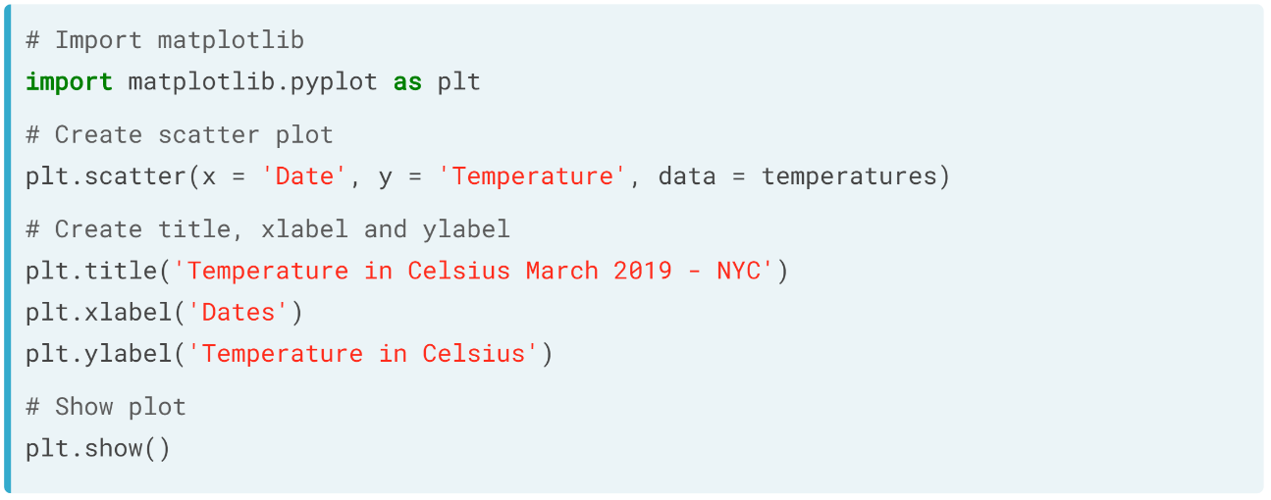  
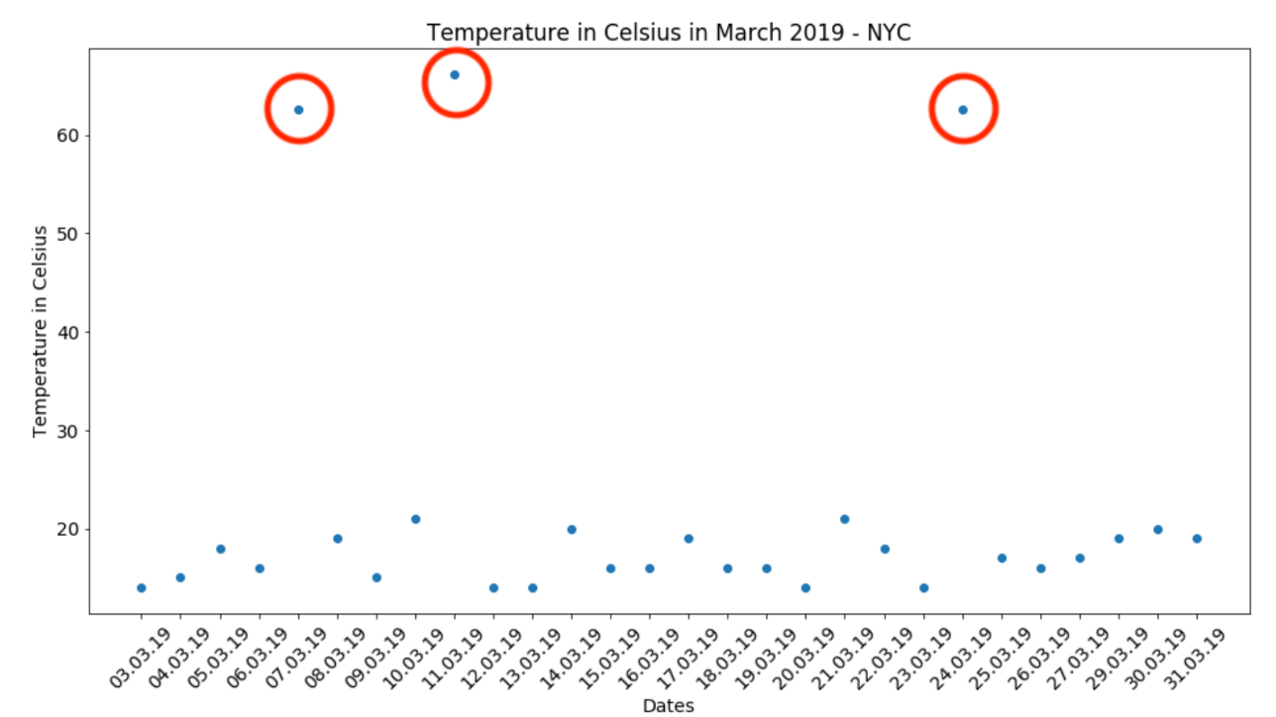

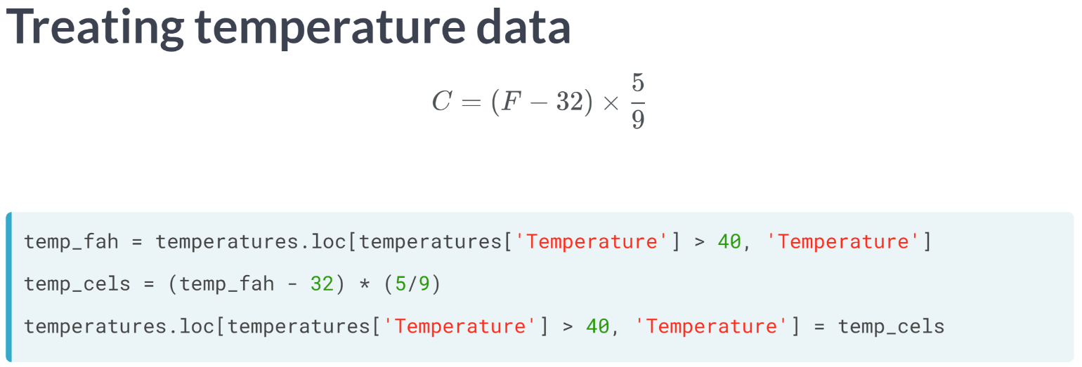  
To convert our temperature data, we isolate all rows of temperature column where it is above 40 using the loc method. We chose 40 because it is a commonsense maximum for Celsius temperatures in NYC.

We then covert these values to Celsius using the formula above and reassign them to their respective Fahrenheit values in temperatures.

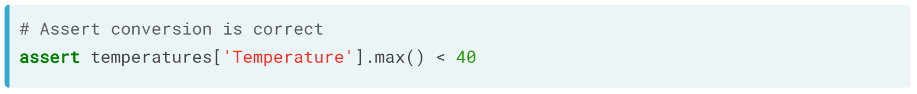  
We can make sure that our conversion was correct with an assert statement, by making sure the maximum value of temperature is less than 40.

Here's another common uniformity problem with date data. This is a DataFrame called birthdays containing birth dates for a variety of individuals. It has been collected from a variety of sources and merged into one.

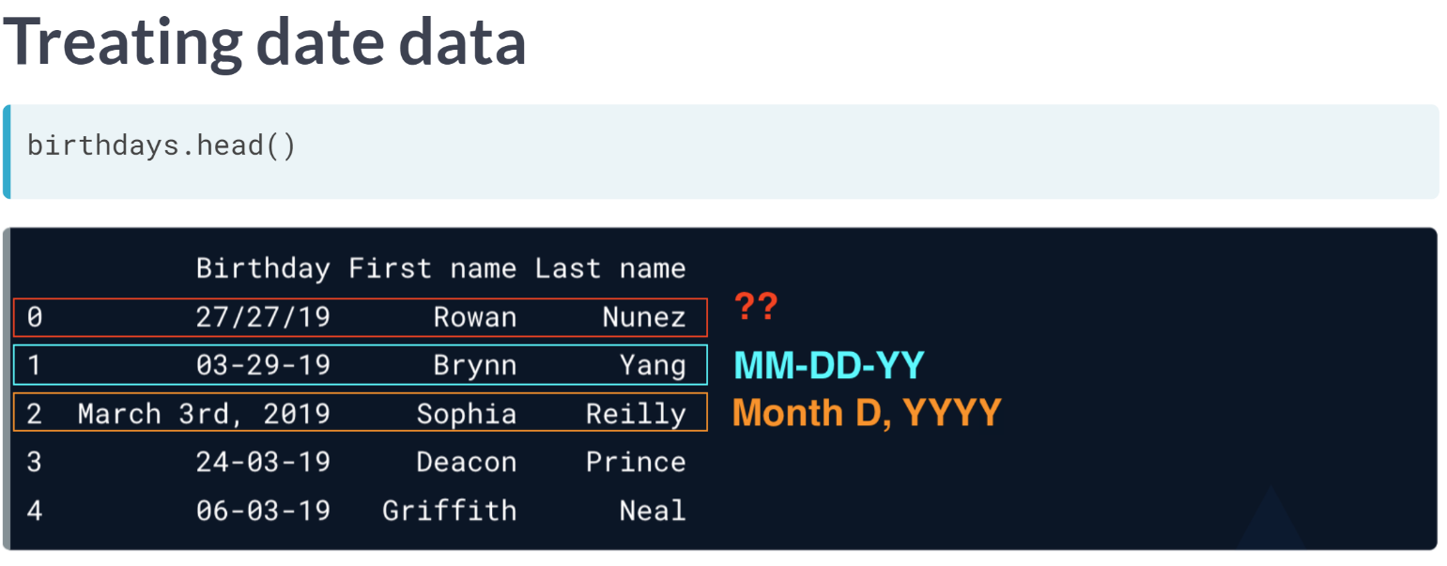  
Notice there are different formats among dates.

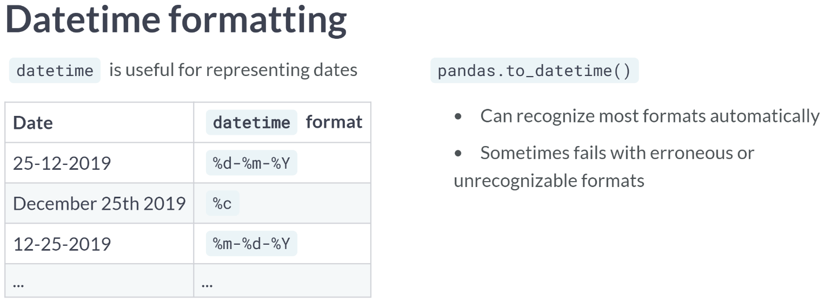  
datetime accepts different formats that help you format your dates as pleased. The pandas to datetime function automatically accept most date formats, but it could raise errors when certain formats are unrecognizable. You don't have to memorize these formats, just know that they exist and are easily searchable.

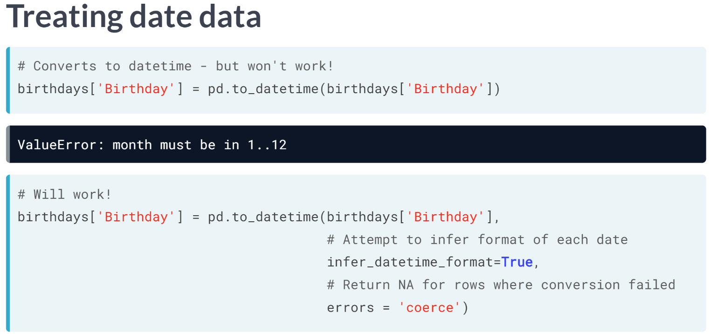  
You can treat these date inconsistencies easily by converting your date column to datetime. We can do this in pandas with the ***to_datetime()*** function.

However, this isn't enough and will most likely return an error, since we have dates in multiple formats, especially the weird day/day/format, which triggers an error with months.

Instead, we set the *infer_datetime_format* argument to *True* and set *errors* equal to *coerce*.

This will infer the format and return missing values for dates that couldn't be identified and converted instead of a value error.

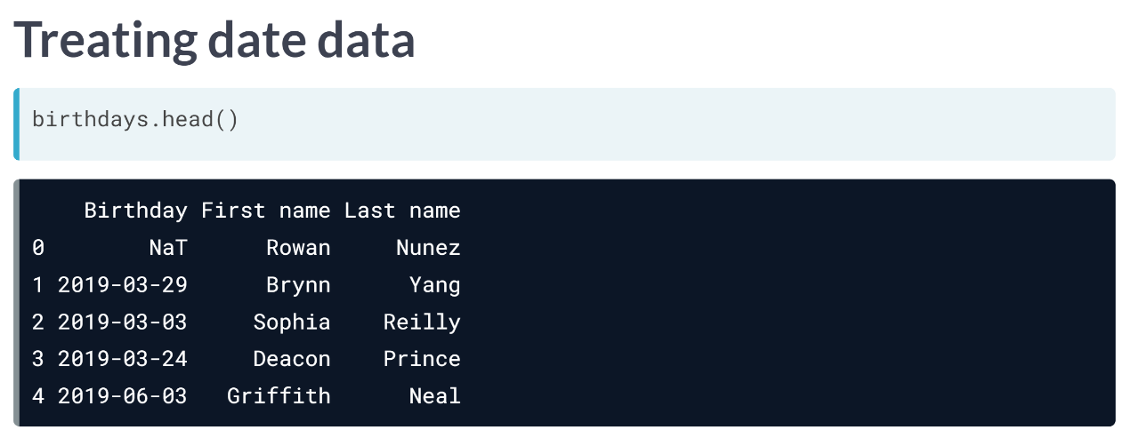  
This returns the birthday column with aligned formats, with the initial ambiguous format of day day year, being set to NaT, which represents missing values in Pandas for datetime objects.

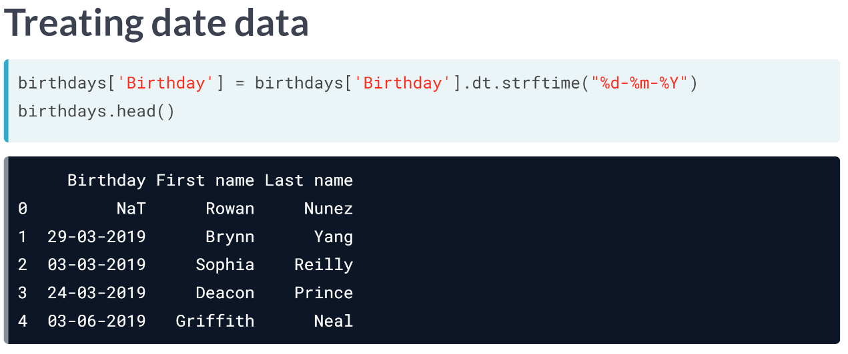  
We can also convert the format of a datetime column using the ***dt.strftime()*** method, which accepts a datetime format of your choice. For example, here we convert the Birthday column to day month year, instead of year month day.

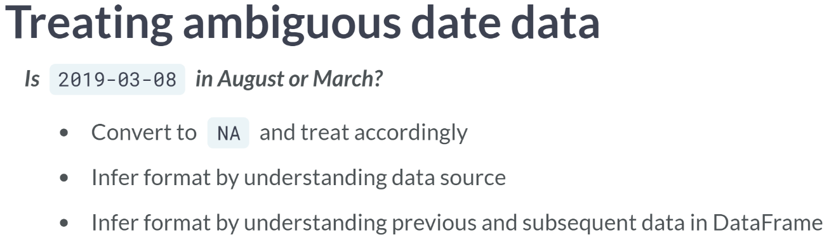  
However, common problem is having ambiguous dates with vague formats.

For example, a date like 2019-03-08 has no clear-cut way to spot this inconsistency and to treat it. Depending on the size of the dataset and suspected ambiguities, we can either convert these dates to NAs and deal with them accordingly.

Or if you have additional context of the data, you can probably infer the format. If the majority of subsequent or previous data is of one format, you can also probably infer the format as well.

# Ambiguous dates

You have a DataFrame containing a subscription_date column that was collected from various sources with different Date formats such as YYYY-mm-dd and YYYY-dd-mm.

What is the best way to unify the formats for ambiguous values such as 2019-04-07?

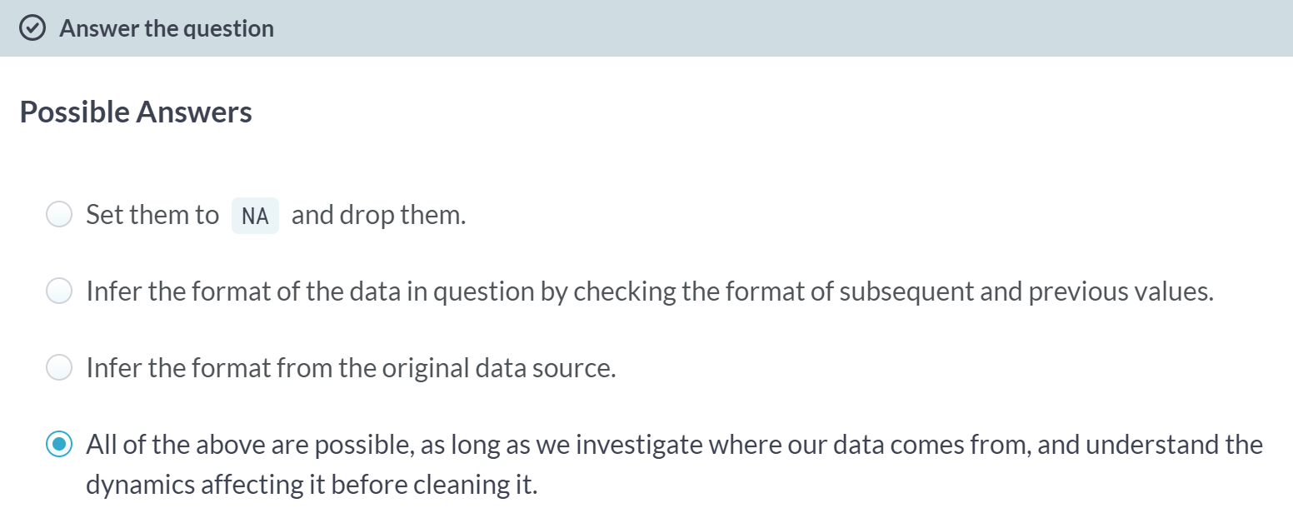

Great work! Like most cleaning data tasks, ambiguous dates require a thorough understanding of where your data comes from. Diagnosing problems is the first step in finding the best solution!

# Uniform currencies

In this exercise and throughout this chapter, you will be working with a retail banking dataset stored in the banking DataFrame. The dataset contains data on the amount of money stored in accounts, their currency, amount invested, account opening date and last transaction date that were consolidated from American and European branches.

You are tasked with understanding the average account size and how investments vary by the size of account, however in order to produce this analysis accurately, you first need to unify the currency amount into dollars. The pandas package has been imported as pd, and the banking DataFrame is in your environment.

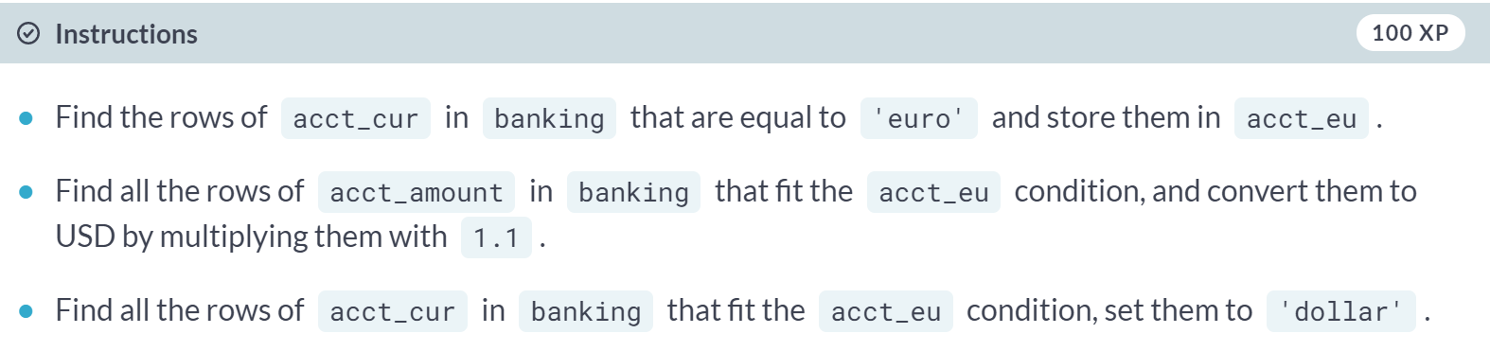  
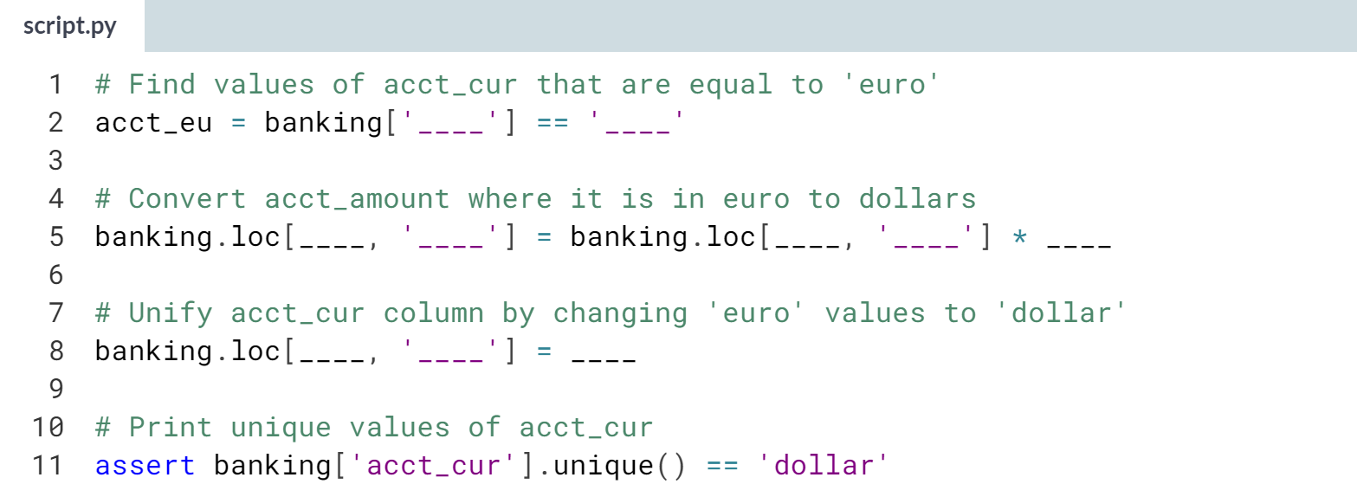  
  
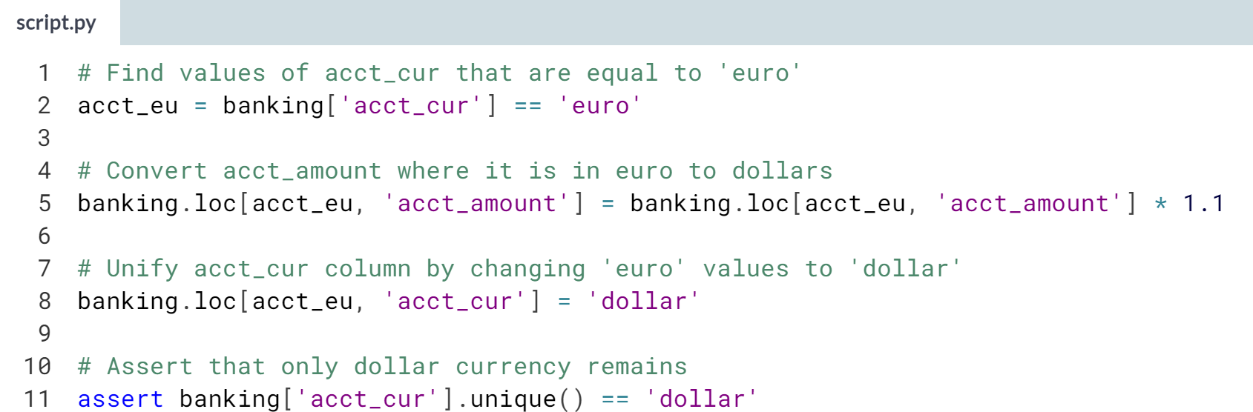  
Crafty currency conversion! With just a few lines of code you made this column ready for analysis!

# Uniform dates

After having unified the currencies of your different account amounts, you want to add a temporal dimension to your analysis and see how customers have been investing their money given the size of their account over each year.

The account_opened column represents when customers opened their accounts and is a good proxy for segmenting customer activity and investment over time.

However, since this data was consolidated from multiple sources, you need to make sure that all dates are of the same format.

You will do so by converting this column into a datetime object, while making sure that the format is inferred, and potentially incorrect formats are set to missing.

The banking DataFrame is in your environment and pandas was imported as pd.

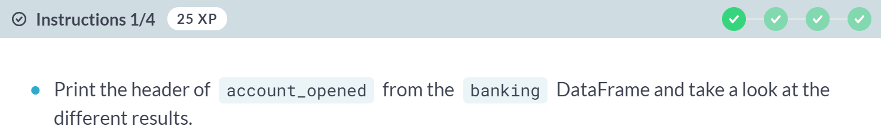

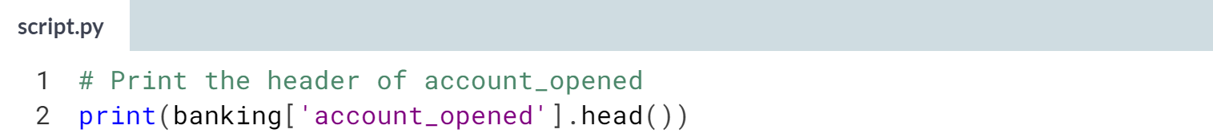

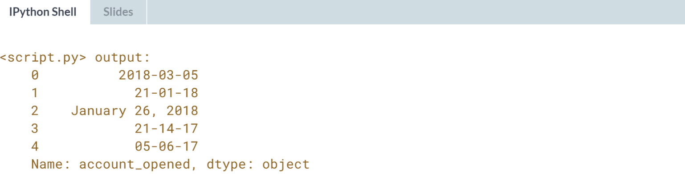

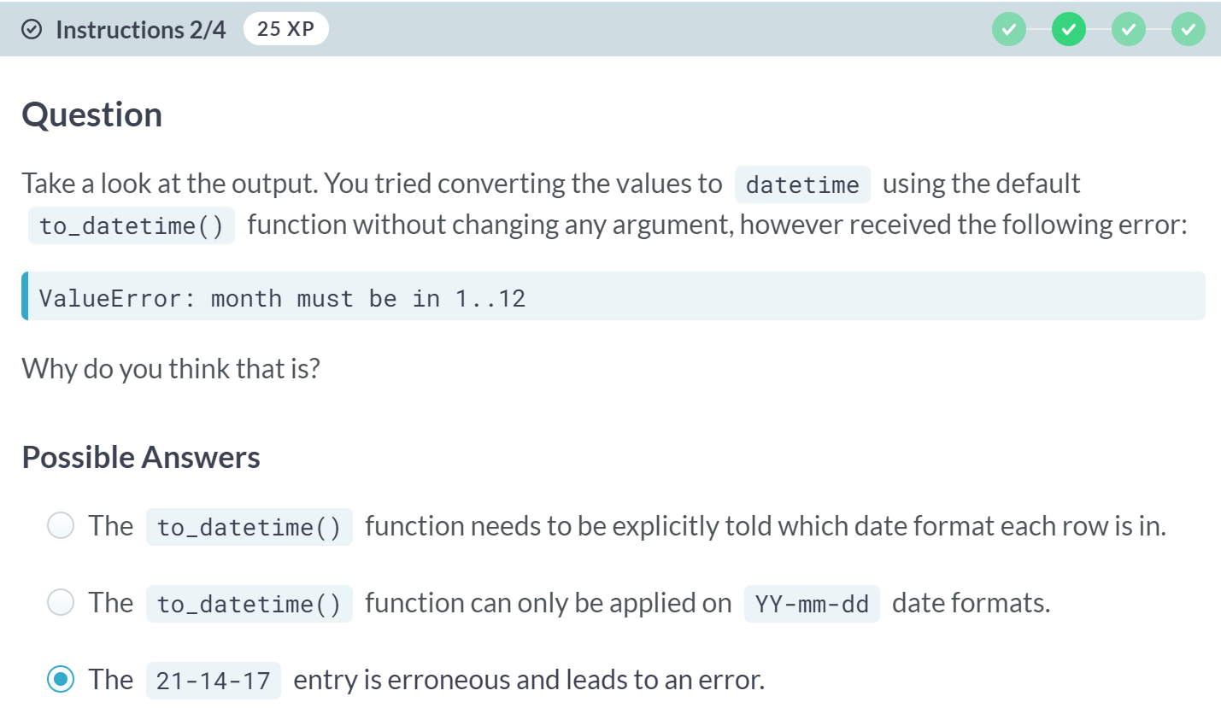

A: Not quite, ***to_datetime()*** can convert most date formats automatically.

B: Not quite, ***to_datetime()*** can handle and output multiple date formats.

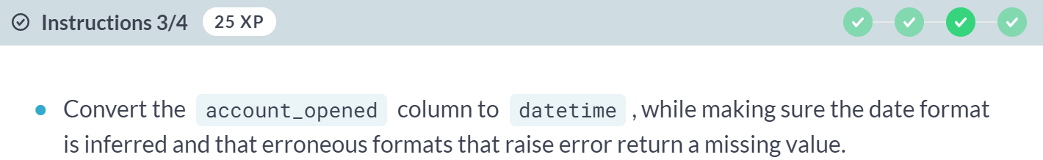

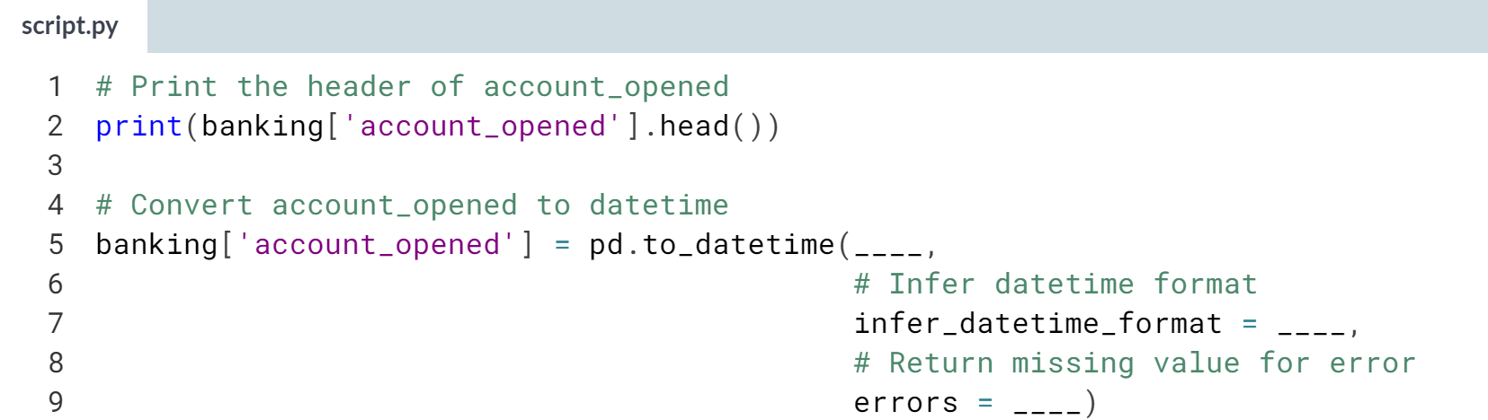

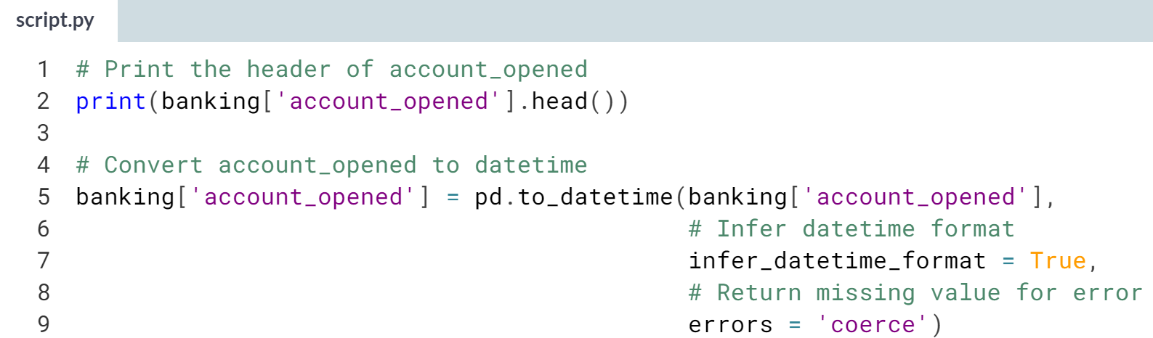

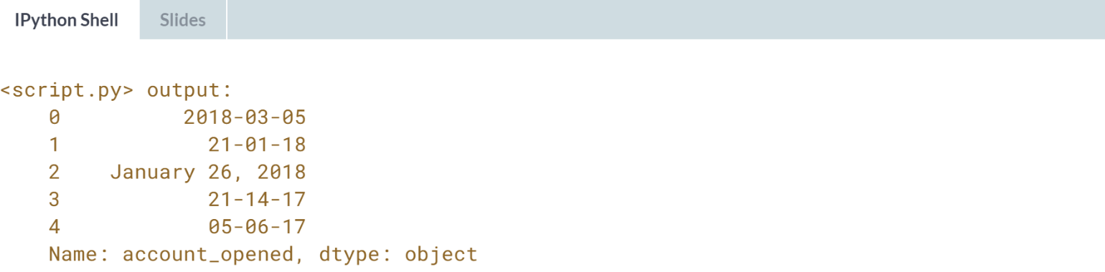

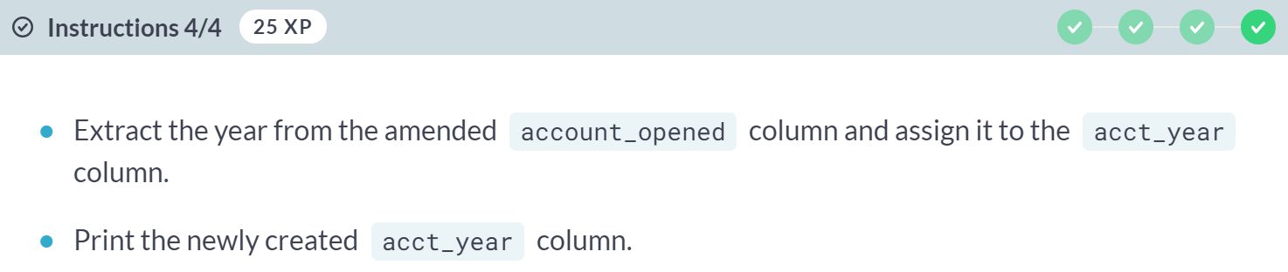

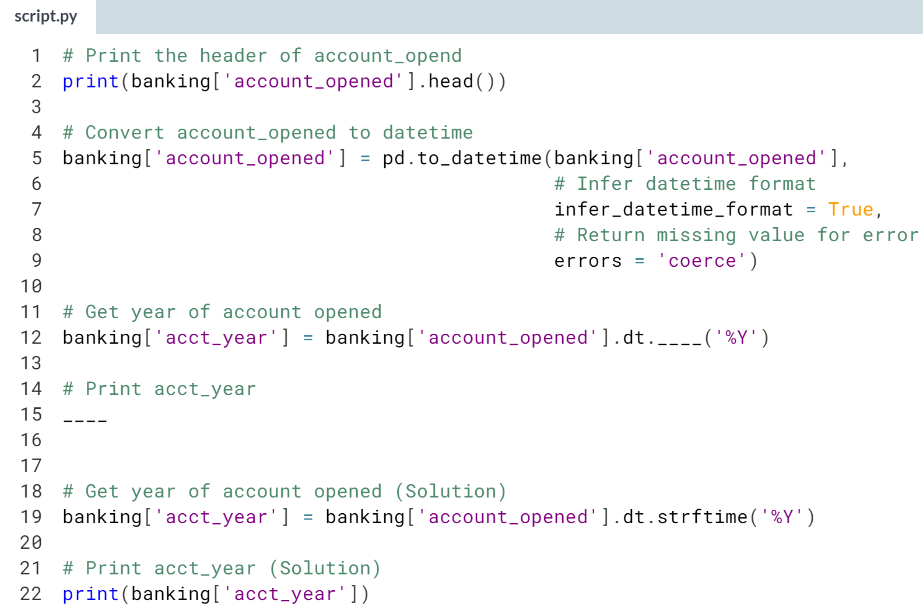

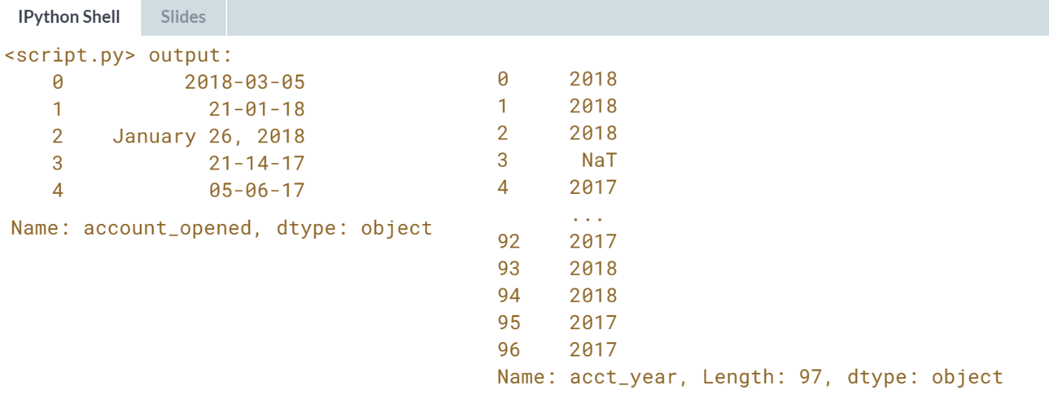  
Cunning calendar cleaning! Now that the *acct_year* column is created, a simple **.groupby()** will show you how accounts are opened on a yearly!



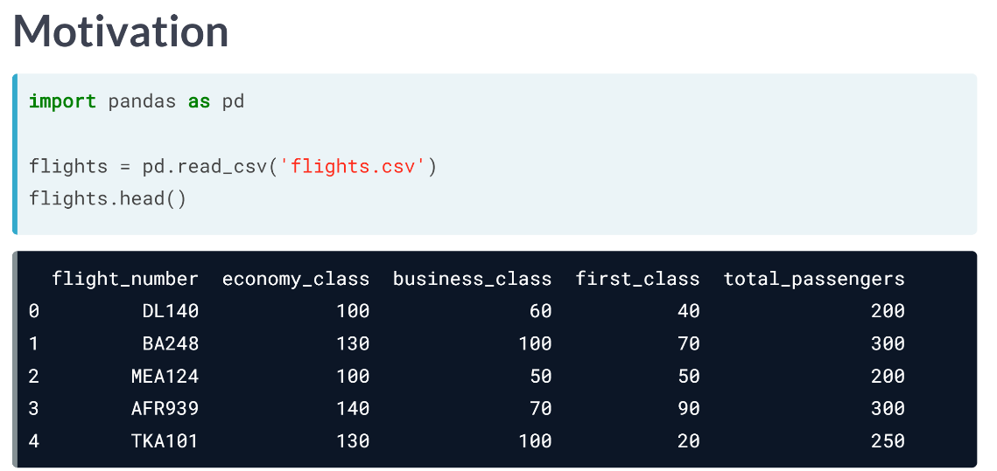  
This dataset contains flight statistics on the total number of passengers in economy, business, and first class as well as total passenger for each flight.

We know that these columns have been collected and merged from different data sources, and a common challenge when merging data from different sources is data integrity, or more broadly making sure that our data is correct.

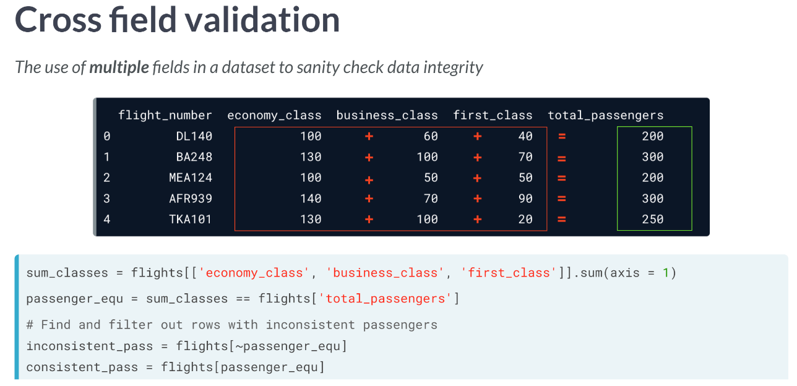  
This is where cross validation comes in. Cross field validation is the use of multiple fields in your dataset to sanity check the integrity of your data.

For example, in our flights dataset, this could be summing economy, business, and first-class values and making sure they are equal to the total passengers on the plane. This could be easily done on pandas, by first subsetting on the columns to sum, then using the sum method with the axis argument set to 1 to indicate row wise summing.

We then find instances where the total passengers column is equal to the sum of the classes. And find and filter out instances of inconsistent passenger amounts by subsetting on the equality we created with **brackets** and the **tilde(~)** symbol.

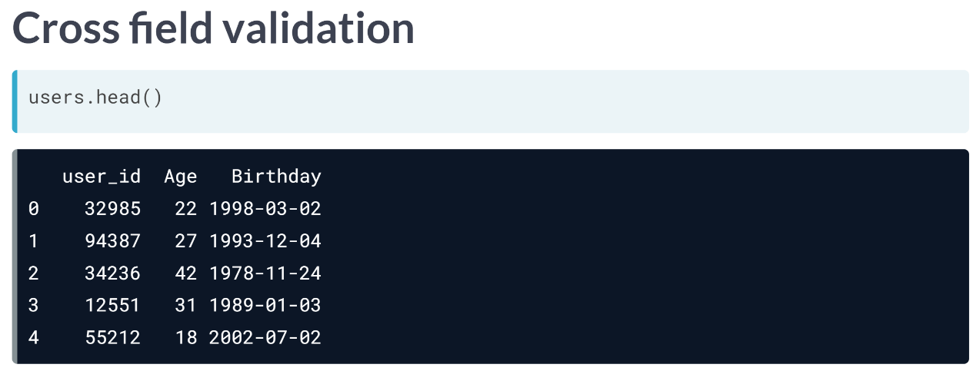  
Here's another example containing user IDs, birthdays, and age values for a set of users. We can for example make sure that the age and birthday columns are correct by subtracting the number of years between today's date and each birthday.

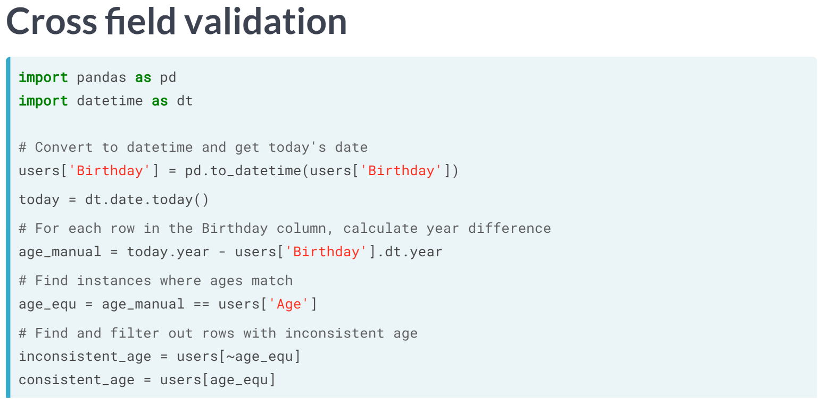

1. We can do this by first making sure the Birthday column is converted to datetime with the pandas ***to_datetime()*** function.
2. We then create an object storing today's date using the datetime package's ***date.today()*** function.
3. We then calculate the difference in years between today's date's year and the year of each birthday by using the *.dt.year* attribute of the user's Birthday column.
4. We then find instances where the calculated ages are equal to the actual age column in the users DataFrame.
5. We then find and filter out the instances where we have inconsistencies using subsetting with brackets and the tilde symbol on the equality we created.

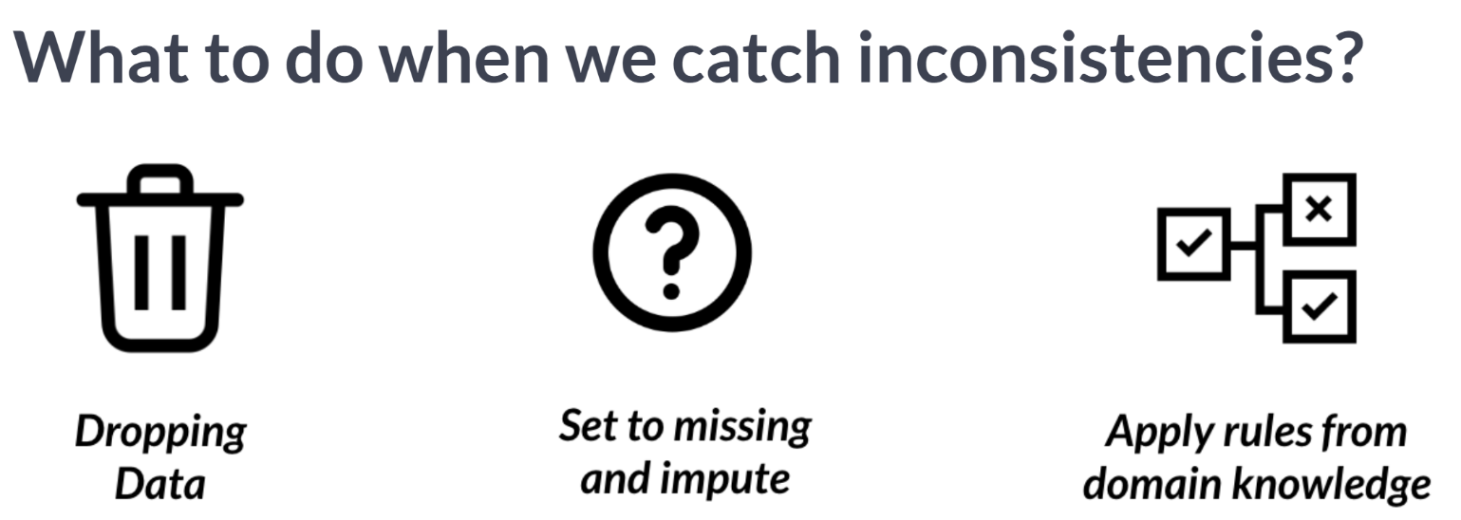  
So, what should be the course of action in case we spot inconsistencies with cross-field validation?

Just like other data cleaning problems, there is no one size fits all solution, as often the best solution requires an in-depth understanding of our dataset.

All these routes and assumptions to catch inconsistencies can be decided upon only when you have a good understanding of where your dataset comes from and the different sources feeding into it.

# Cross field or no cross field?

Throughout this course, you've been immersed in a variety of data cleaning problems from range constraints, data type constraints, uniformity and more.

In this lesson, you were introduced to cross field validation as a means to sanity check your data and making sure you have strong data integrity.

Now, you will map different applicable concepts and techniques to their respective categories.

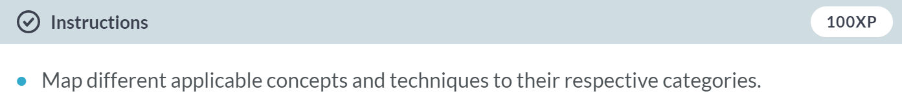

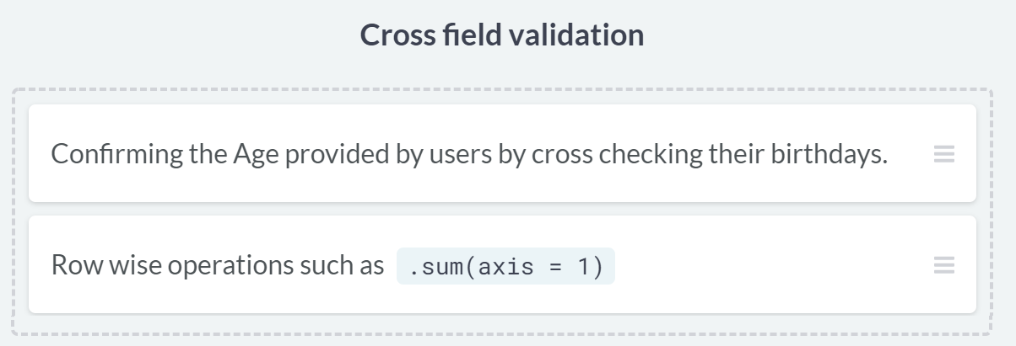

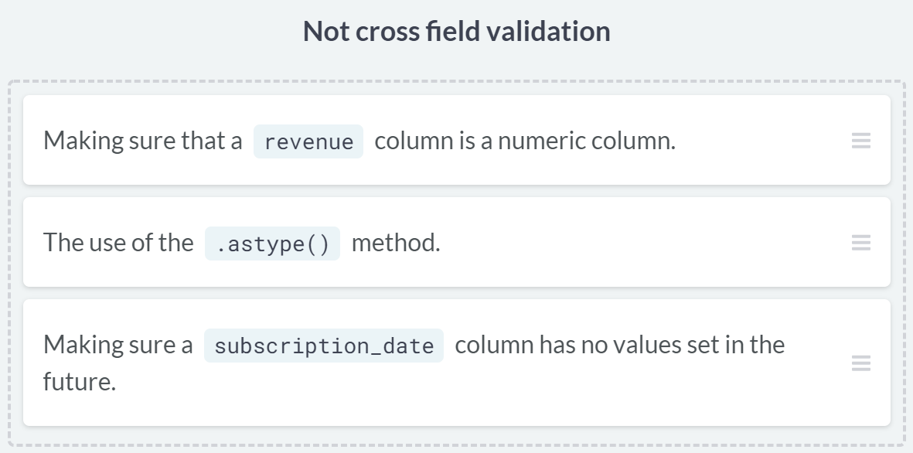  
Awesome work! In the next couple of exercises, you'll be seeing some of these techniques in action!

# How's our data integrity? – **REVIEW**

New data has been merged into the banking DataFrame that contains details on how investments in the inv_amount column is allocated across four different funds A, B, C and D.

Furthermore, the age and birthdays of customers are now stored in the age and birth_date columns, respectively.

You want to understand how customers of different age groups invest. However, you want to first make sure the data you're analyzing is correct.

You will do so by cross field checking values of inv_amount and age against the amount invested in different funds and customers' birthdays.

Both pandas and datetime have been imported as pd and dt respectively.

(Exercise on the next page)

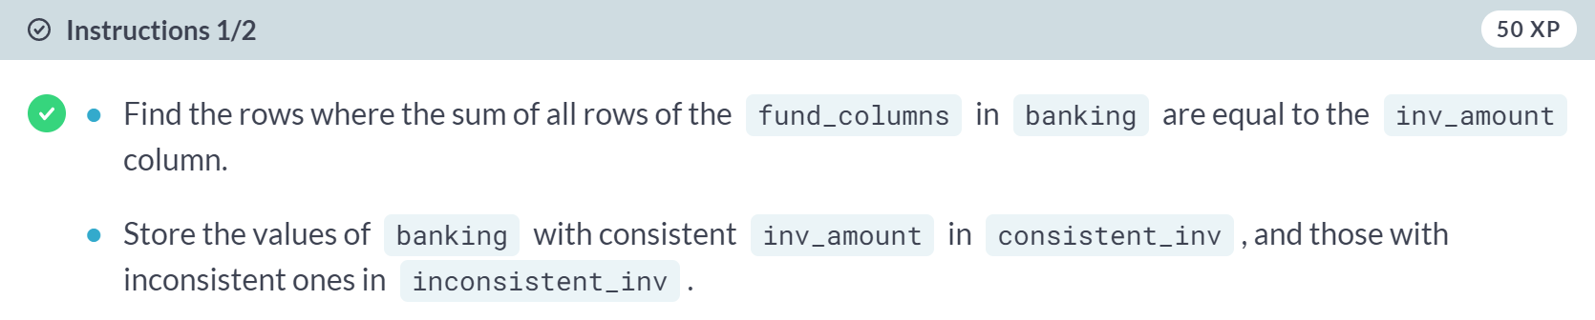

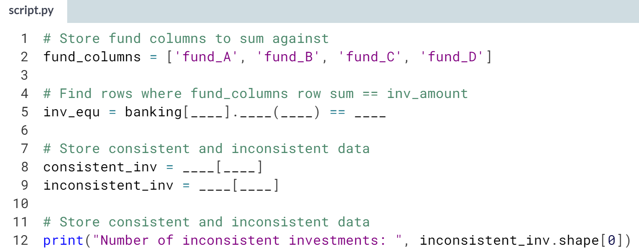

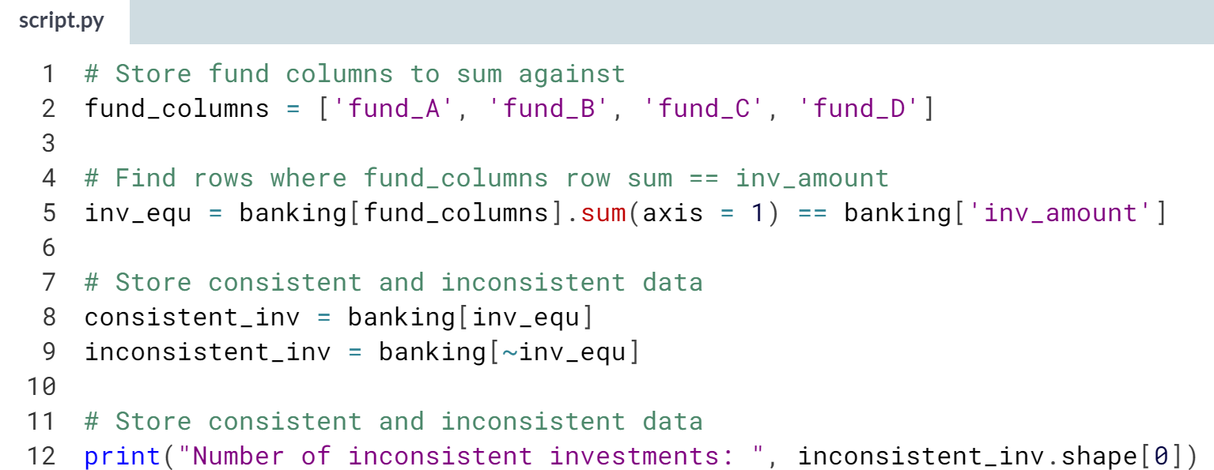

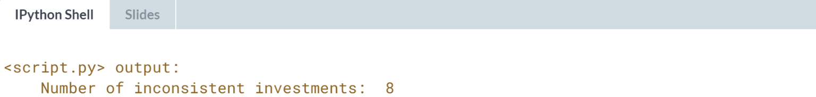

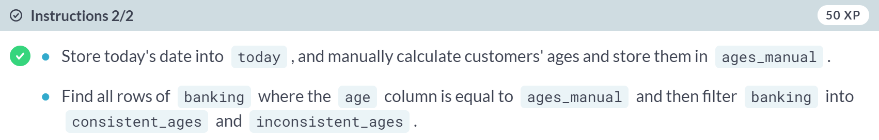

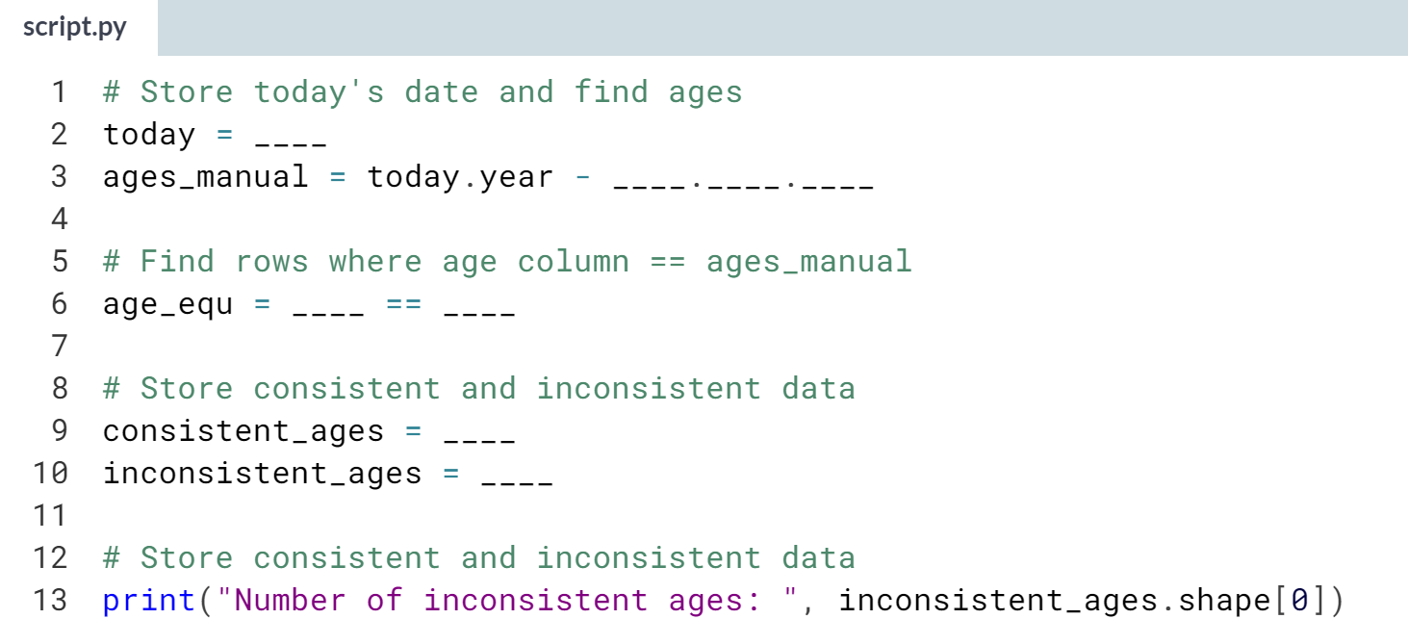

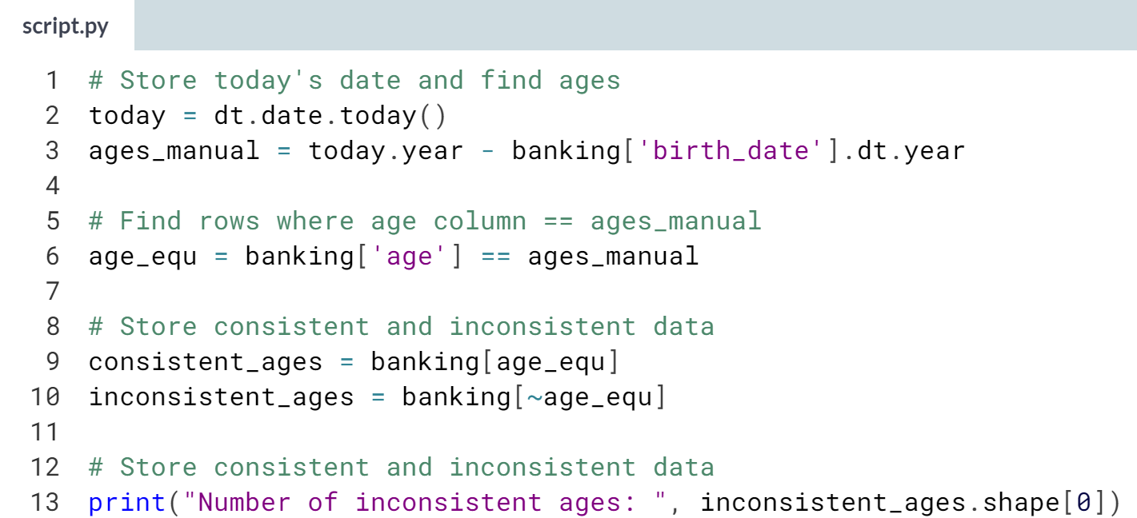

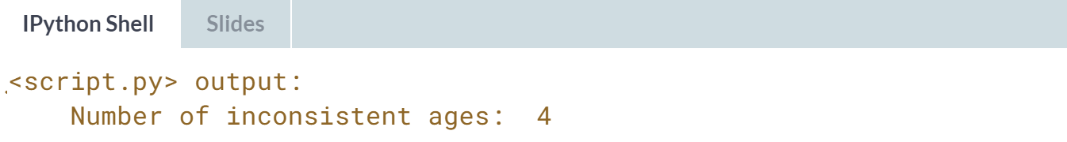   
Awesome work! There are only 8 and 4 rows affected by inconsistent inv_amount and age values, respectively. In this case, it's best to investigate the underlying data sources before deciding on a course of action!



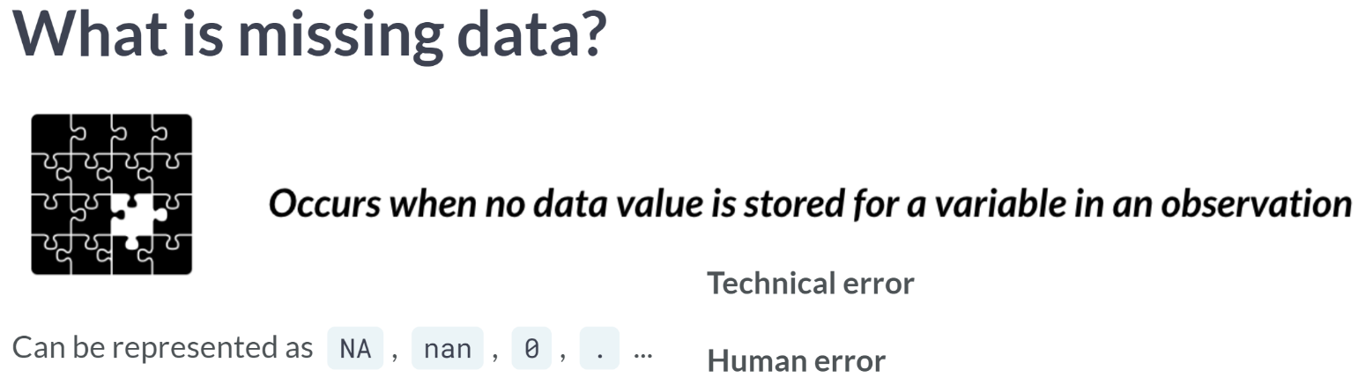  
  
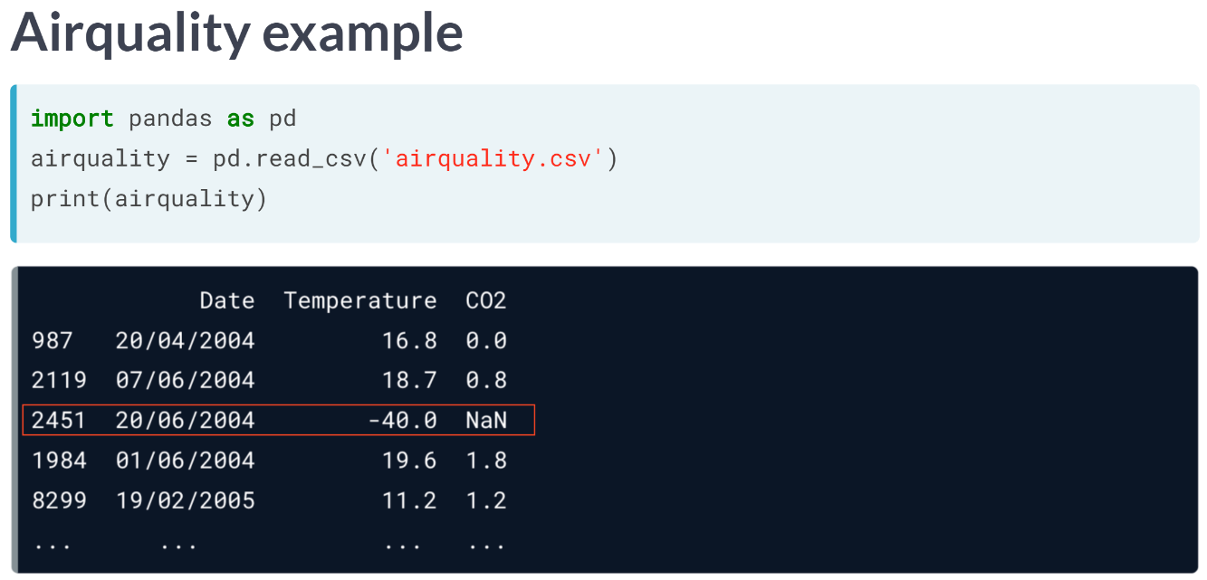

We can see that the CO2 value in this row above is represented as NaN. We can find the rows with missing values by using the ***isna()*** method, which returns True for missing values and False for complete values across all our rows and columns.

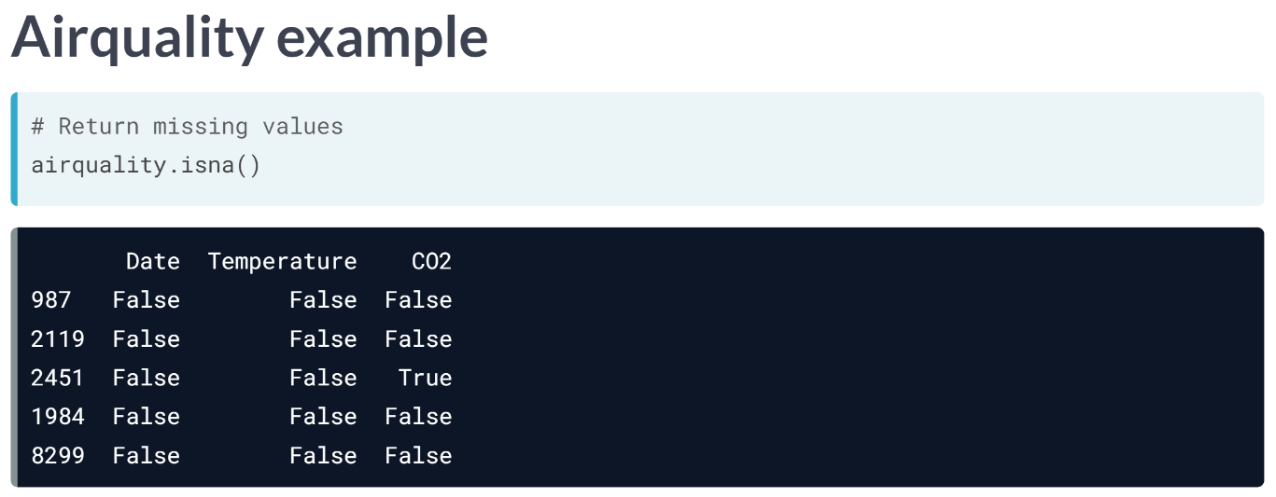

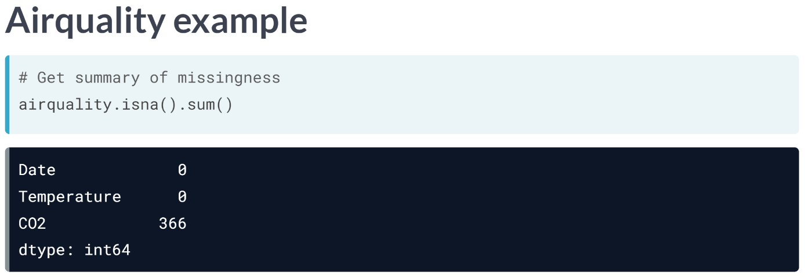  
We can also chain the ***isna()*** method with the ***sum()*** method, which returns a breakdown of missing values per column in our DataFrame.

We notice that CO2 column is the only column with missing value - let's find out why and dig further into the nature of this missingness by first visualizing our missing values.

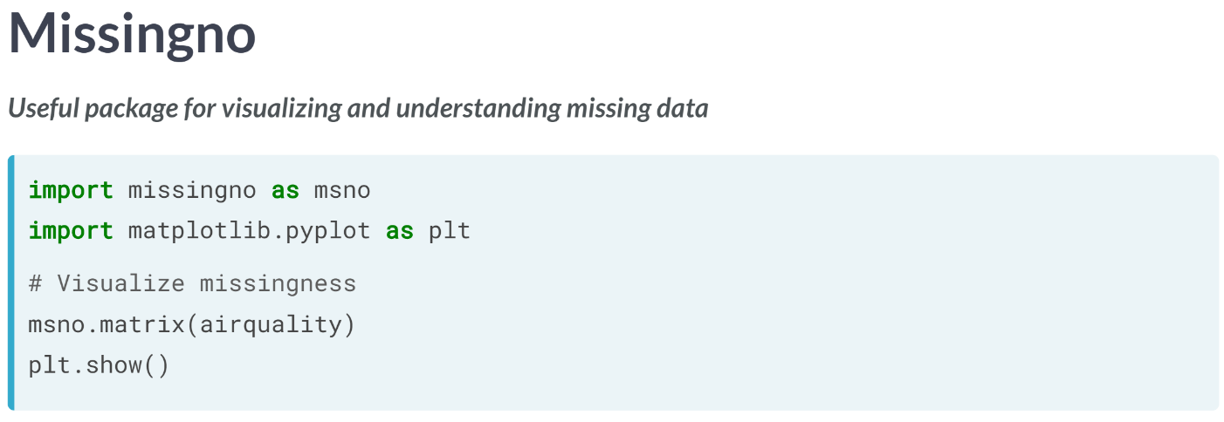  
We visualize the missingness of the *airquality* DataFrame with the ***msno.matrix()*** from the *missingno* package and show it with pyplot's ***show()*** function from matplotlib, which returns the following image.  
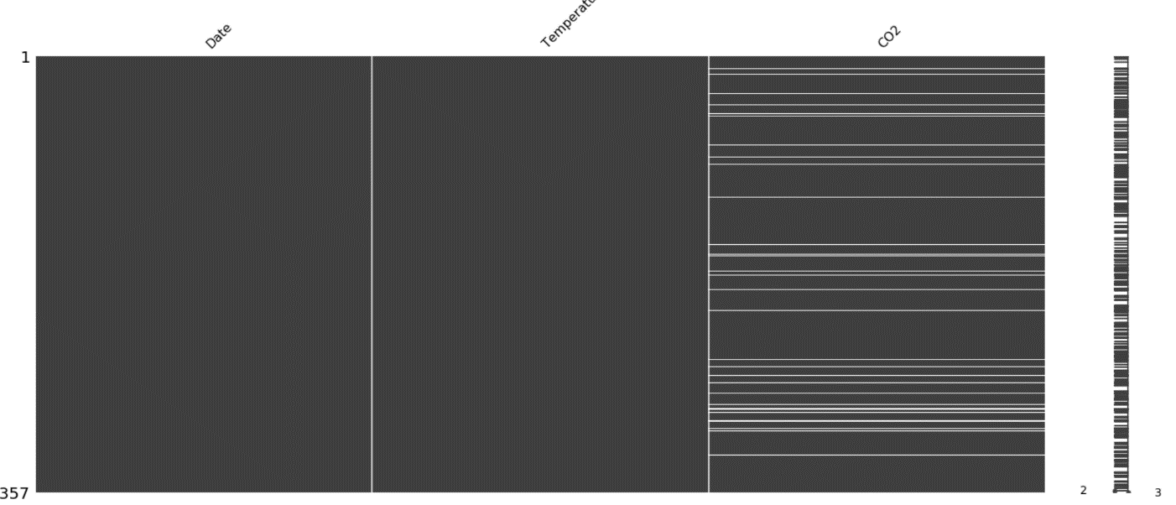  
This matrix basically shows how missing values are distributed across a column. We see that missing CO2 values are randomly scattered throughout the column, but is that really the case? Let’s dig deeper.

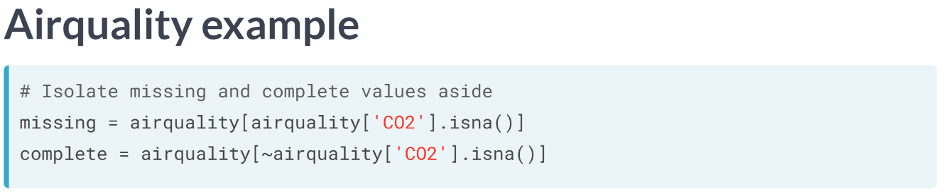  
We first isolate the rows of airquality with missing CO2 values in one DataFrame, and complete CO2 values in another. Then let's use the ***describe()*** method on each of the created DataFrames.

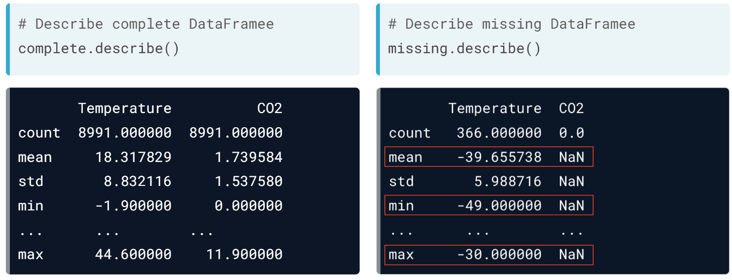  
We see that for all missing values of CO2, they occur at really low temperatures, with the mean temperature at -39 degrees and a minimum and maximum of -49 and -30, respectively.

Let's confirm this again with the missingno package.

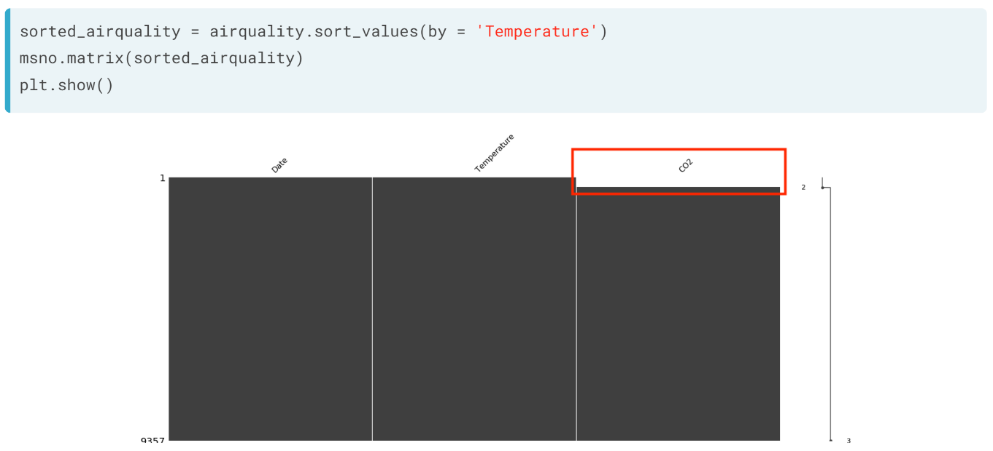  
We first sort the DataFrame by the temperature columns. Then, we put the sorted DataFrame to the matrix function from *msno*.

Notice how all missing values are on the top? This is because values are sorted from smallest to largest by default. This essentially confirms that CO2 measurements are lost for really low temperatures.

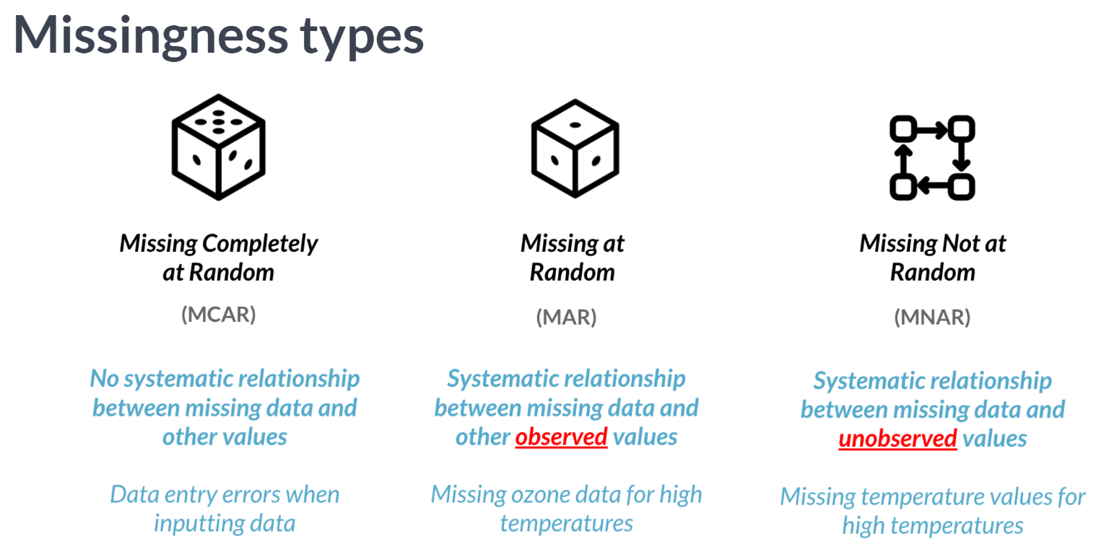  
This leads us to missingness types. Without going too much into the details, there are a variety of types of missing data.

**MCAR**: there is no relationship between missing data and remaining values, such as data entry errors. **MAR**: CO2 data missing for low temperatures. Or when we take a sample from a population, where the probability to be included depends on some known property.  
**MNAR**: when it's really hot outside, the thermometer might stop working, rendering a lack of measurements for days with high temperatures.

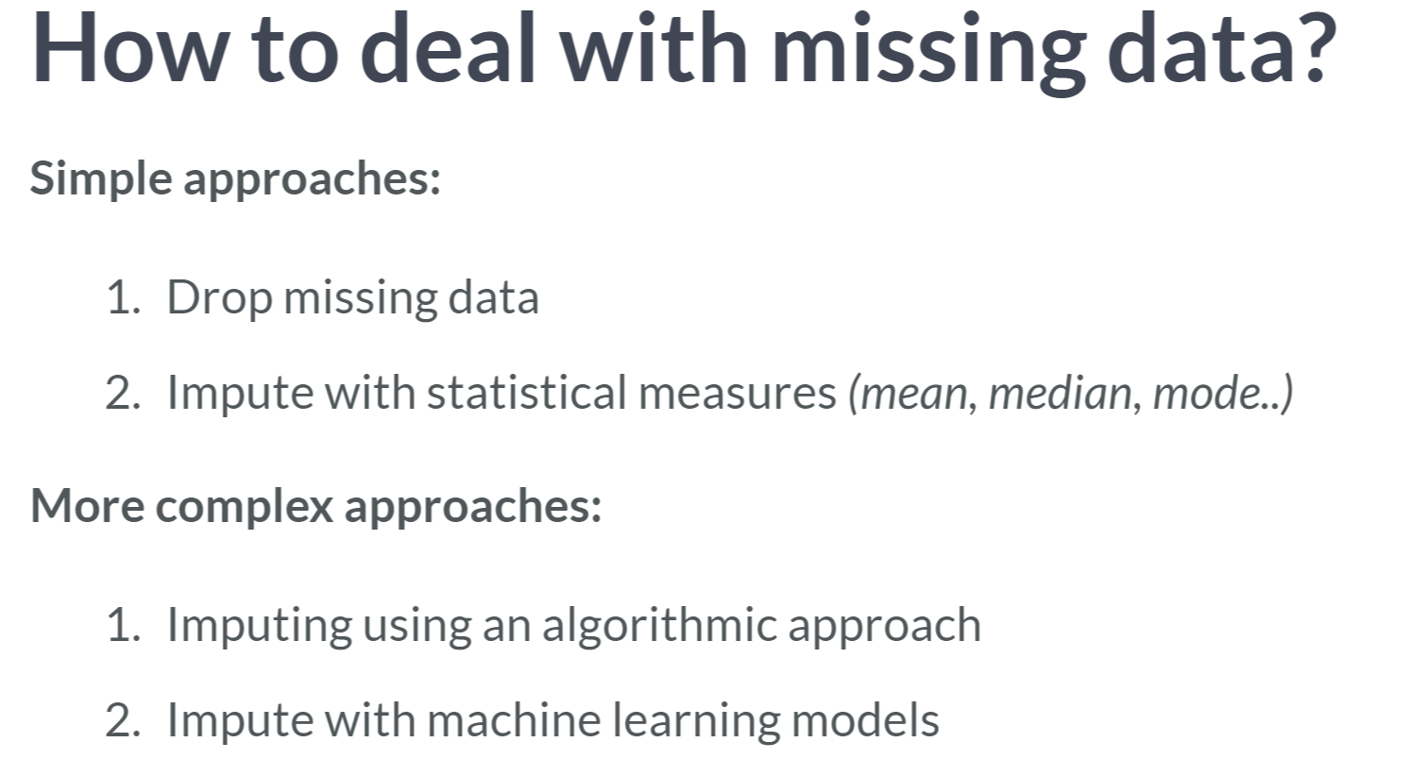

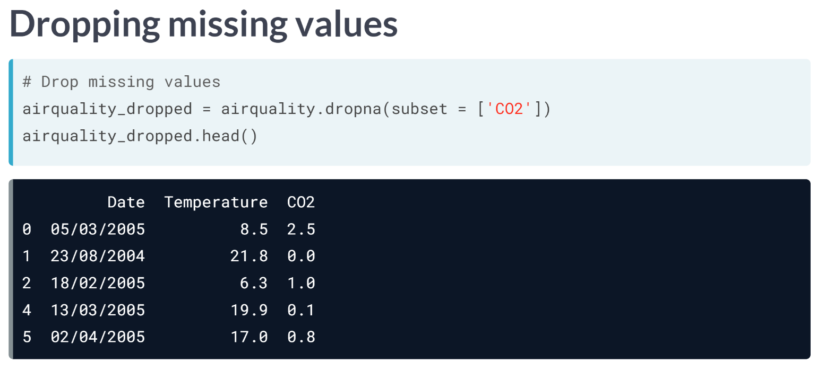  
We can drop missing values, by using the ***.dropna()*** method, alongside the subset argument, which lets us pick which column's missing values to drop.

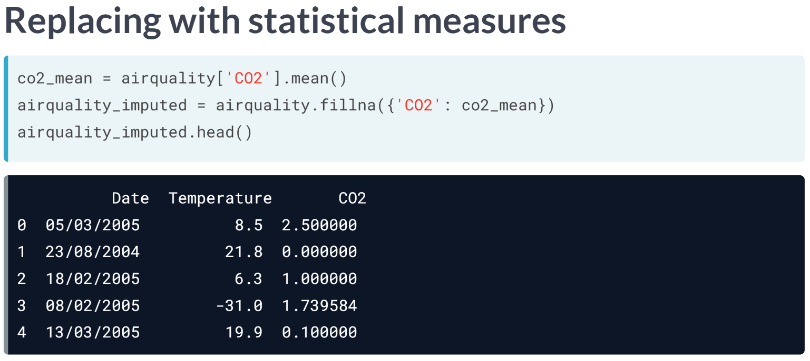  
We can also replace the missing values of CO2 with the mean values of CO2, by using the ***fillna()*** method, which is in this case 1.73.

***fillna()*** takes in a dictionary with columns as keys and the imputed value as values.

We can even feed custom values into ***fillna()*** pertaining to our missing data if we have enough domain knowledge about our dataset.

# Is this missing at random?

You've seen in the video exercise how there are a variety of missingness types when observing missing data. As a reminder, missingness types can be described as the following:

* ***Missing Completely at Random:*** No systematic relationship between a column's missing values and other or own values.
* ***Missing at Random:*** There is a systematic relationship between a column's missing values and other ***observed*** values.
* ***Missing not at Random:*** There is a systematic relationship between a column's missing values and ***unobserved*** values.

You have a DataFrame containing customer satisfaction scores for a service. What type of missingness is the following?  
  
A customer satisfaction_score column with missing values for highly dissatisfied customers.

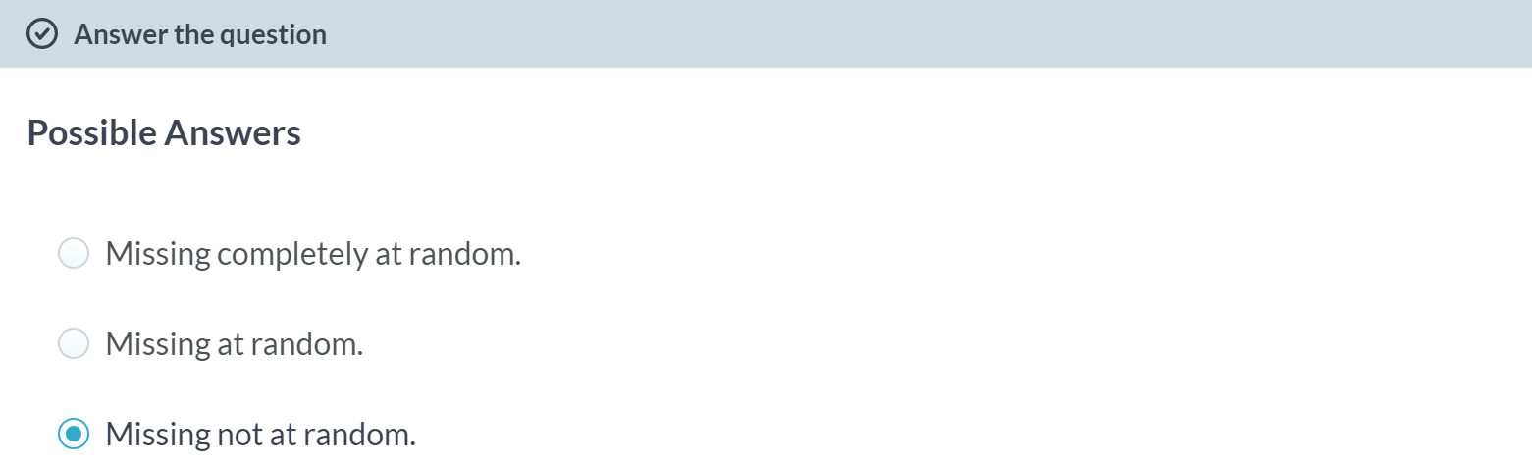  
Awesome work! This is a clear example of missing not at random, where low values of *satisfaction_score* are missing because of inherently low satisfaction!

A: Hmm not really, there's obviously an underlying mechanism behind the missingness of the data.

B: Are you sure about that one? This would be more applicable if missing *satisfaction_score* values were due to values in another column of the DataFrame.

# Missing investors – **REVIEW**

Dealing with missing data is one of the most common tasks in data science. There are a variety of types of missingness, as well as a variety of types of solutions to missing data.

You just received a new version of the banking DataFrame containing data on the amount held and invested for new and existing customers. However, there are rows with missing inv_amount values.

You know for a fact that most customers below 25 do not have investment accounts yet, and suspect it could be driving the missingness.

The pandas, missingno and matplotlib.pyplot packages have been imported as pd, msno and plt respectively. The banking DataFrame is in your environment.

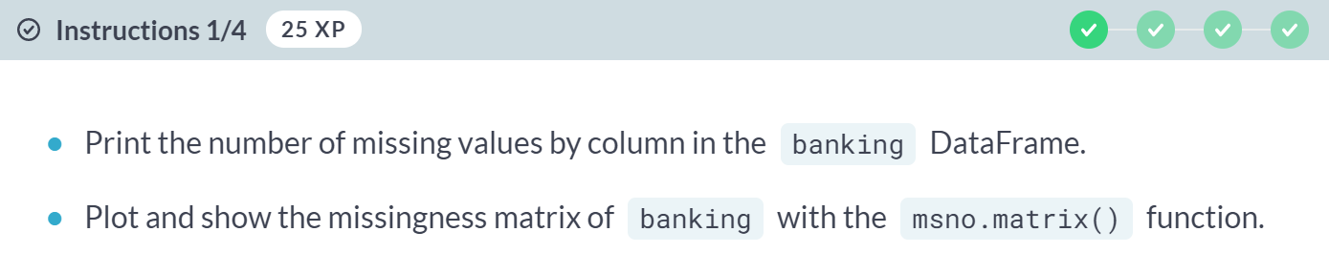

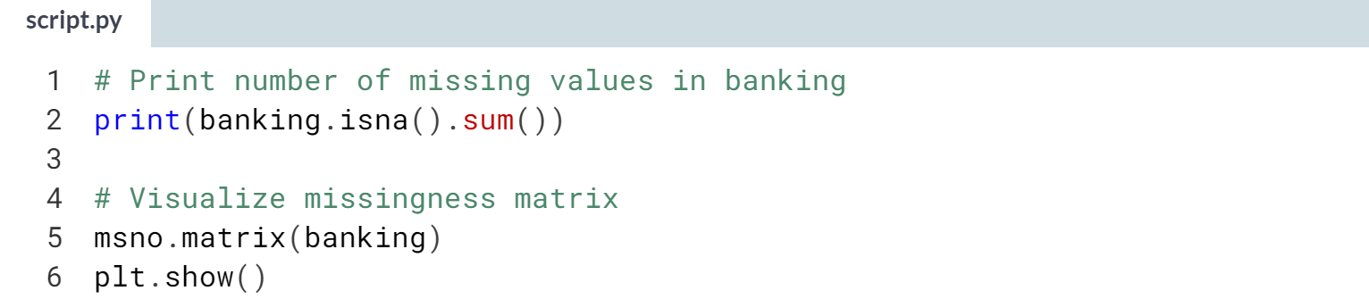

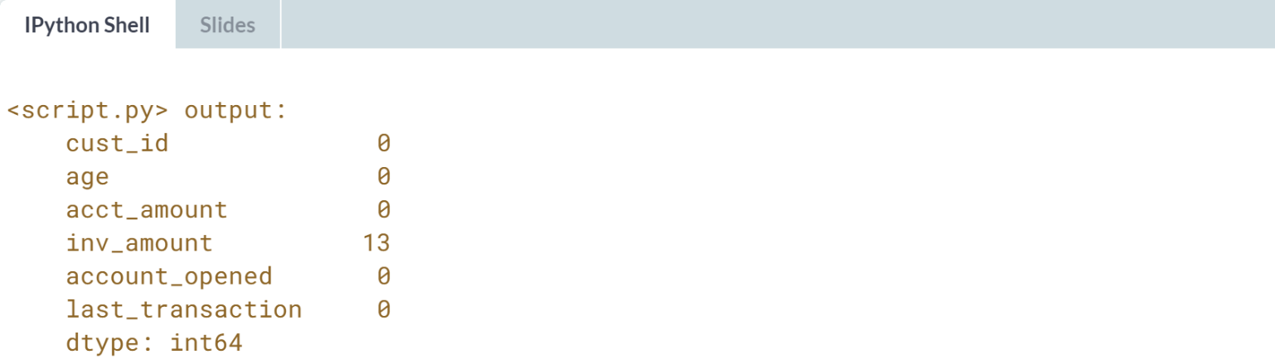

(Plot on the next page)

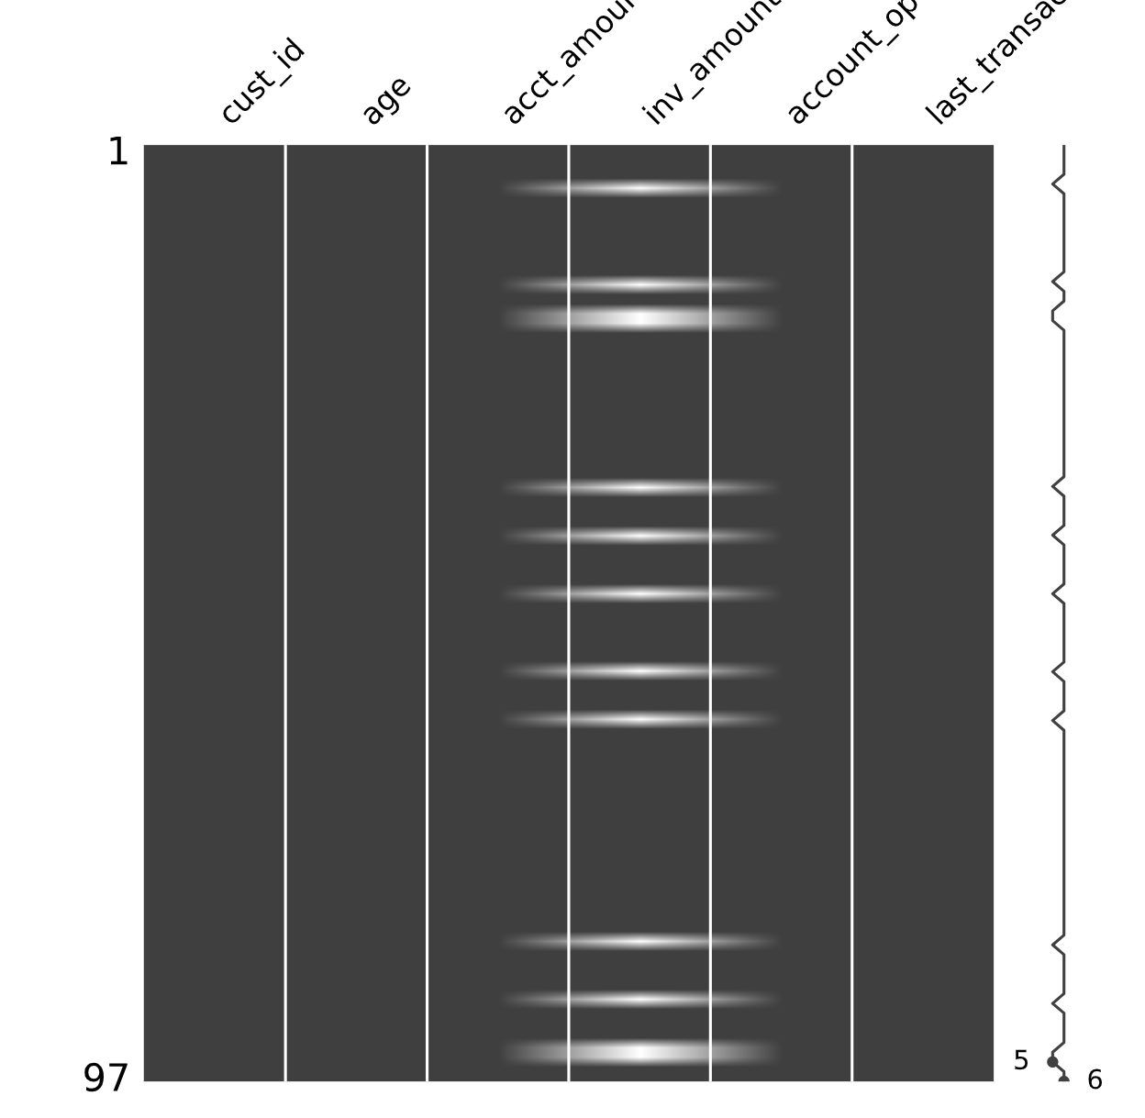

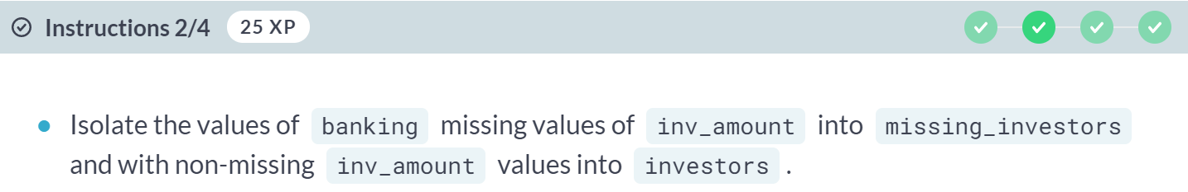

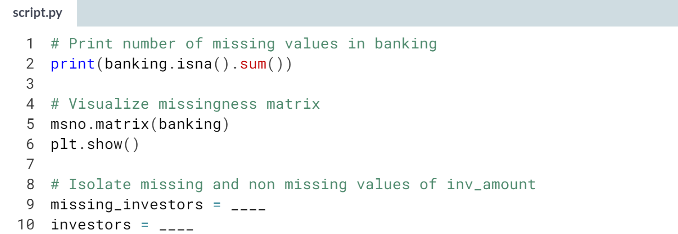

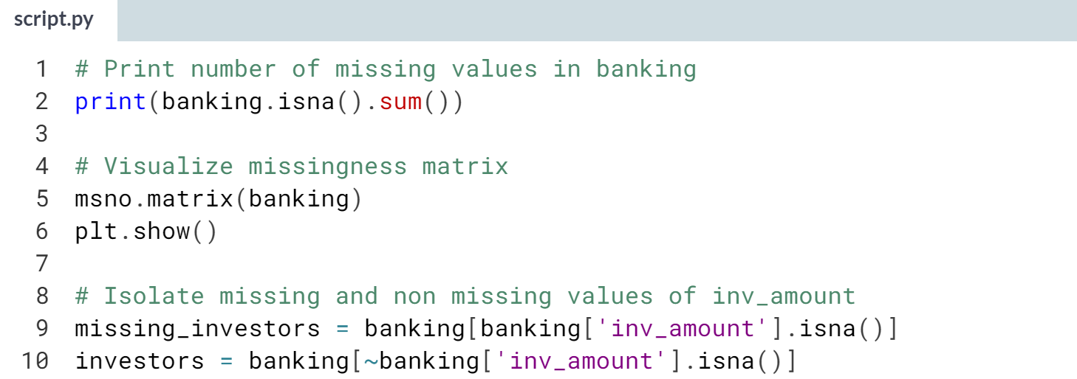

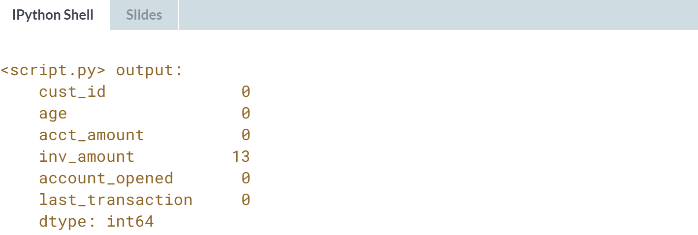  
(Plot on the next page)

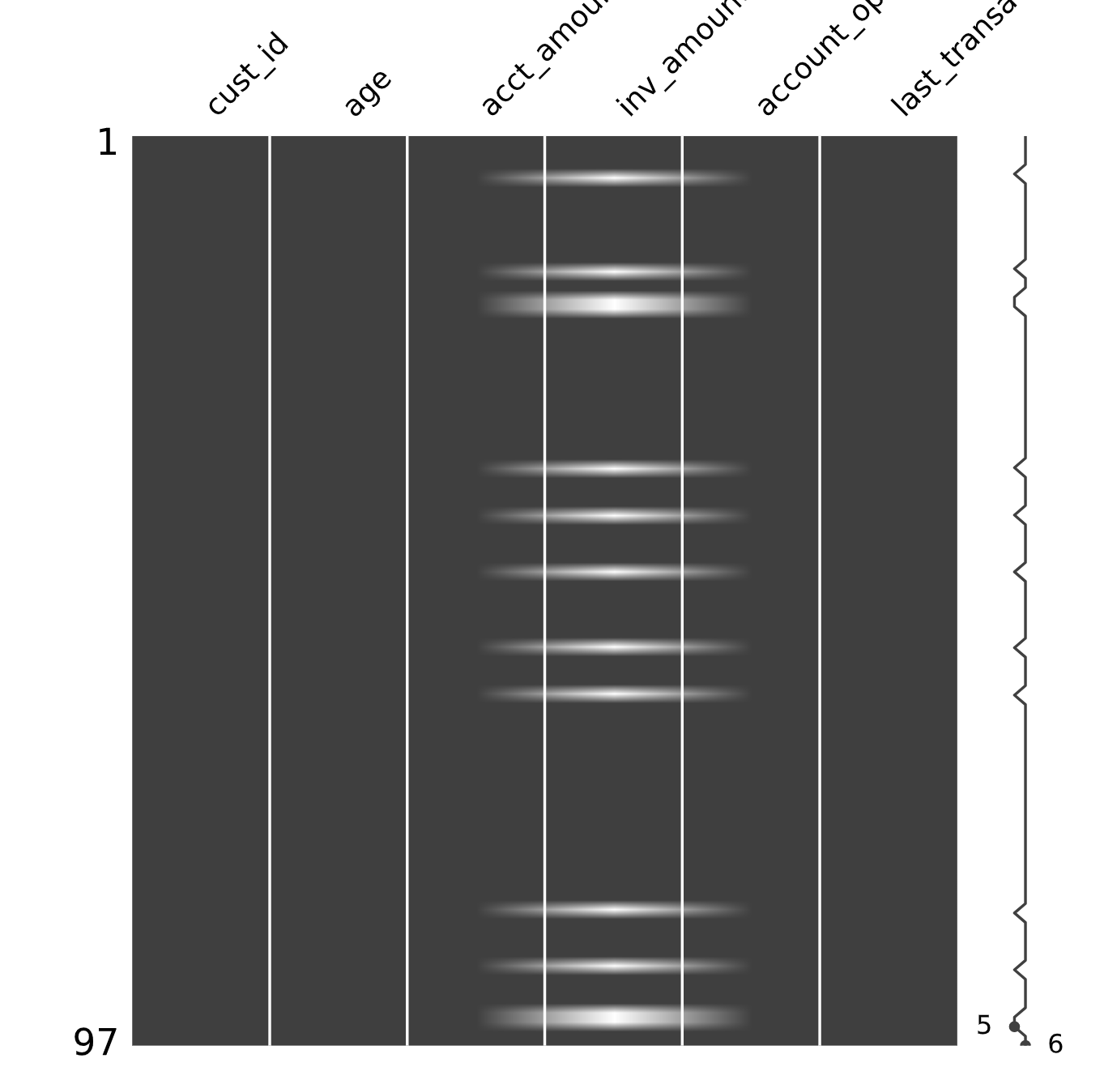

(Exercise continues on the next page)

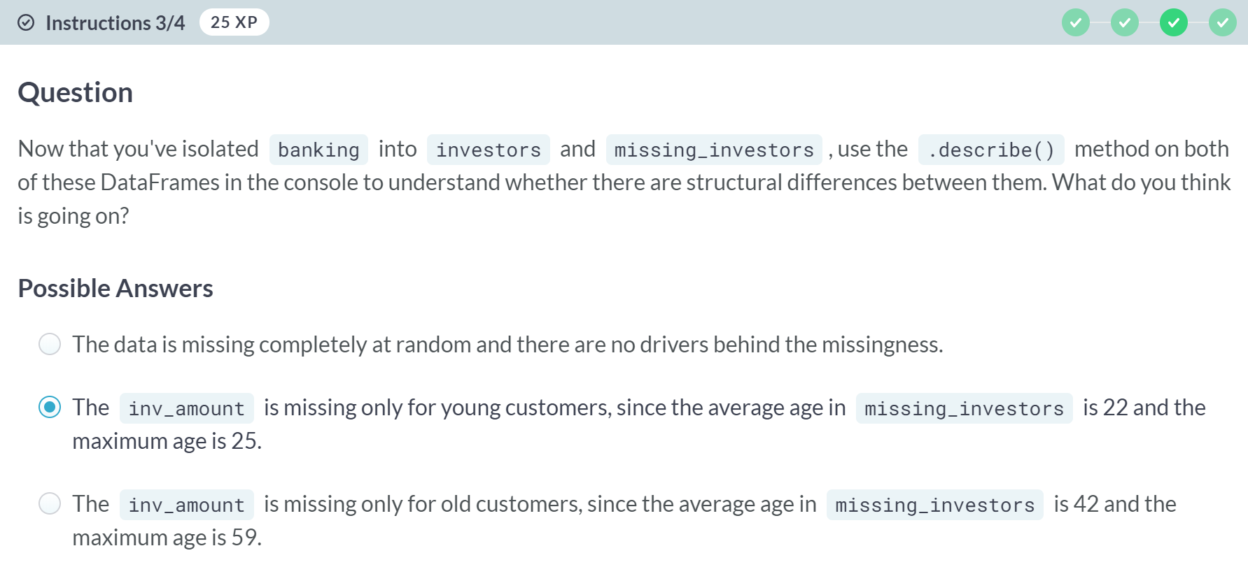

A: Are you sure about that? Take a look at the age of missing and non-missing investors.

C: Are you sure about that? These are the age values of non-missing investors.

(Exercise continues on the next page)

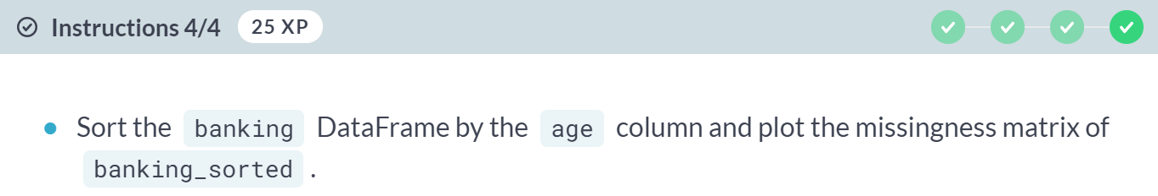

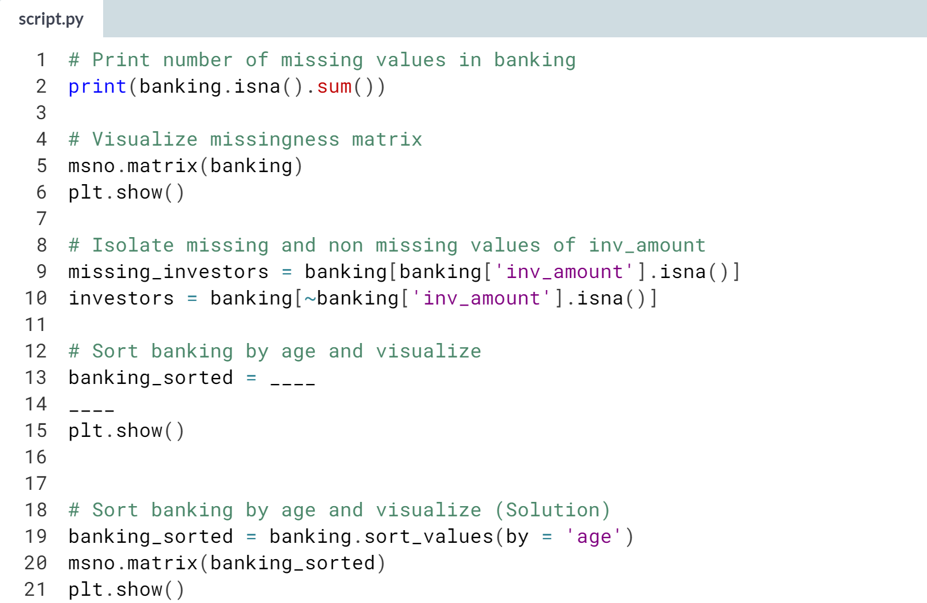

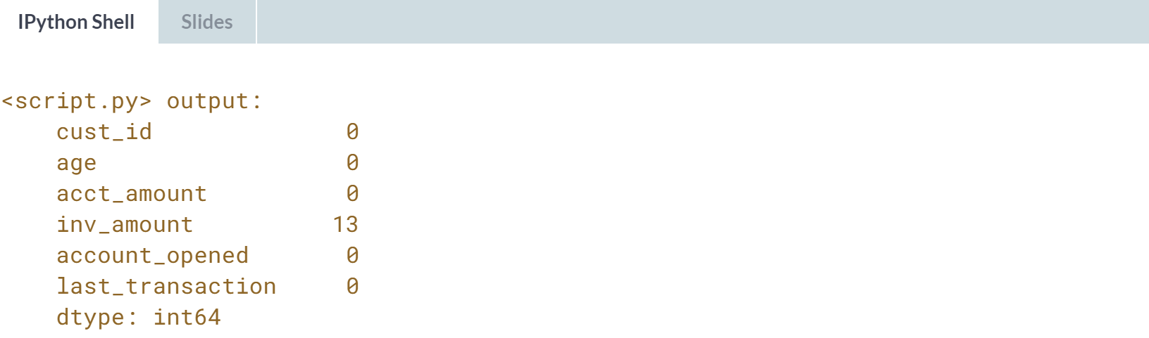

Great job! Notice how all the white spaces for *inv_amount* are on top? Indeed, missing values are only due to young bank account holders not investing their money! Better set it to 0 with ***.fillna()***.

# Follow the money

In this exercise, you're working with another version of the banking DataFrame that contains missing values for both the cust_id column and the acct_amount column.

You want to produce analysis on how many unique customers the bank has, the average amount held by customers and more. You know that rows with missing cust_id don't really help you, and that on average acct_amount is usually 5 times the amount of inv_amount.

In this exercise, you will drop rows of banking with missing cust_ids, and impute missing values of acct_amount with some domain knowledge.

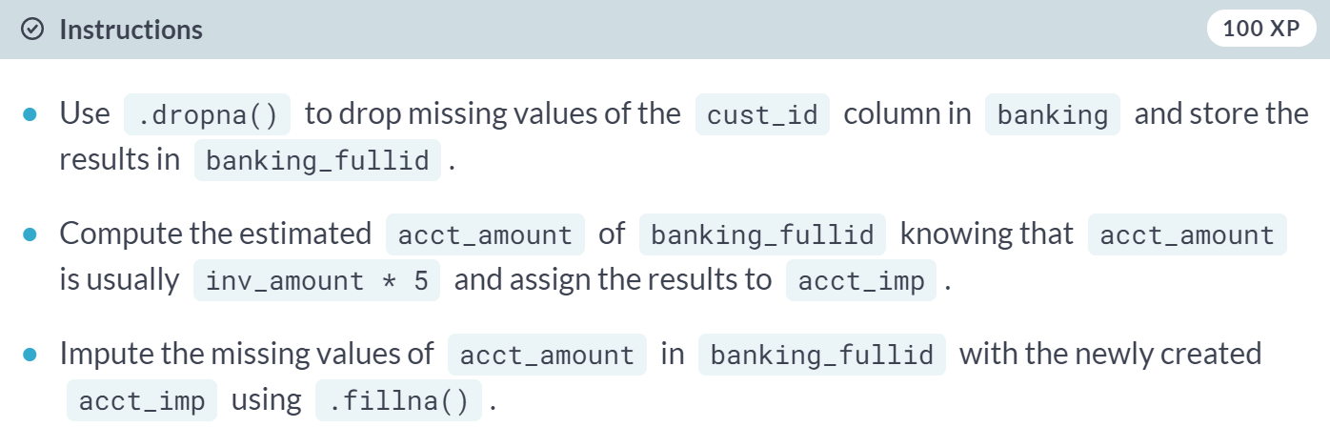

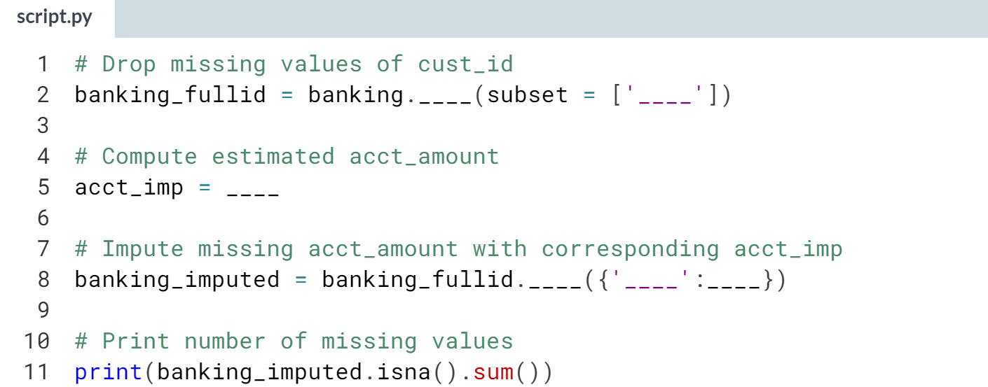

(Solution on the next page)

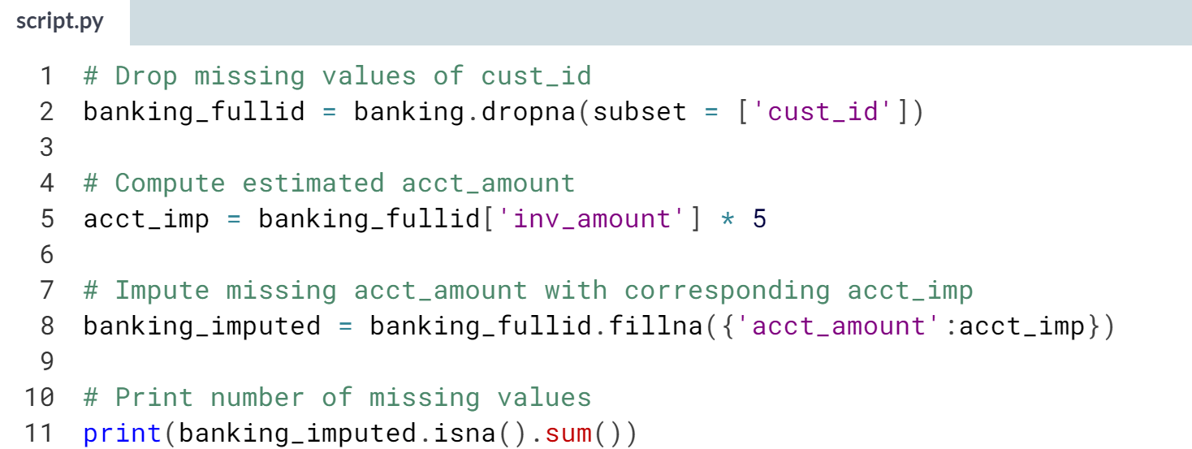

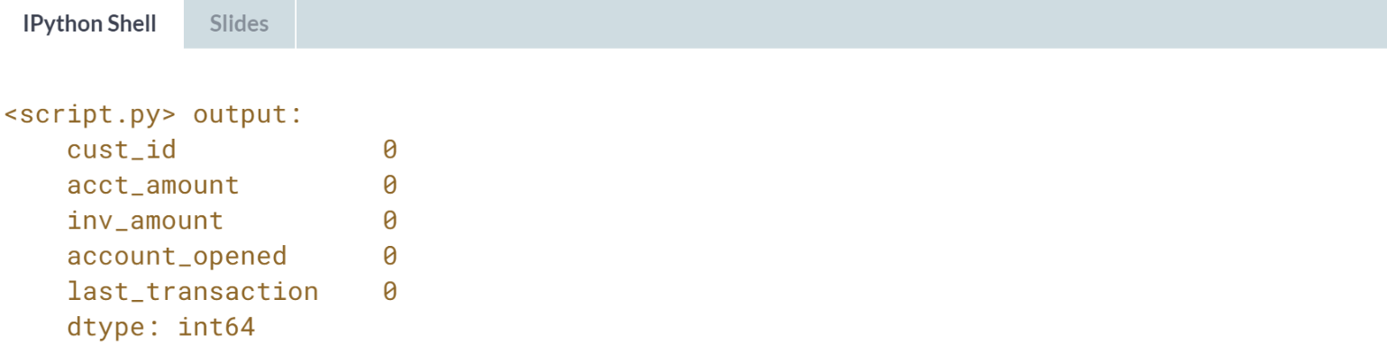

Awesome work! As you can see no missing data left, you can definitely bank on getting your analysis right!

**4. Record linkage**

Record linkage is a powerful technique used to merge multiple datasets together, used when values have typos or different spellings. In this chapter, you'll learn how to link records by calculating the similarity between strings—you’ll then use your new skills to join two restaurant review datasets into one clean master dataset.



Before we get deep dive into record linkage, let's sharpen our understanding of string similarity and minimum edit distance.  
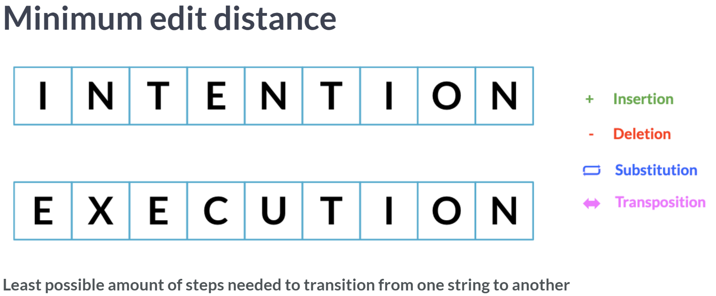  
Minimum edit distance is a systematic way to identify how close two strings are. For example, let's take a look at the following two words: intention and execution.

MED is the least possible number of steps using these four ways to transition from one strings to another.

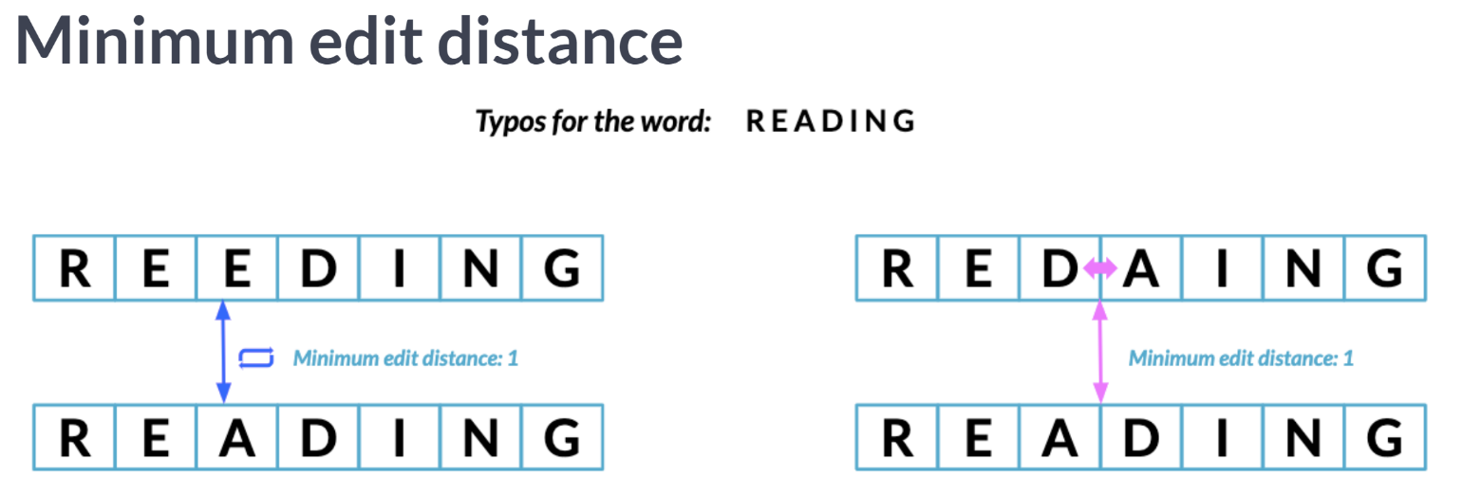  
The lower the edit distance, the closer two words are. For example, the two different typo of reading have a minimum edit distance of 1 between them and reading.

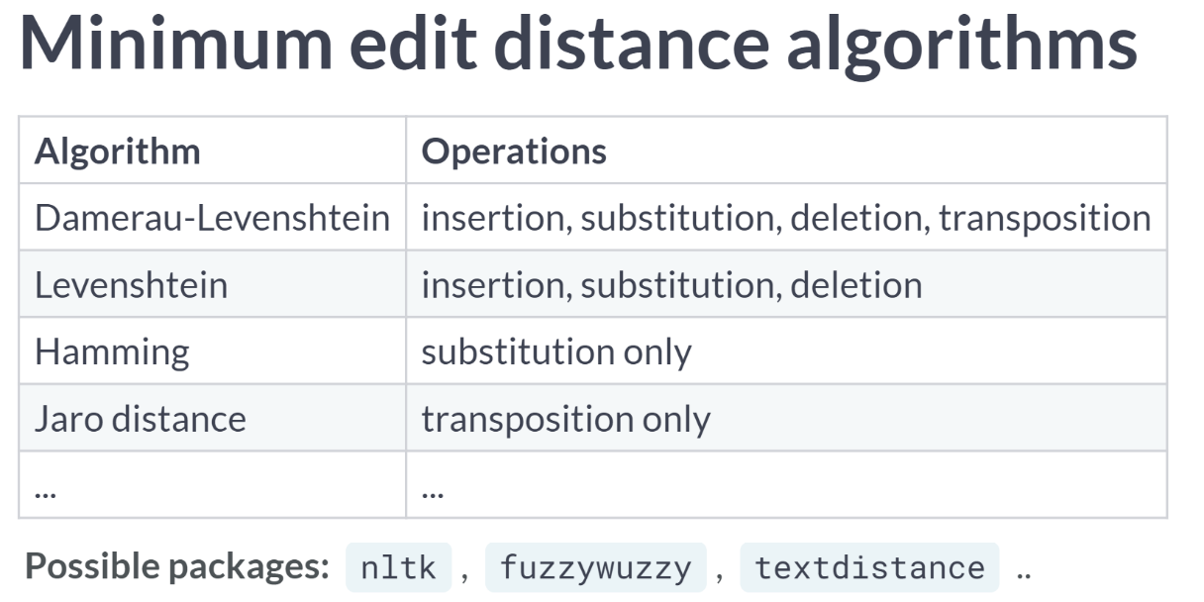  
There's a variety of algorithms based on edit distance that differ on which operations they use, how much weight attributed to each operation, which type of strings they're suited for and more, with a variety of packages to get each similarity.

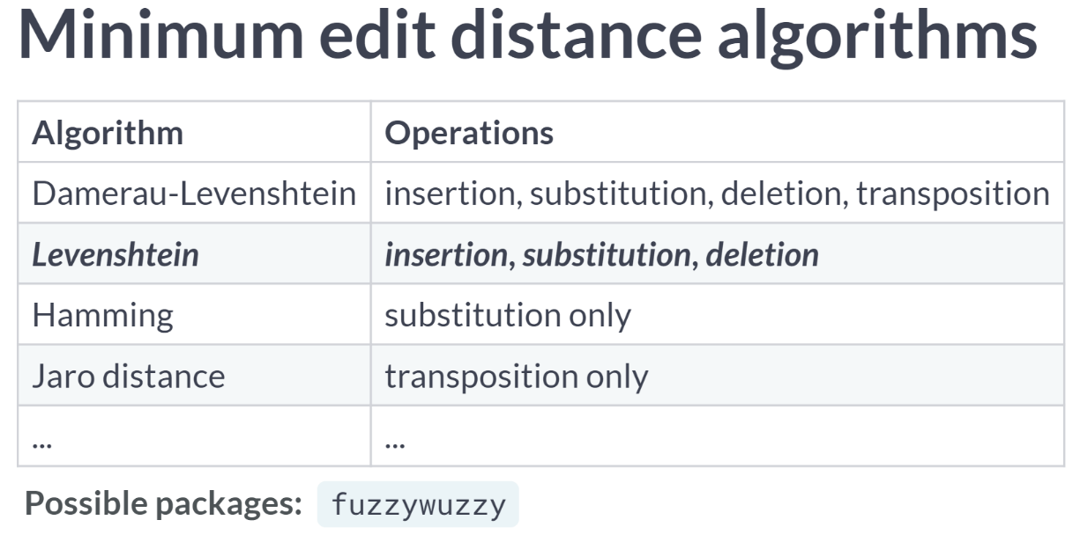  
For this lesson, we will be comparing strings using *Levenshtein distance* since it's the most general form of string matching by using the *fuzzywuzzy* package.

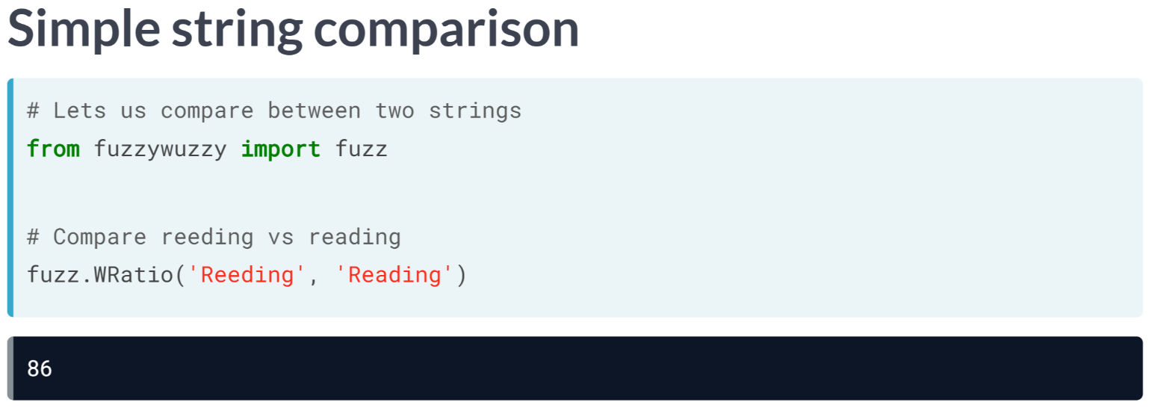  
Fuzzywuzzy is a simple to use package to perform string comparison. We first import fuzz from fuzzywuzzy, which allows us to compare between single strings.

Here, we use fuzz's ***WRatio()*** function to compute the similarity between reading and its typo, inputting each string as an argument.

For any comparison function using fuzzywuzzy, our output is a score from 0 to 100 with 0 being not similar at all, 100 being exact match.

Do NOT confuse this with the minimum edit distance score, where a lower MED means a closer match.

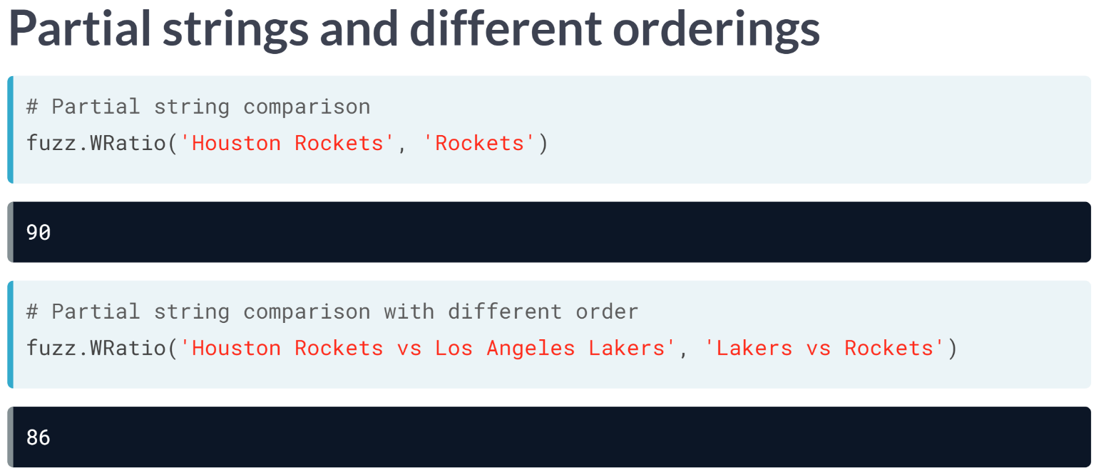  
The ***WRatio()*** function is highly robust against partial string comparison with different orderings.

For example, we compare the strings Houston Rockets and Rockets, and still received a high similarity score.

The same can be said for the strings Houston Rockets versus Los Angeles Lakers and Lakers versus Rockets, where the team names are only partial, and they are differently ordered.

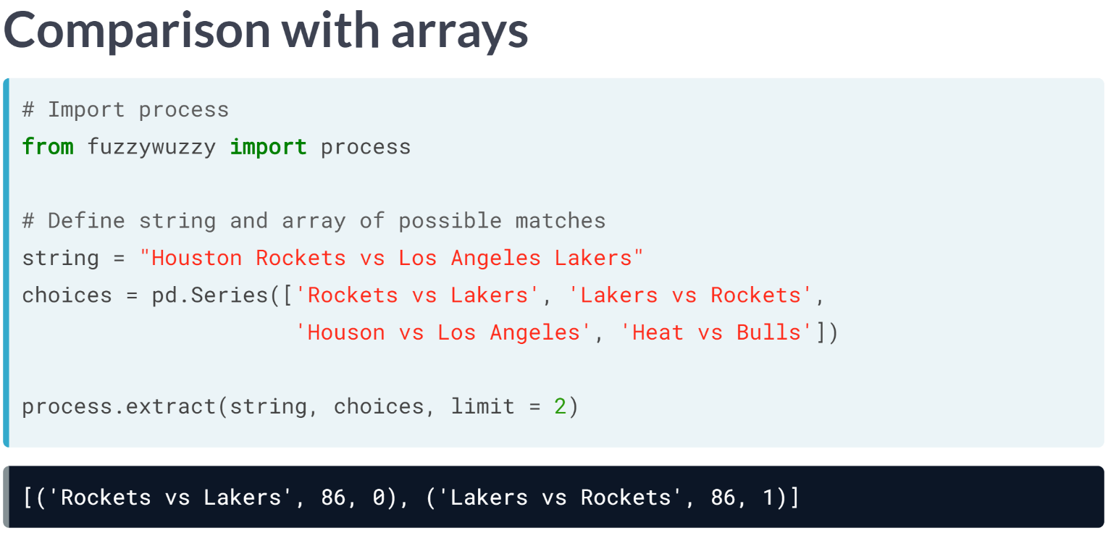  
We can also compare a string with an array of strings by using the extract function from the process module from *fuzzywuzzy*.

Extract takes in a string, an array of strings, and the number of possible matches to return ranked from highest to lowest.

It returns a list of tuples with three elements, the first one being the matching string being returned, the second one being its similarity score, and the third one being its index in the array.

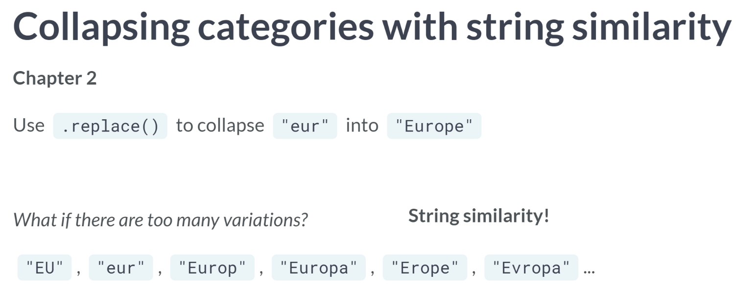  
We already saw how to manually replace categories in a column of a DataFrame.

But what if we had so many inconsistent categories that a manual replacement is simply not feasible?

We can easily do that with string similarity.

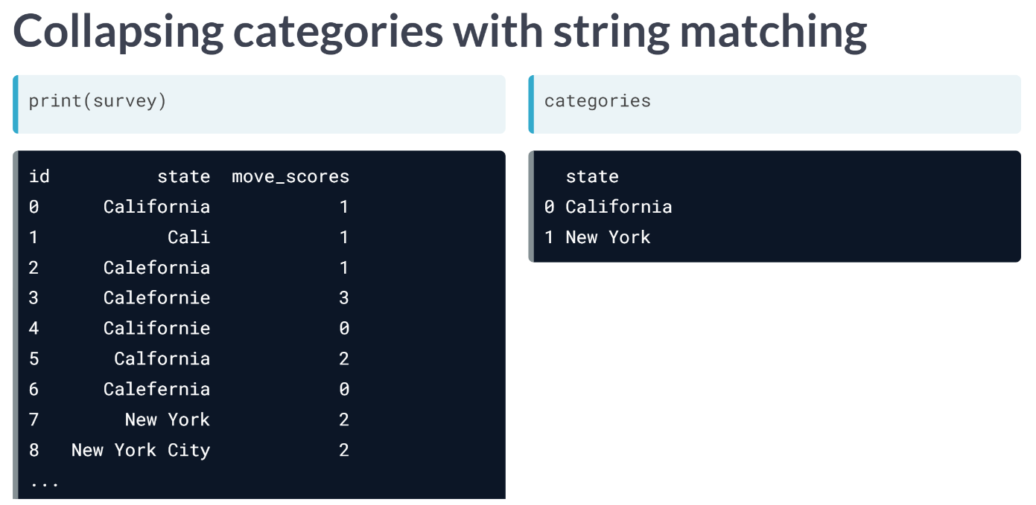  
Say we have DataFrame named survey containing answers from respondents from the state of NY and CA asking them how likely one is to move on a scale of 0 to 5.

The state field was free text and contains hundreds of typos. And remapping them manually would take a huge amount of time.

Instead, we will use string similarity. We also have the category DataFrame that contains the correct categories for each state. Let's collapse the incorrect categories with string matching.

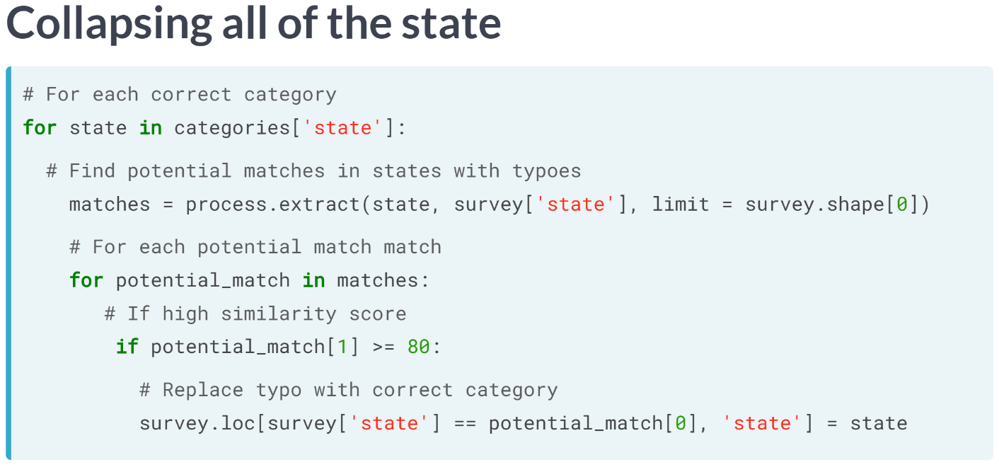  
We first create a for loop iterating over each correctly typed state in the categories DataFrame. For each state, we find its matches in the state column of the survey DataFrame, returning all possible matches by setting the limit argument of extract to the length of the survey DataFrame.

Then we iterate over each potential match, isolating the ones only with a similarity score higher or equal than 80 with an if statement. Then for each of those returned strings, we replace it with the correct state using the ***loc()*** method.

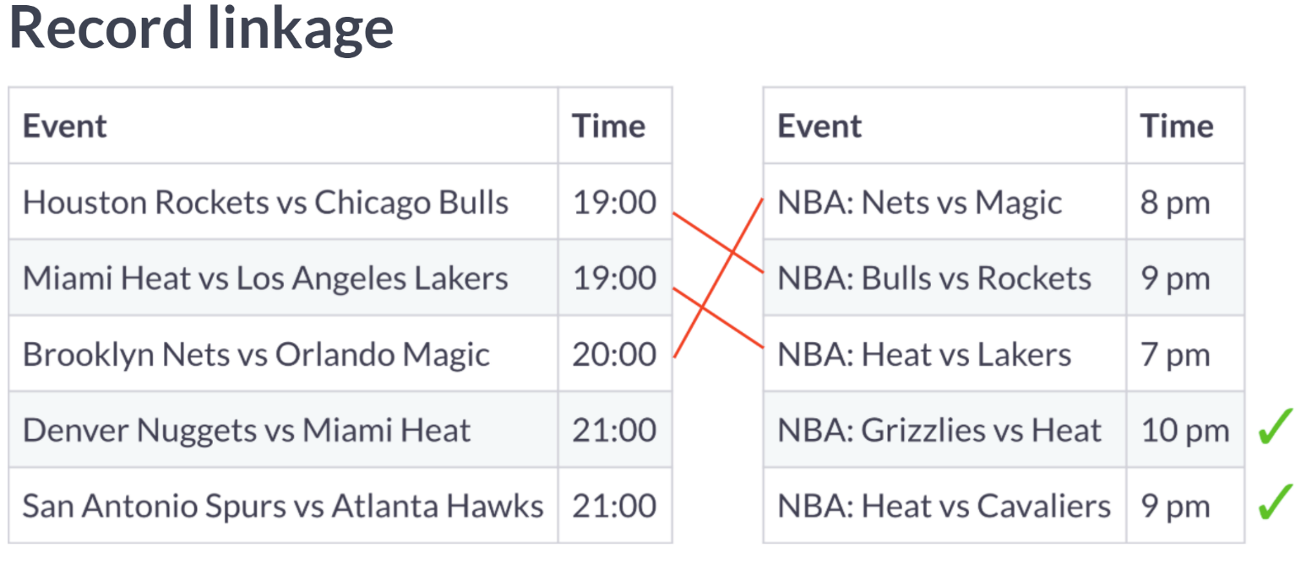  
Record linkage attempts to join data sources that have similarly fuzzy duplicate values, so that we end up with a final DataFrame with no duplicates by using string similarity.

# Minimum edit distance

In the video exercise, you saw how minimum edit distance is used to identify how similar two strings are. As a reminder, minimum edit distance is the minimum number of steps needed to reach from ***String A*** to ***String B***, with the operations available being:

* **Insertion** of a new character.
* **Deletion** of an existing character.
* **Substitution** of an existing character.
* **Transposition** of two existing consecutive characters.

 What is the minimum edit distance from 'sign' to 'sing', and which operation(s) gets you there?

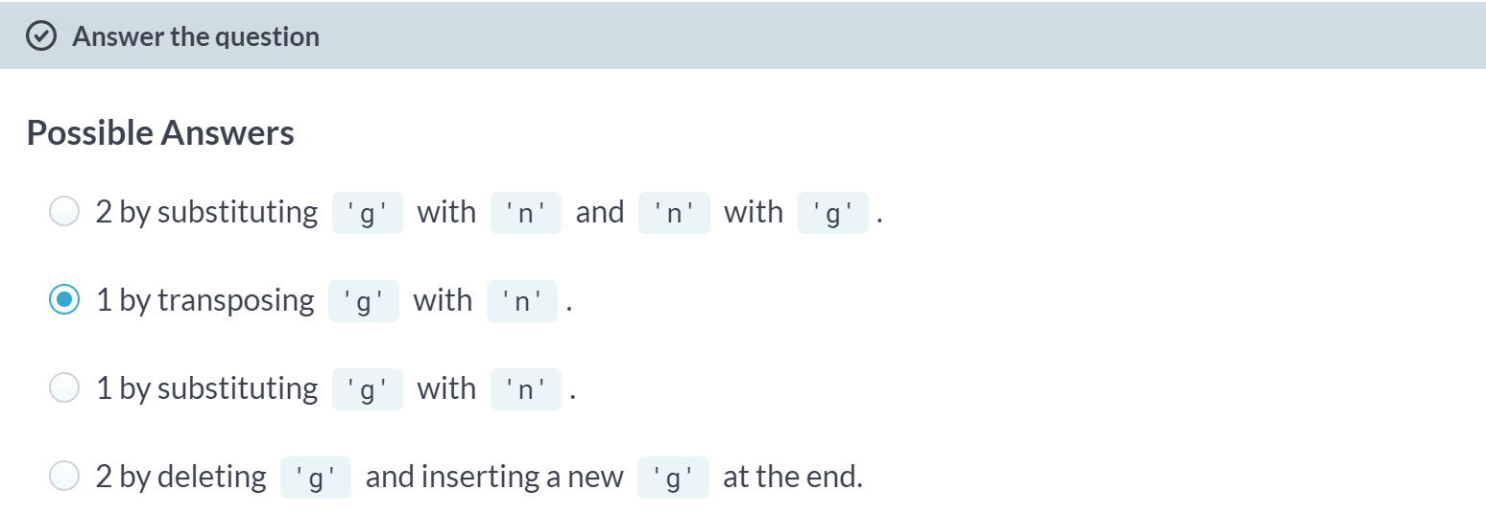  
Correct! Transposing the last two letters of 'sign' is the easiest way to get to 'sing' - in the next exercise, you'll use edit distance at scale to remap categories!

A: That's not really correct - do you think this is the minimum edit distance?

C: That's the correct edit distance, but substituting g with n would take you from 'sign' to 'sinn'.

D: That's not really correct - do you think this is the minimum edit distance?

# The cutoff point

In this exercise, and throughout this chapter, you'll be working with the restaurants DataFrame which has data on various restaurants. Your ultimate goal is to create a restaurant recommendation engine, but you need to first clean your data.

This version of restaurants has been collected from many sources, where the cuisine_type column is riddled with typos, and should contain only italian, american and asian cuisine types. There are so many unique categories that remapping them manually isn't scalable, and it's best to use string similarity instead.

Before doing so, you want to establish the cutoff point for the similarity score using the fuzzywuzzy's process.extract() function by finding the similarity score of the most distant typo of each category.

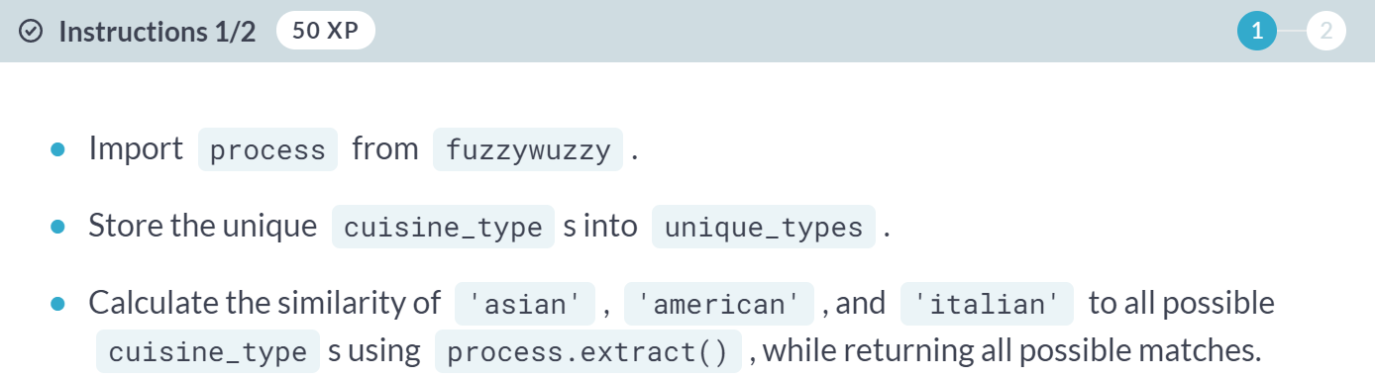

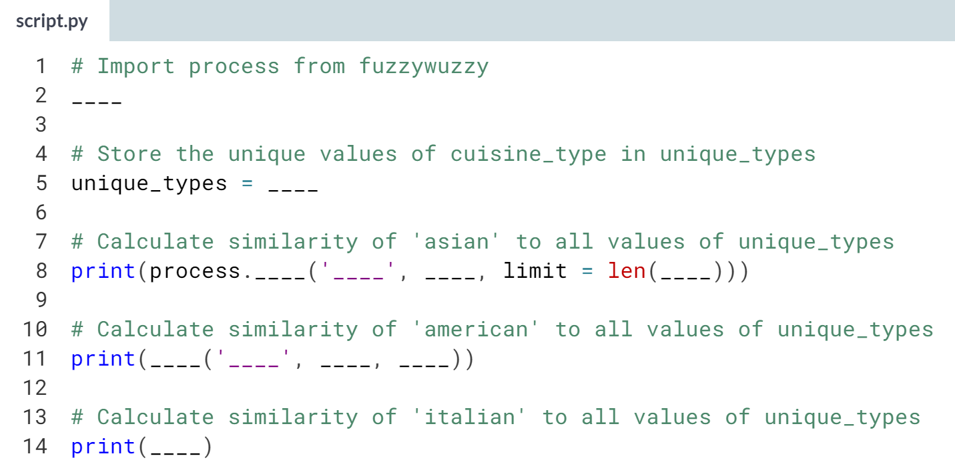

(Solution on the next page)

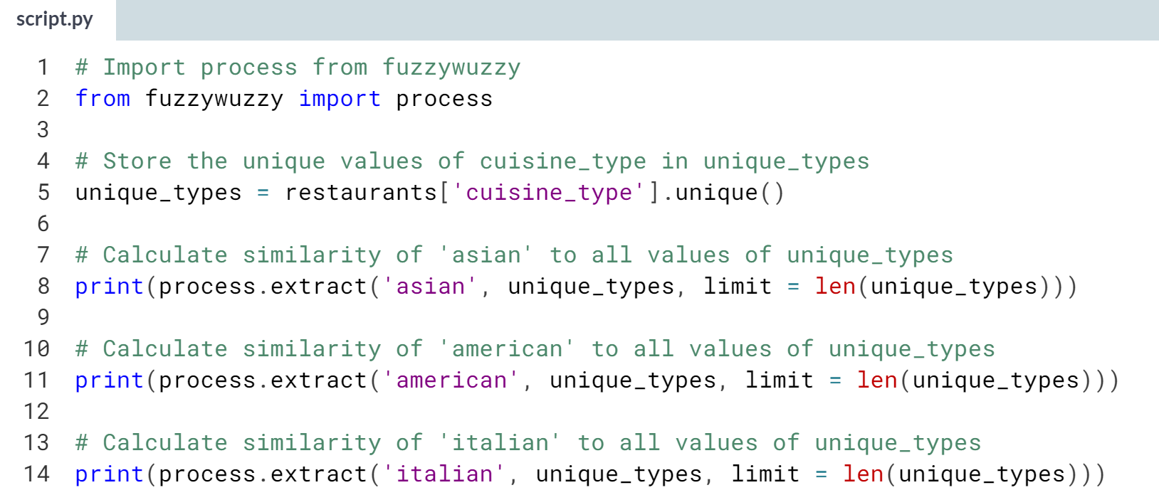

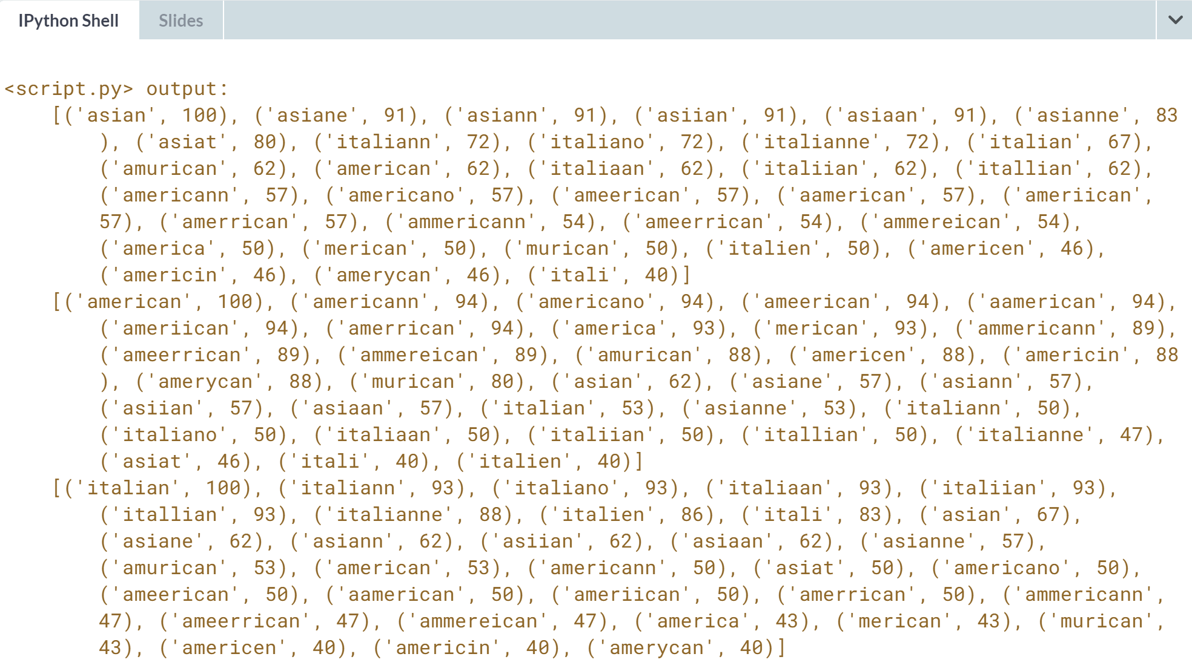

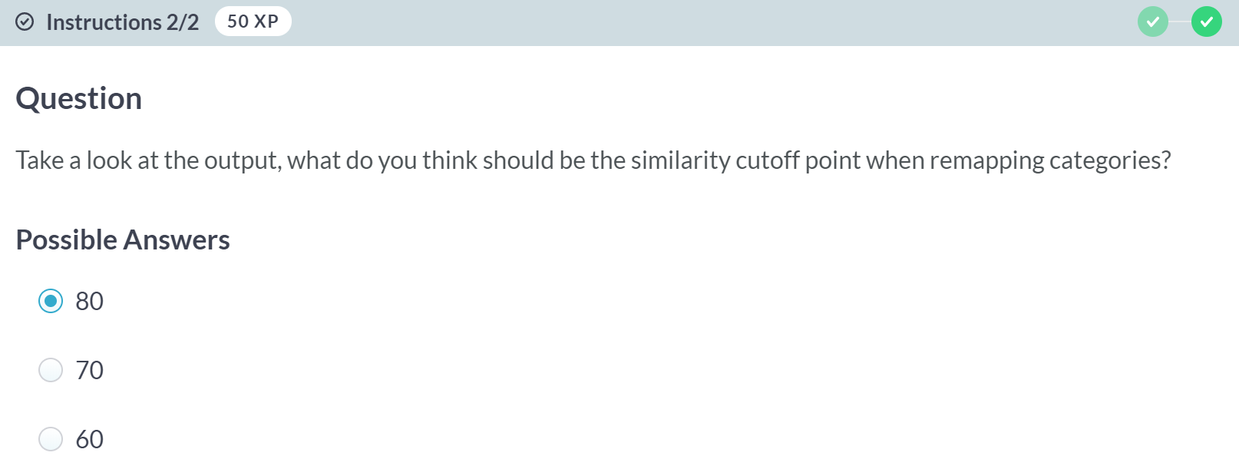

A: Correct! 80 is that sweet spot where you convert all incorrect typos without remapping incorrect categories. Often times though, you may need to combine the techniques learned in chapter 2, especially since there could be strings that make it beyond our cutoff point, but are not actually a match!

B: Not quite, 'asian' and 'italiann' have a similarity score of 72, meaning 'italiann' would be converted to 'asian'.

C: That's too low, and you risk converting a lot more categories than you should.

# Remapping categories II – **REVIEW**

In the last exercise, you determined that the distance cutoff point for remapping typos of 'american', 'asian', and 'italian' cuisine types stored in the cuisine_type column should be 80.

In this exercise, you're going to put it all together by finding matches with similarity scores equal to or higher than 80 by using fuzywuzzy.process's extract() function, for each correct cuisine type, and replacing these matches with it. Remember, when comparing a string with an array of strings using process.extract(), the output is a list of tuples where each of tuple is as such:

(closest match, similarity score, index of match)

The restaurants DataFrame is in your environment, and you have access to a categories list containing the correct cuisine types.

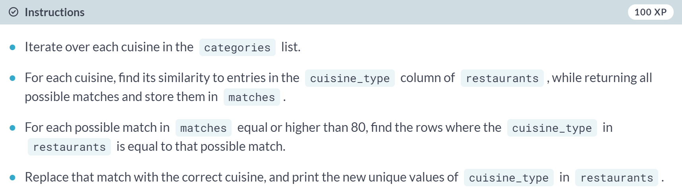

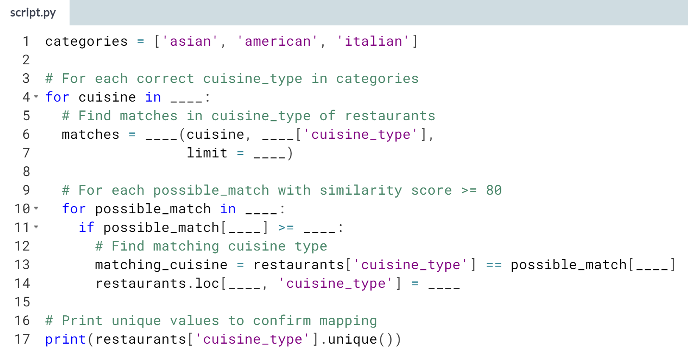  
(Solution on the next page)

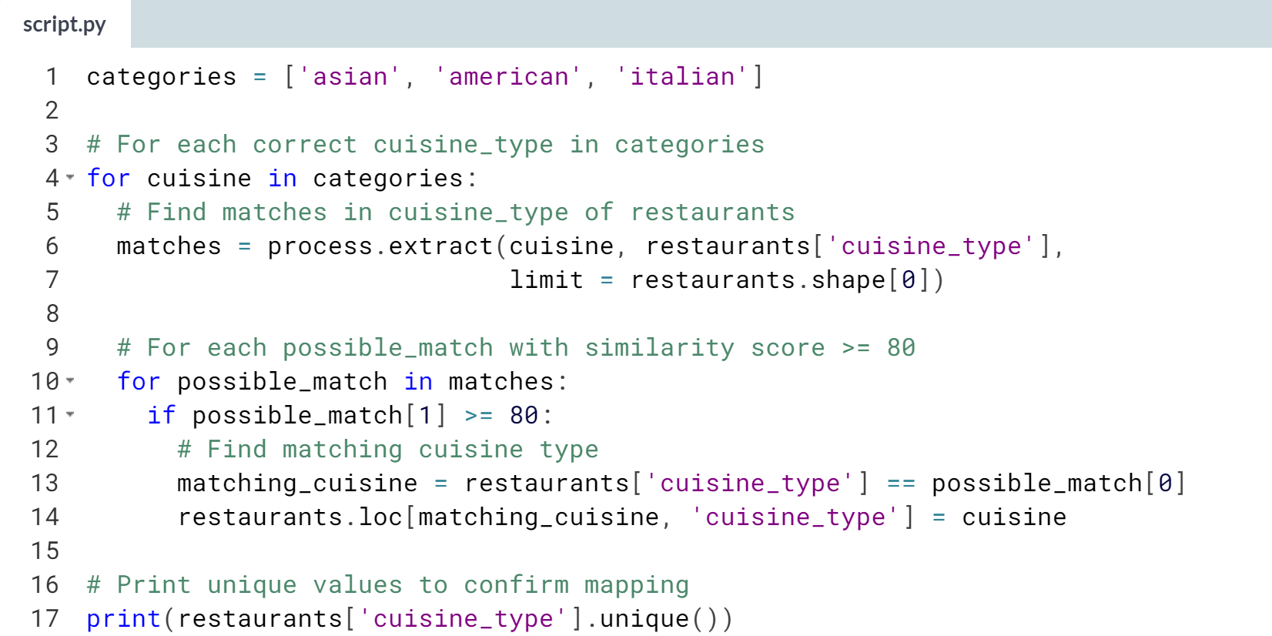

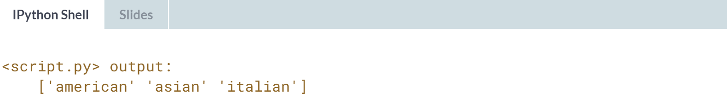

Tremendous work! All your cuisine types are properly mapped! Now you'll build on string similarity, by jumping into record linkage!



At the end of the last lesson, we saw how record linkage attempts to join data sources with fuzzy duplicate values.

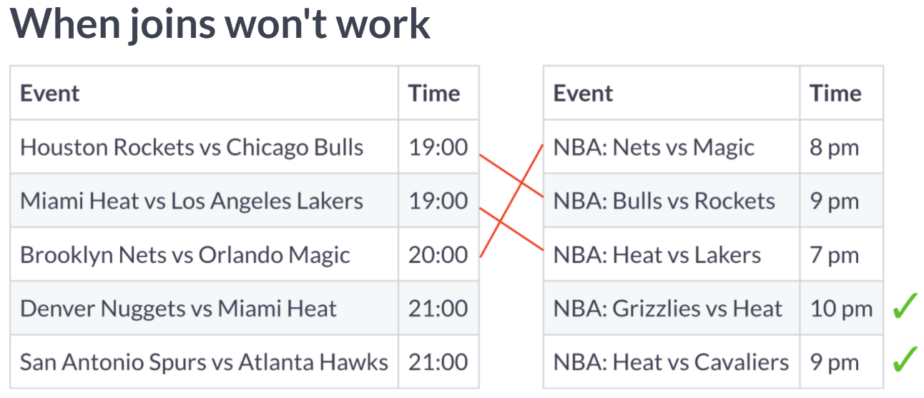  
For example, here are two DataFrames containing NBA games and their schedules. They have both been scraped from different sites, and we would want to merge them together and have one DataFrame containing all unique games.

We see that there are duplicate values in both DataFrames with different naming marked here in red, and non-duplicate values, marked here in green.

Since there are games happening at the same time, no common unique identifier between the DataFrames, and the events are differently named, a regular join or merge will not work. This is where the record linkage comes in.

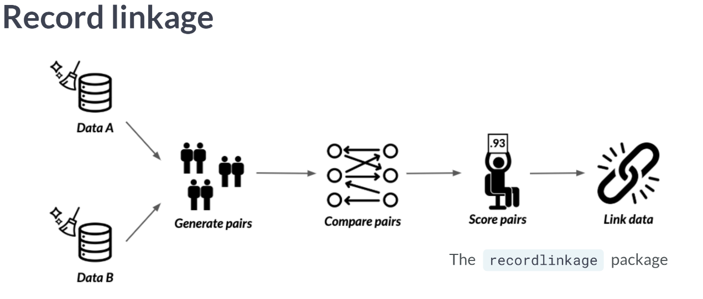  
Record linkage is the act of linking data from different sources regarding the same entity. Generally, we clean two or more DataFrames, generate pairs of potentially matching records, score these pairs according to string similarity and other similarity metrics, and link them. All of these steps can be achieved with the *recordlinkage* package, let's find how!

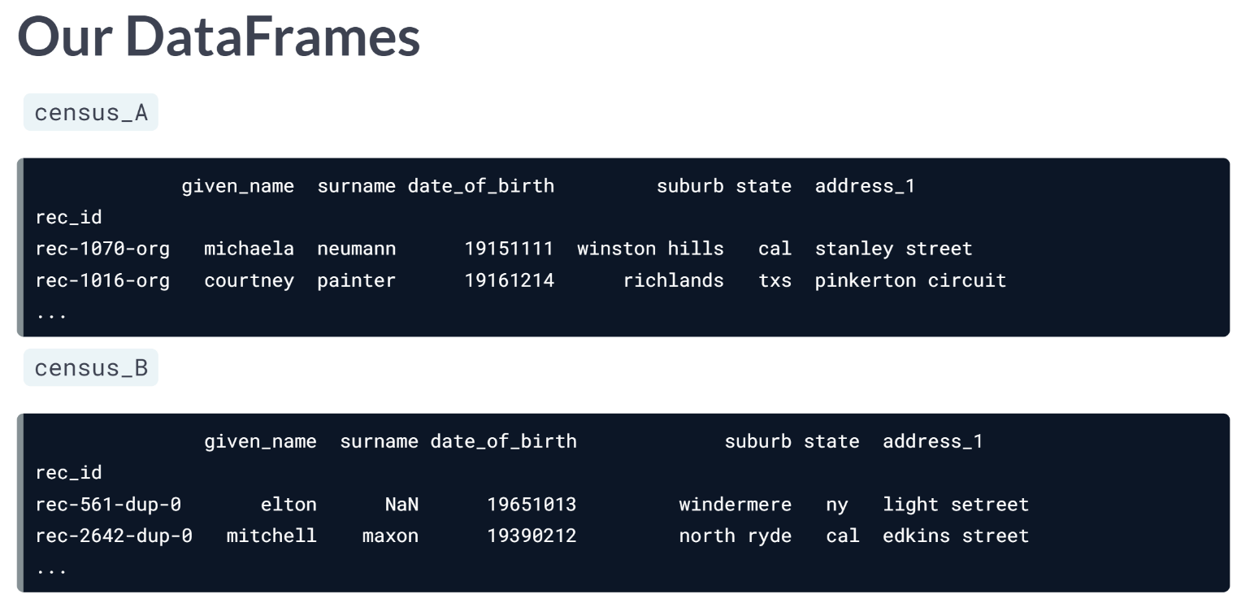  
Here we have two DataFrames, *census_A*, and *census_B*, containing data on individuals throughout the states. We want to merge them while avoiding duplication using record linkage, since they are collected manually and are prone to typos, there are no consistent IDs between them.

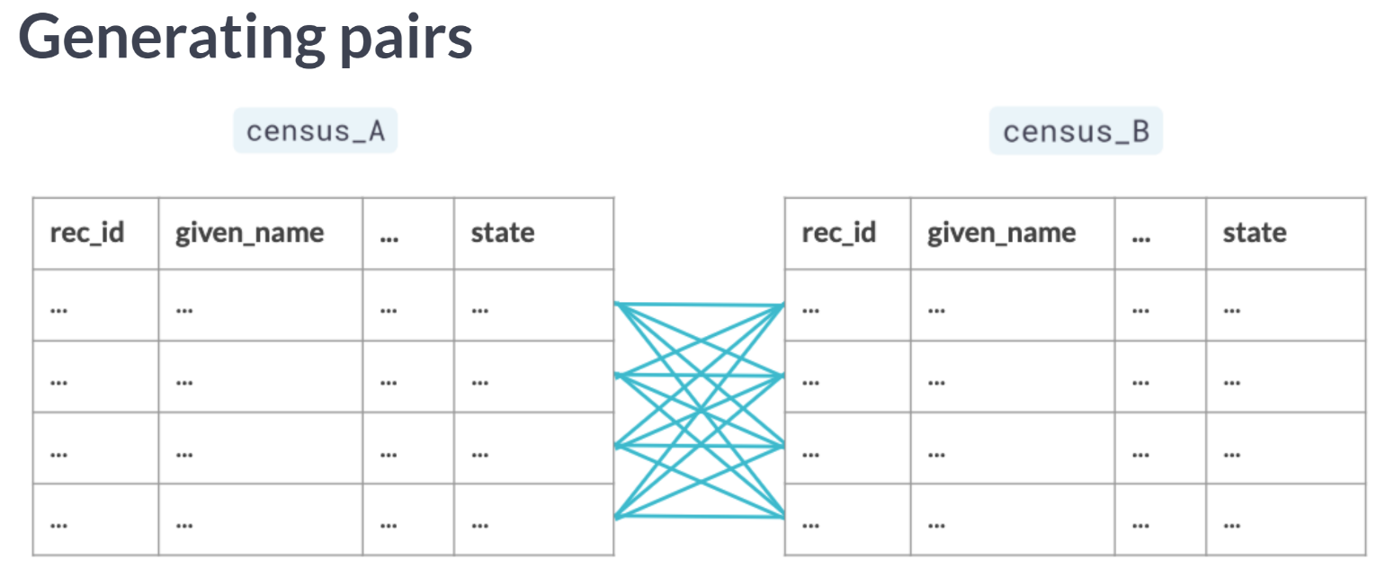  
We first want to generate pairs between both DataFrames. Ideally, we want to generate all possible pairs between our DataFrames.

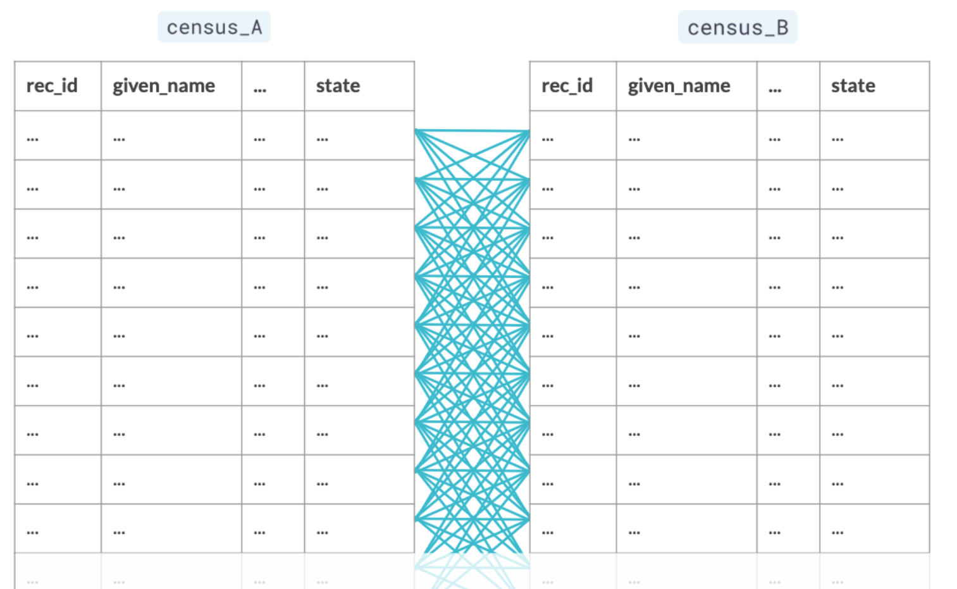  
But what if we had big DataFrames and ended up having to generate millions if not billions of pairs? It wouldn't prove scalable and could easily hamper development time.

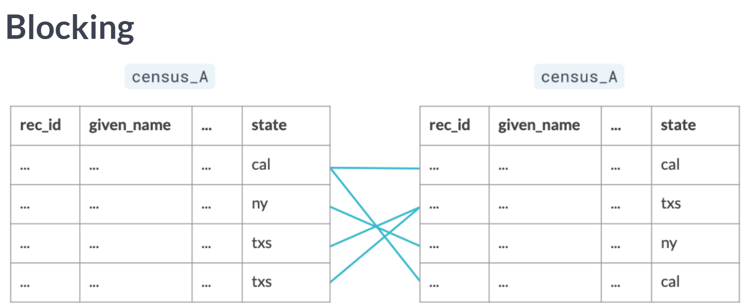  
This is where we apply what we call blocking, which creates pairs based on a matching column, which is in this case, the state column, reducing the number of possible pairs.

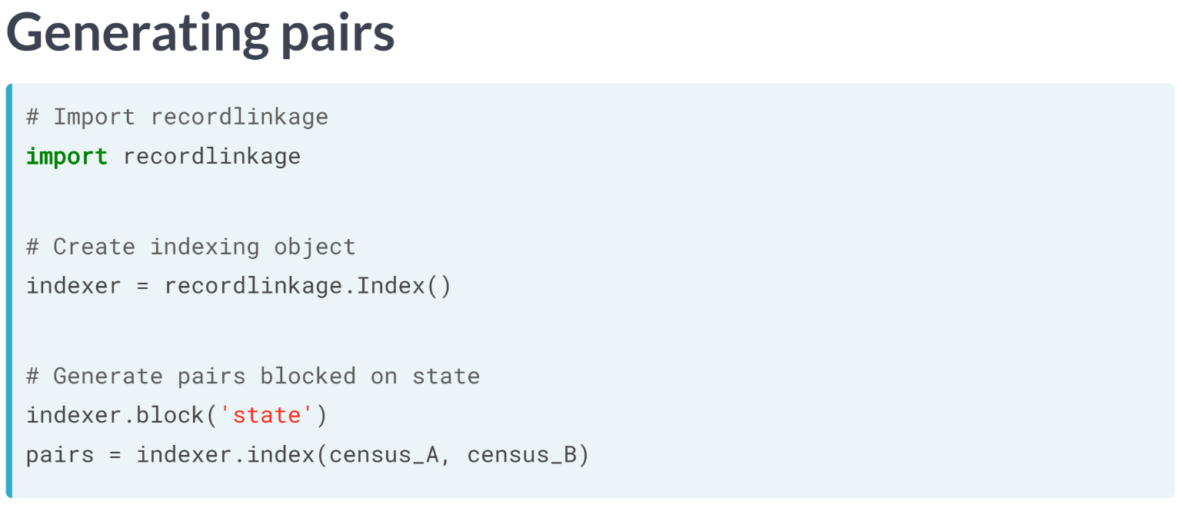  
To do this, we first start off by importing recordlinkage. We then use the ***recordlinkage.index()*** function, to create an indexing object. This essentially is an object we can use to generate pairs from our DataFrames.

To generate pairs blocked on state, we use the ***block()*** method, inputting the state column as input. Once the indexer object has been initialized, we generate our pairs using the ***.index()*** method, which takes in the two DataFrames.

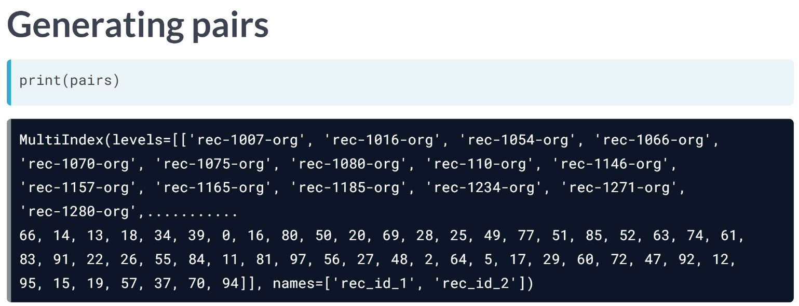  
The resulting object, is a pandas multi index object containing pairs of row indices from both DataFrames, which is a fancy way to say it is an array containing possible pairs of indices that makes it much easier to subset DataFrames on.

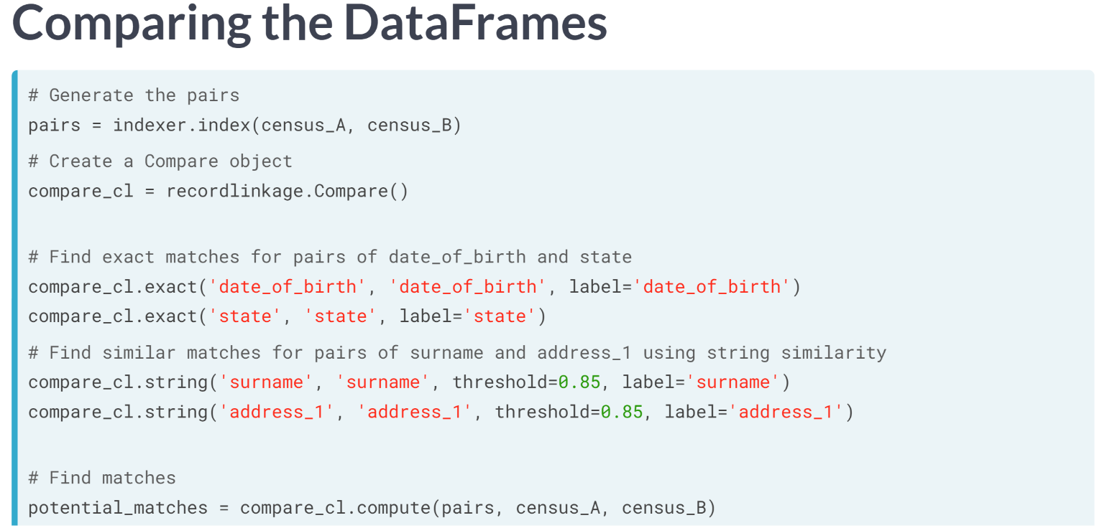  
Since we've already generated our pairs, it's time to find potential matches. We start by creating a comparison object using the ***recordlinkage.compare()*** function.

This is similar to the indexing object we created while generating pairs, but this one is responsible for assigning different comparison procedures for pairs.

Let's say there are columns for which we want exact matches between the pairs. To do that, we use the ***exact()*** method. It takes in the column name in question for each DataFrame, which is in this case *date_of_birth* and *state*, and a *label* argument, which lets us set the column name in the resulting DataFrame.

Now in order to compute string similarities between pairs of rows for columns that have fuzzy values, we use the ***.string()*** method, which also takes in the *column* names in question, the similarity cutoff point in the *threshold* argument, which takes in a value between 0 and 1, which we here set to 0.

Finally, to compute the matches, we use the ***compute()*** function, which takes in the possible pairs, and the two DataFrames in question. Note that you need to always have the same order of DataFrames when inserting them as arguments when generating pairs, comparing between columns and computing comparisons.

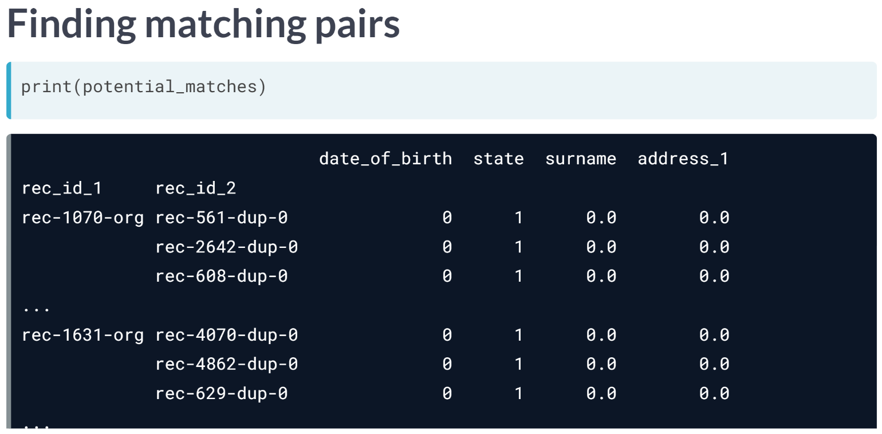  
The output is a multi-index DataFrame, where the first index is the row index from the first DataFrame, or census A, and the second index is a list of all row indices in census B. The columns are the columns being compared, with values being 1 for a match, and 0 for not a match.

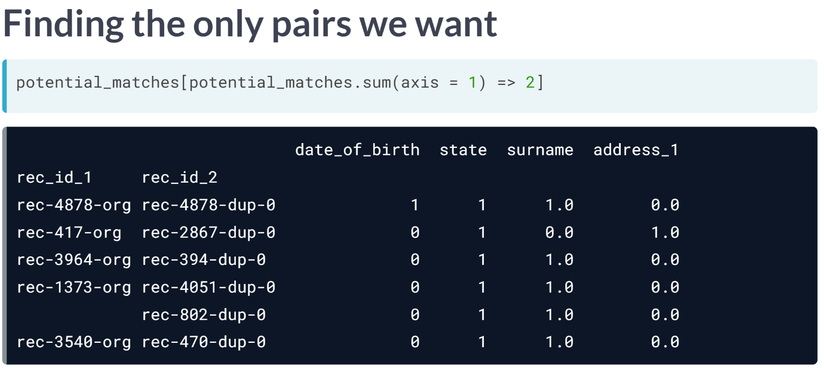  
To find potential matches, we just filter for rows where the sum of row values is higher than a certain threshold, which in this case is higher or equal to 2.

# To link or not to link?

Similar to joins, record linkage is the act of linking data from different sources regarding the same entity. But unlike joins, record linkage does not require exact matches between different pairs of data, and instead can find close matches using string similarity.

This is why record linkage is effective when there are no common unique keys between the data sources you can rely upon when linking data sources such as a unique identifier.

In this exercise, you will classify each card whether it is a traditional join problem, or a record linkage one.

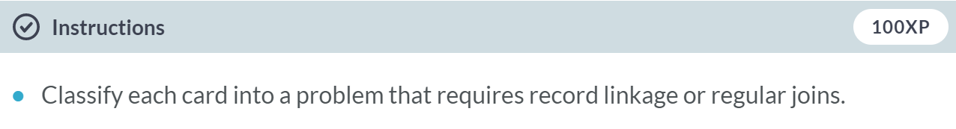

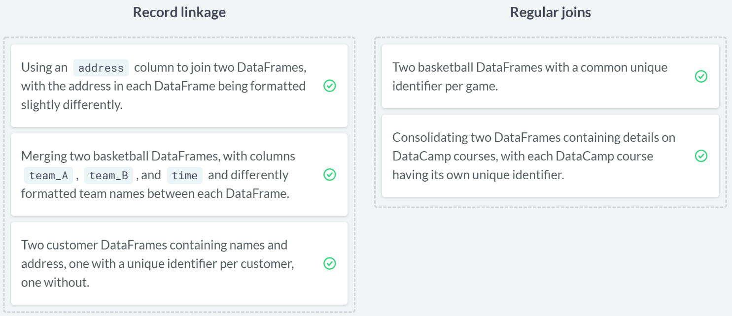

Fabulous! Don't make things more complicated than they need to be: record linkage is a powerful tool, but it's more complex than using a traditional join.

# Pairs of restaurants

In the last lesson, you cleaned the restaurants dataset to make it ready for building a restaurants recommendation engine. You have a new DataFrame named restaurants_new with new restaurants to train your model on, that's been scraped from a new data source.

You've already cleaned the cuisine_type and city columns using the techniques learned throughout the course. However, you saw duplicates with typos in restaurants names that require record linkage instead of joins with restaurants.

In this exercise, you will perform the first step in record linkage and generate possible pairs of rows between restaurants and restaurants_new.

Both DataFrames, pandas and recordlinkage are in your environment.

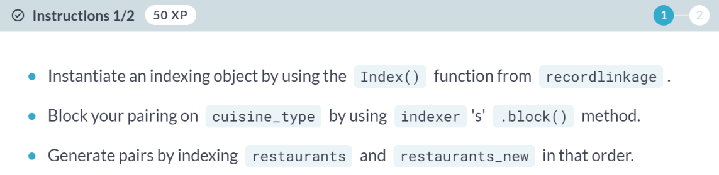

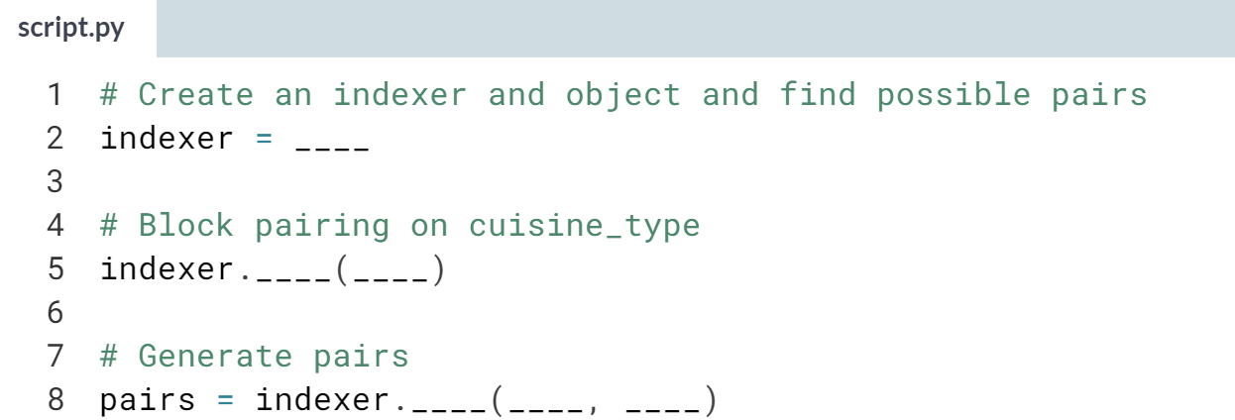  
  
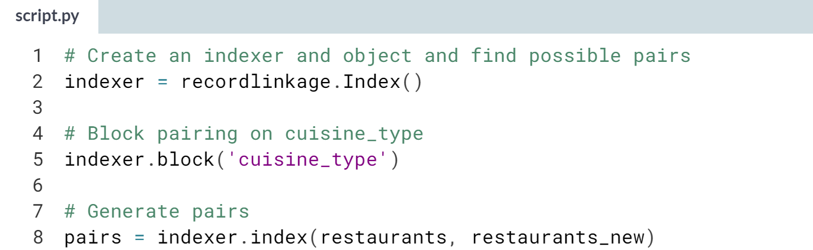

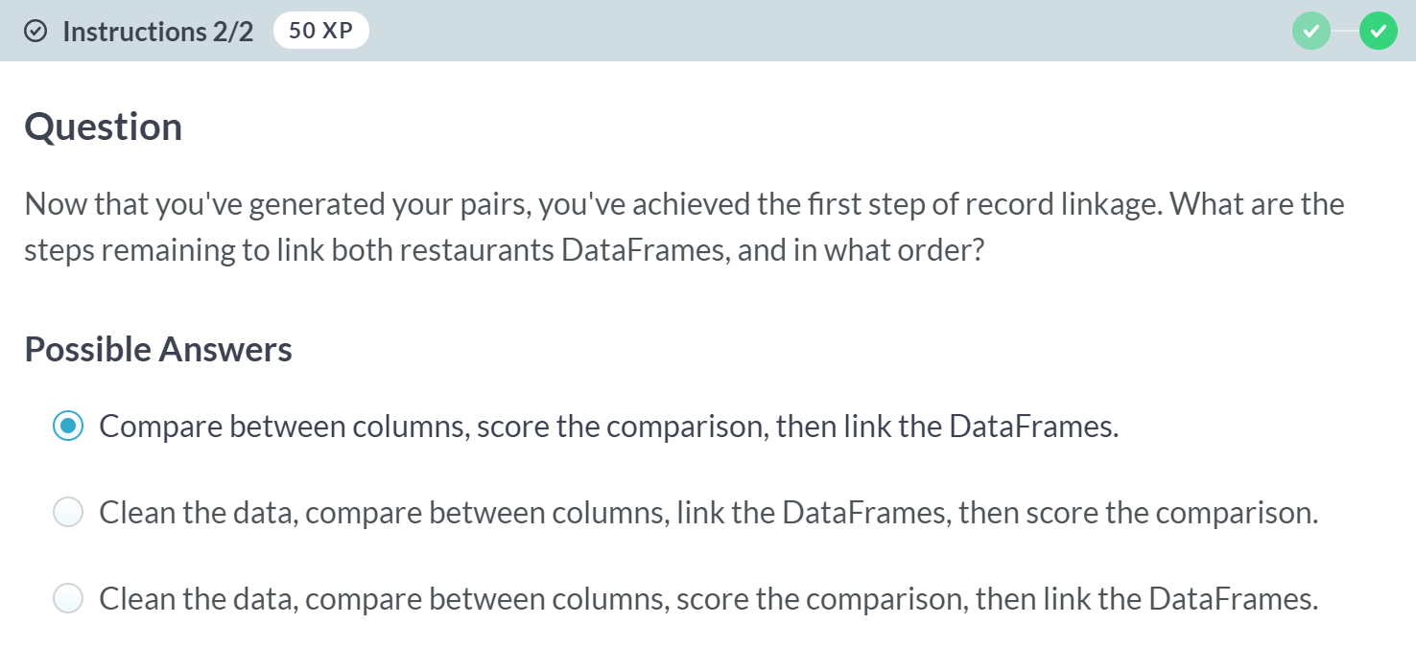  
Correct! In the next exercise, you will compare between columns and check out the matching potentially rows between both DataFrames!

B: Not really, cleaning data precedes the pair generation phase, and linking DataFrames is the final step!

C: Are you sure? Cleaning data precedes the pair generation phase.

# Similar restaurants

In the last exercise, you generated pairs between restaurants and restaurants_new in an effort to cleanly merge both DataFrames using record linkage.

When performing record linkage, there are different types of matching you can perform between different columns of your DataFrames, including exact matches, string similarities, and more.

Now that your pairs have been generated and stored in pairs, you will find exact matches in the city and cuisine_type columns between each pair, and similar strings for each pair in the rest_name column. Both DataFrames, pandas and recordlinkage are in your environment.

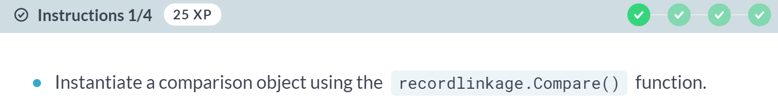

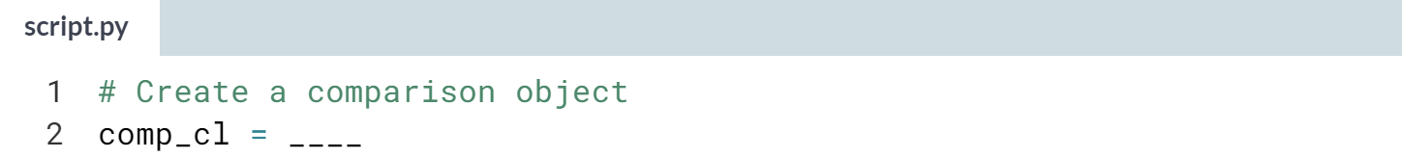

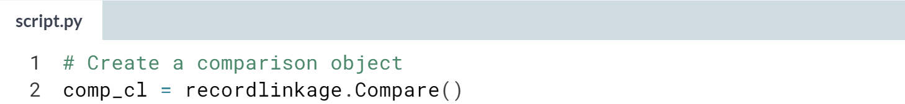

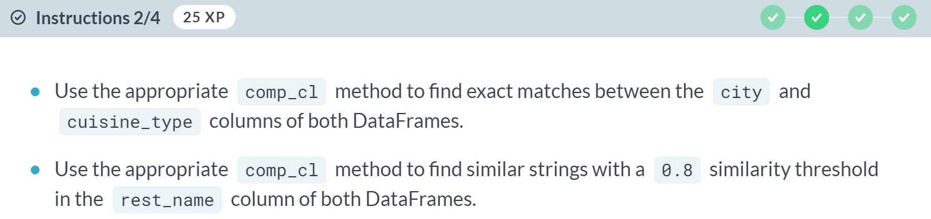

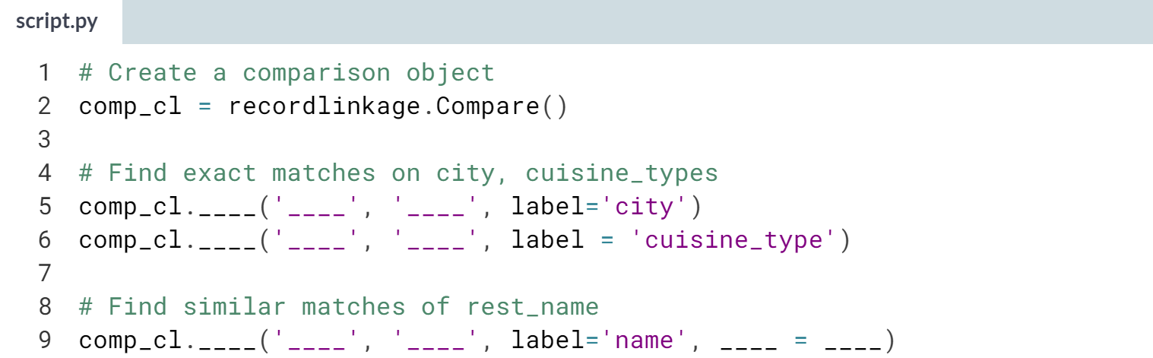

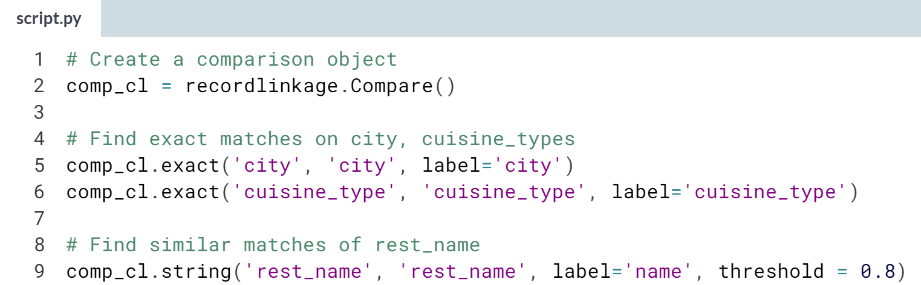

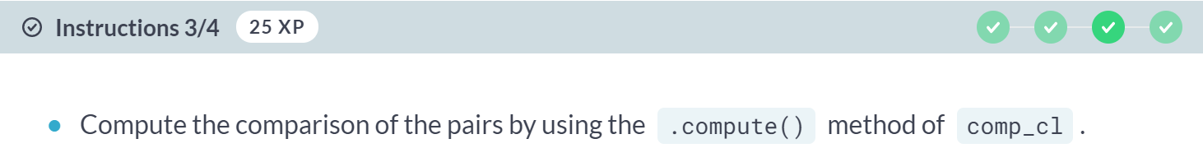

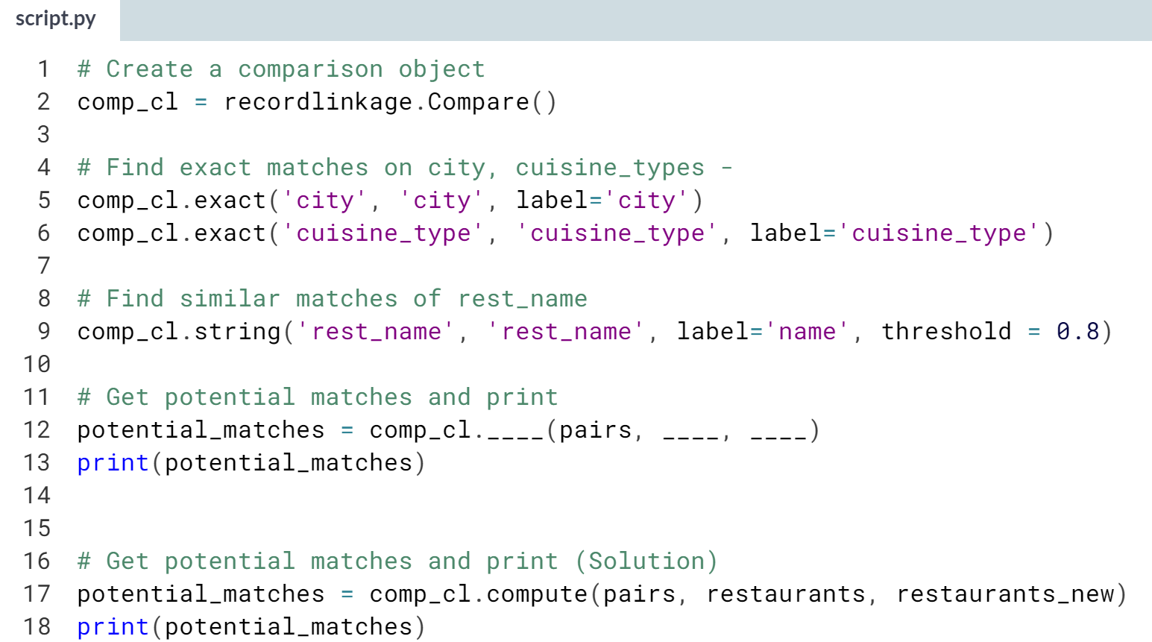

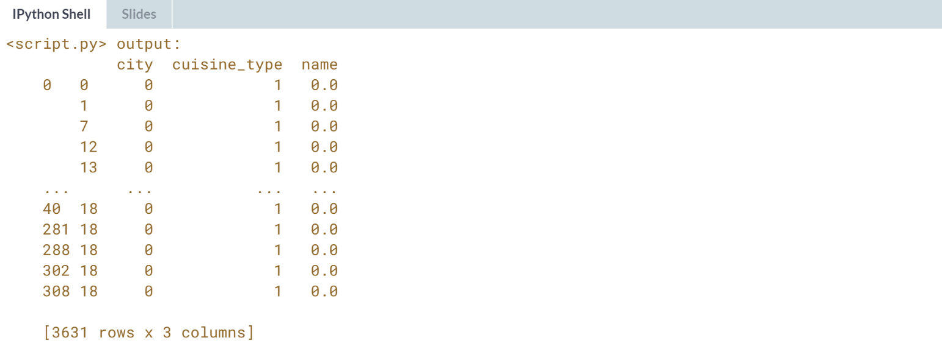

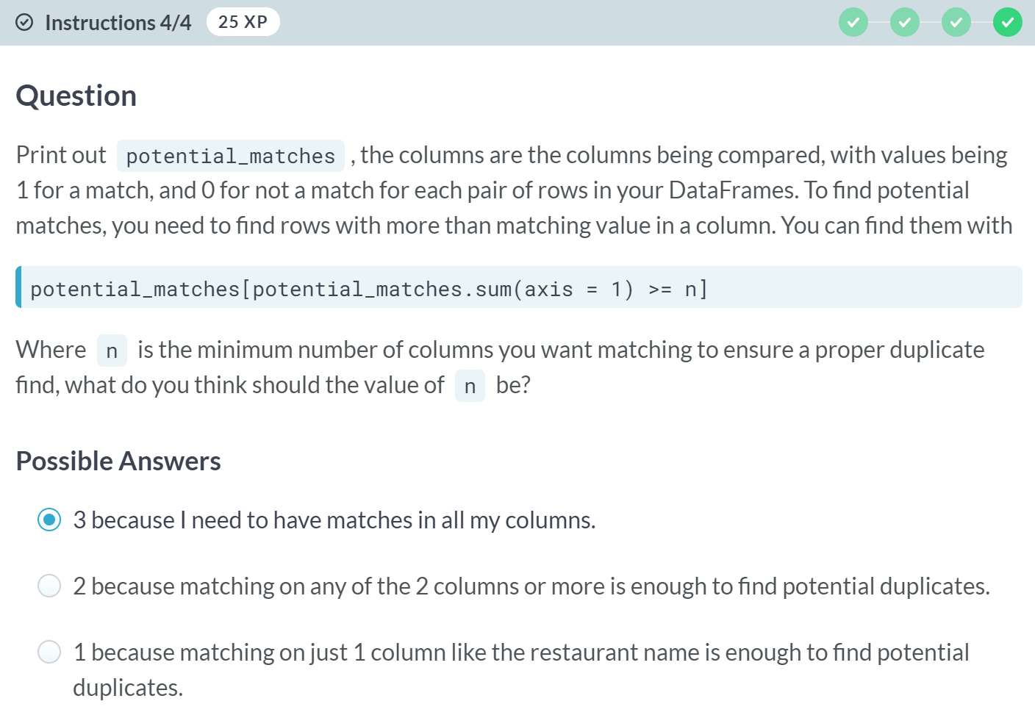  
A: That's correct! For this example, tightening your selection criteria will ensure good duplicate finds! In the next lesson, you're going to build on what you learned to link these two DataFrames!

B: If n is set to 2, then you will get duplicates for all restaurants with the same cuisine type in the same city.

C: What if you had restaurants with the same name in different cities?



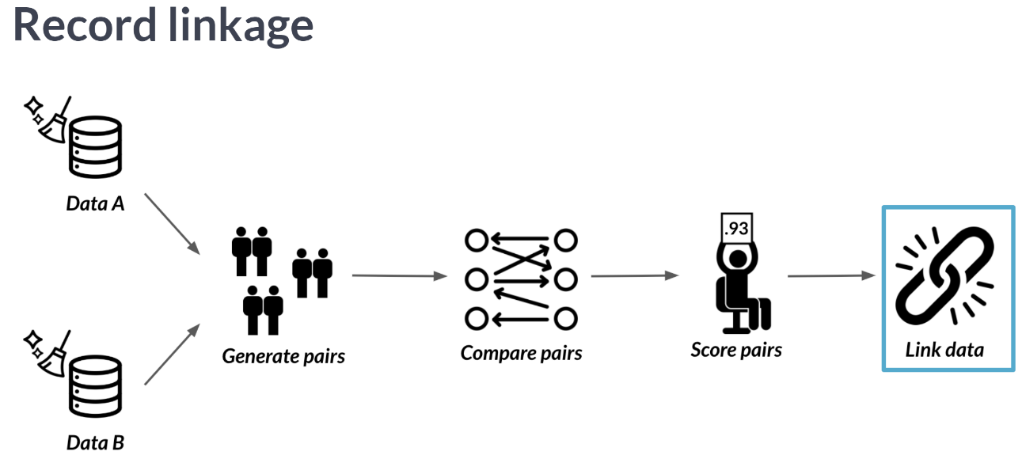  
At this point, you've generated your pairs, compared them, and scored them. Now, it is time to link your data.

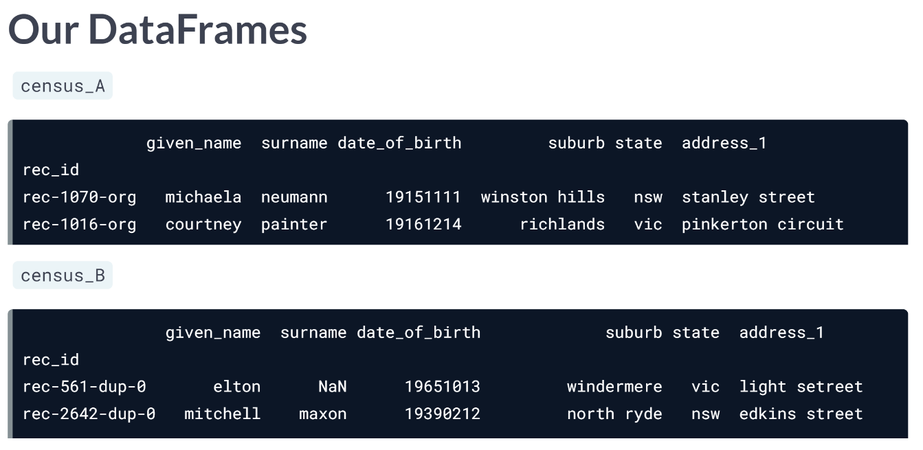  
Remember our census DataFrames from the video of the previous lesson?

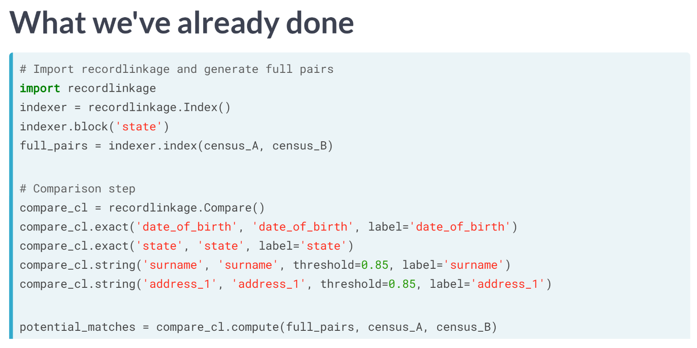  
We've already generated pairs between them, compared four of their columns, two for exact matches and two for string similarity alongside a 0.85 threshold, and found potential matches.

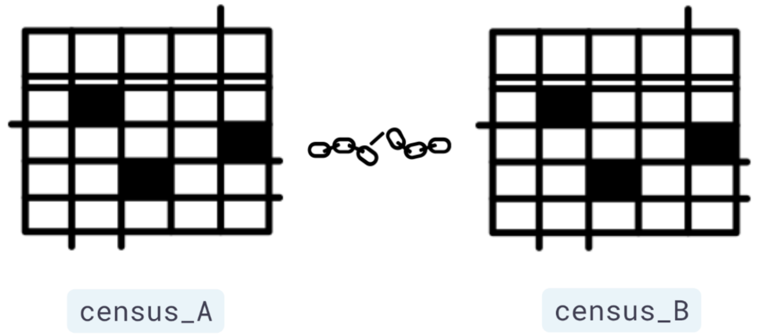  
Now it is time to link both census DataFrames.

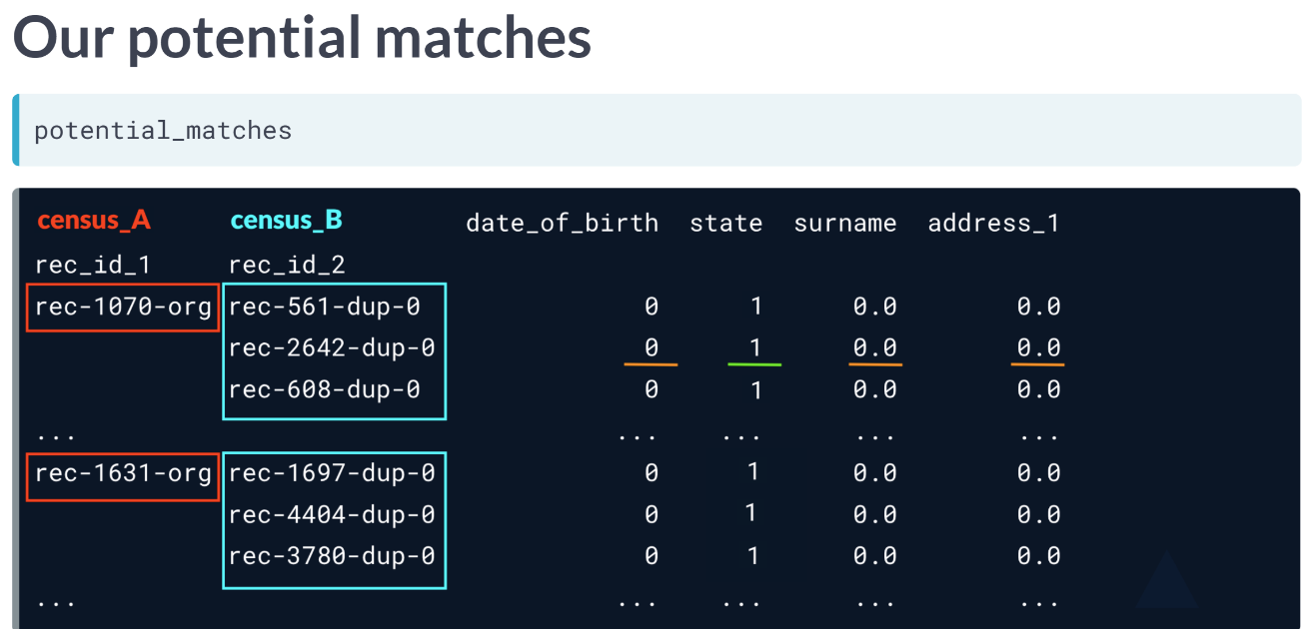  
Let's look closely at our potential matches.

It is a multi-index DataFrame, where we have two index columns, rec_id_1 and rec_id_2. The first index column, stores indices from census_A. The second index column, stores all possible indices from census_B, for each row index of census_A.

The columns of our potential matches are the columns we chose to link both DataFrames on, where the value is 1 for a match and 0 otherwise.

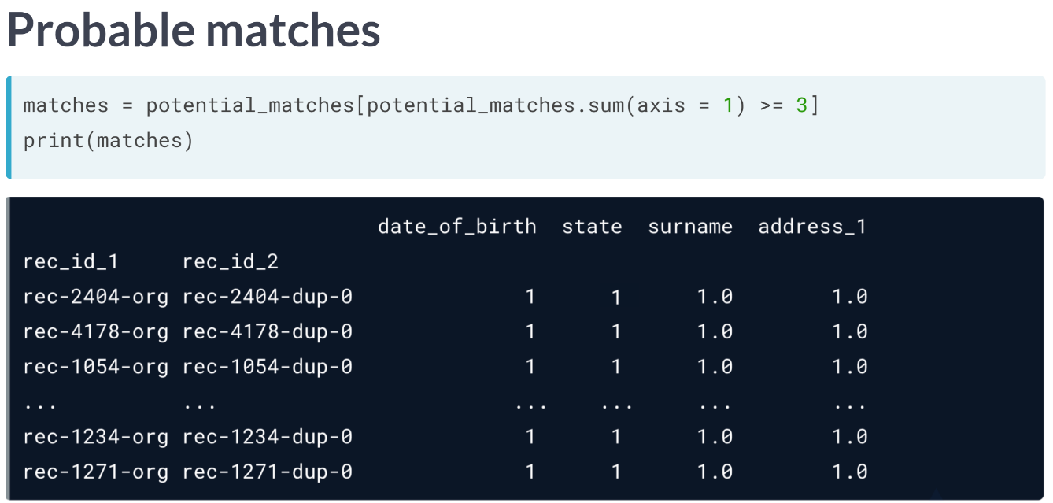  
The first step in linking DataFrames is to isolate the potentially matching pairs to the ones we are pretty sure of. We saw how to do this in the previous lesson, by subsetting the rows where the row sum is above a certain number of columns, in this case 3.

The output is row indices between census A and census B that are most likely duplicates. Our next step is to extract the one of the index columns.

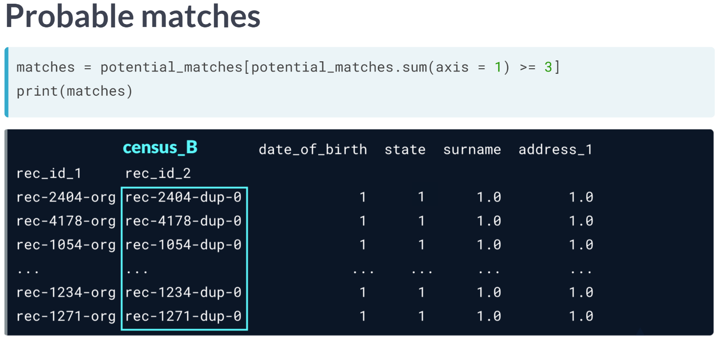  
Here we choose the second index column, which represents row indices of census B. We want to extract those indices and subset census_B on them to remove duplicates with census_A before appending them together.

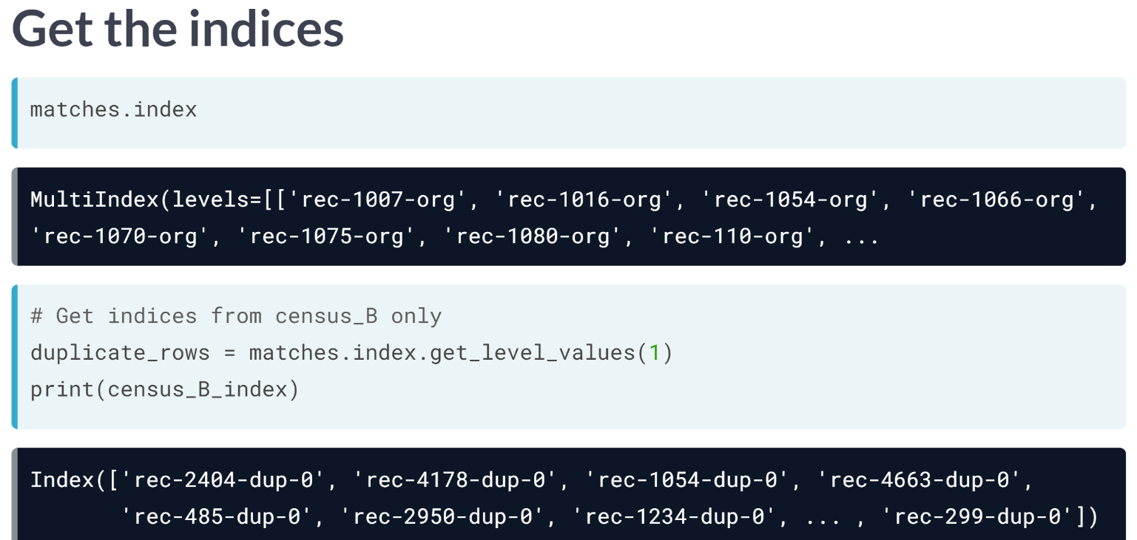  
We can access a DataFrame's index using the index attribute. Since this is a multi-index DataFrame, it returns a multi index object containing pairs of row indices from census_A and census_B, respectively.

We want to extract all *census_B* indices, so we chain it with the ***get_level_values()*** method, which takes in which column index we want to extract its values. We can either input the index column's name or its order, which in this case is 1.

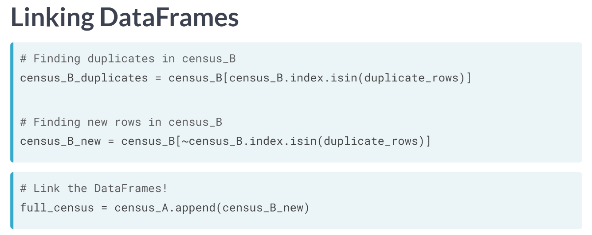  
To find the duplicates in census B, we simply subset on all indices of census_B, with the ones found through record linkage.

You can choose to examine them further for similarity with their duplicates in census_A, but if you are sure of your analysis, you can go ahead and find the non-duplicates by repeating the exact same line of code, except by adding a tilde(~) at the beginning of your subset.

Now that you have your non-duplicates, all you need is a simple append using the DataFrame append method of census A, and you have your linked Data!

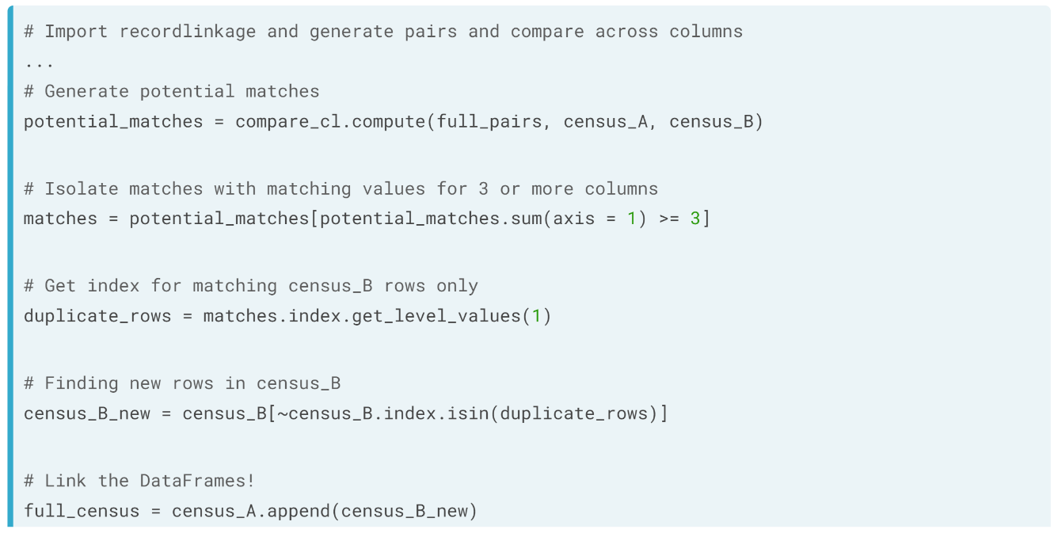  
To recap: what we did was to

1. Build on top of our previous work in generating pairs, comparing across columns, and finding potential matches.
2. We then isolated all possible matches, where there are matches across three columns or more, ensuring we tightened our search for duplicates across both DataFrames before we link them.
3. We then extracted the row indices of census_B where there are duplicates.
4. Then, we found rows of census_B where they are not duplicated with census_A by using the tilde(~) symbol.
5. And then, we linked both DataFrames for full census results.

# Getting the right index

Here's a DataFrame named matches containing potential matches between two DataFrames, users_1 and users_2.

Each DataFrame's row indices is stored in uid_1 and uid_2 respectively.

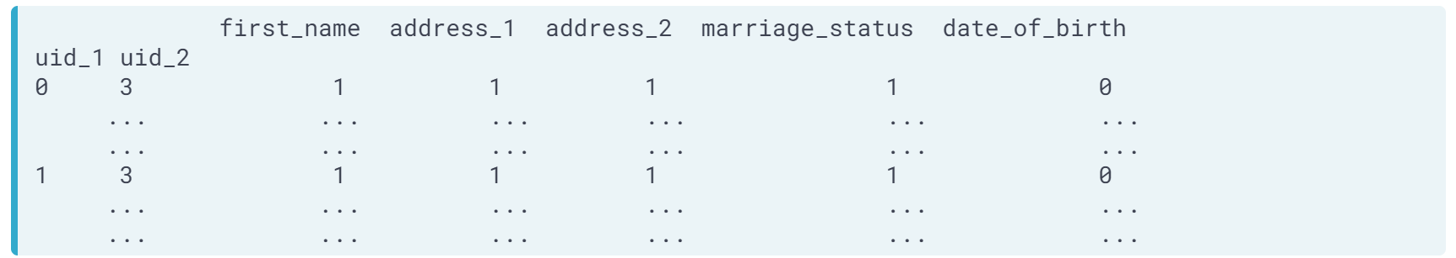

How do you extract all values of the uid_1 index column?

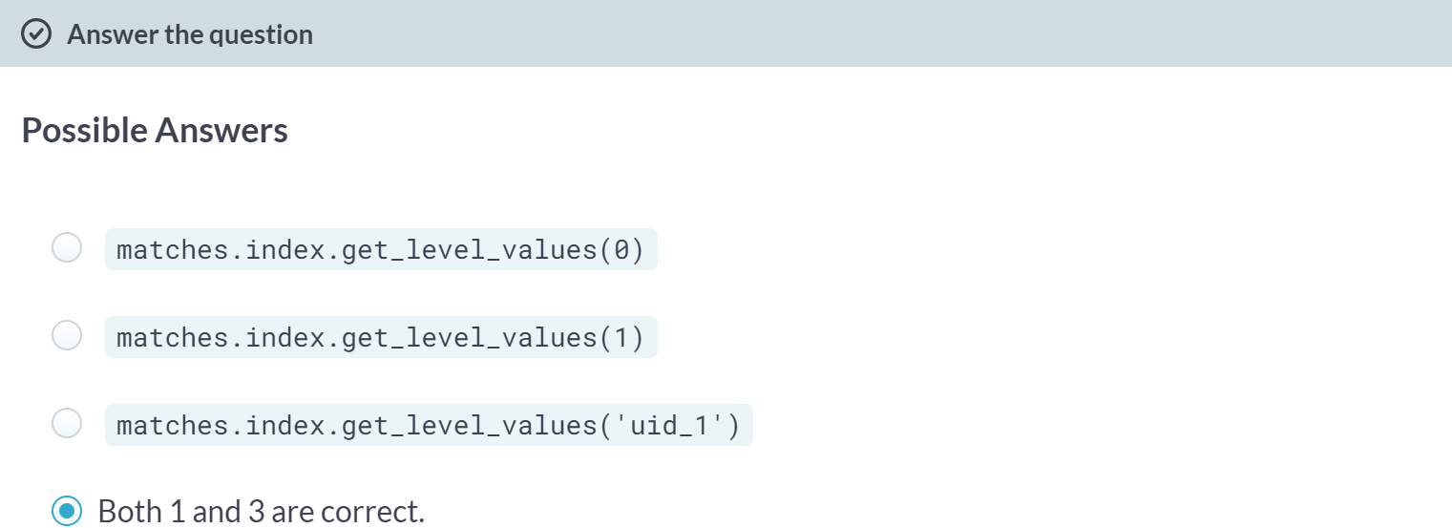  
Correct! In the next exercise, you'll use these functions to subset your data and link your DataFrames!

B: Are you sure about that? uid_2 is the second column index and Python uses zero-based indexing.

# Linking them together!

In the last lesson, you've finished the bulk of the work on your effort to link restaurants and restaurants_new. You've generated the different pairs of potentially matching rows, searched for exact matches between the cuisine_type and city columns, but compared for similar strings in the rest_name column. You stored the DataFrame containing the scores in potential_matches.

Now it's finally time to link both DataFrames. You will do so by first extracting all row indices of restaurants_new that are matching across the columns mentioned above from potential_matches. Then you will subset restaurants_new on these indices, then append the non-duplicate values to restaurants. All DataFrames are in your environment, alongside pandas imported as pd.

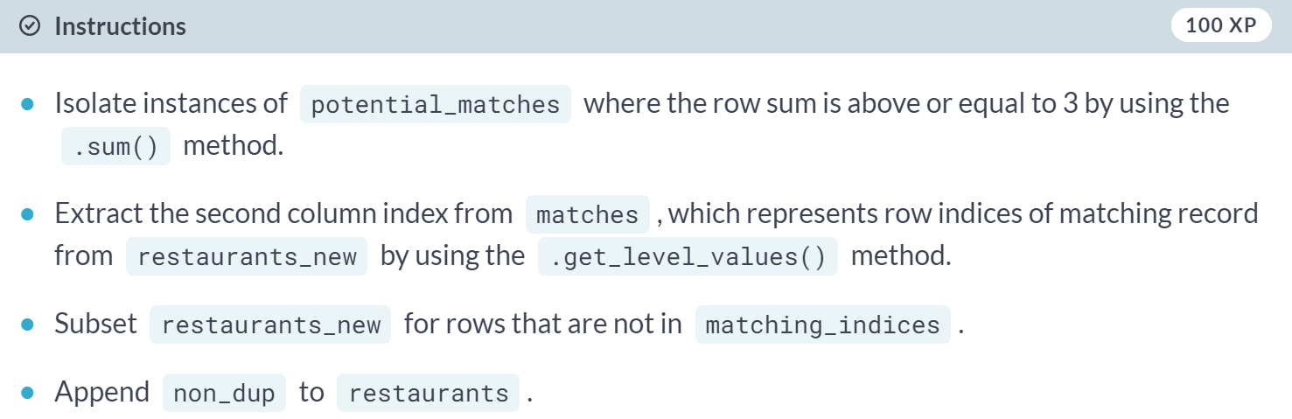

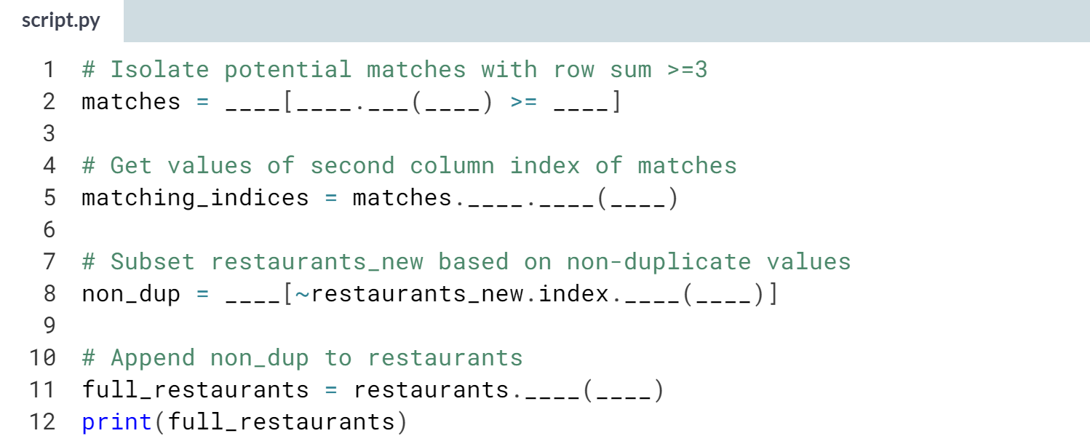

(Solution on the next page)

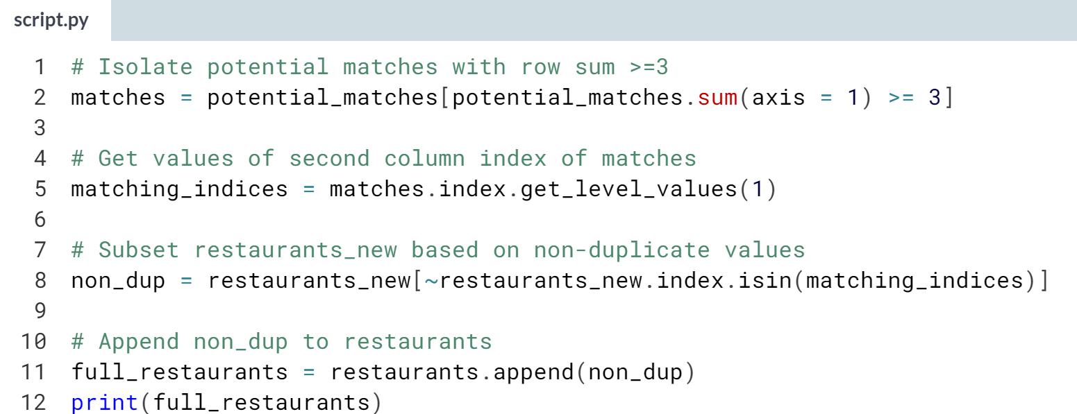

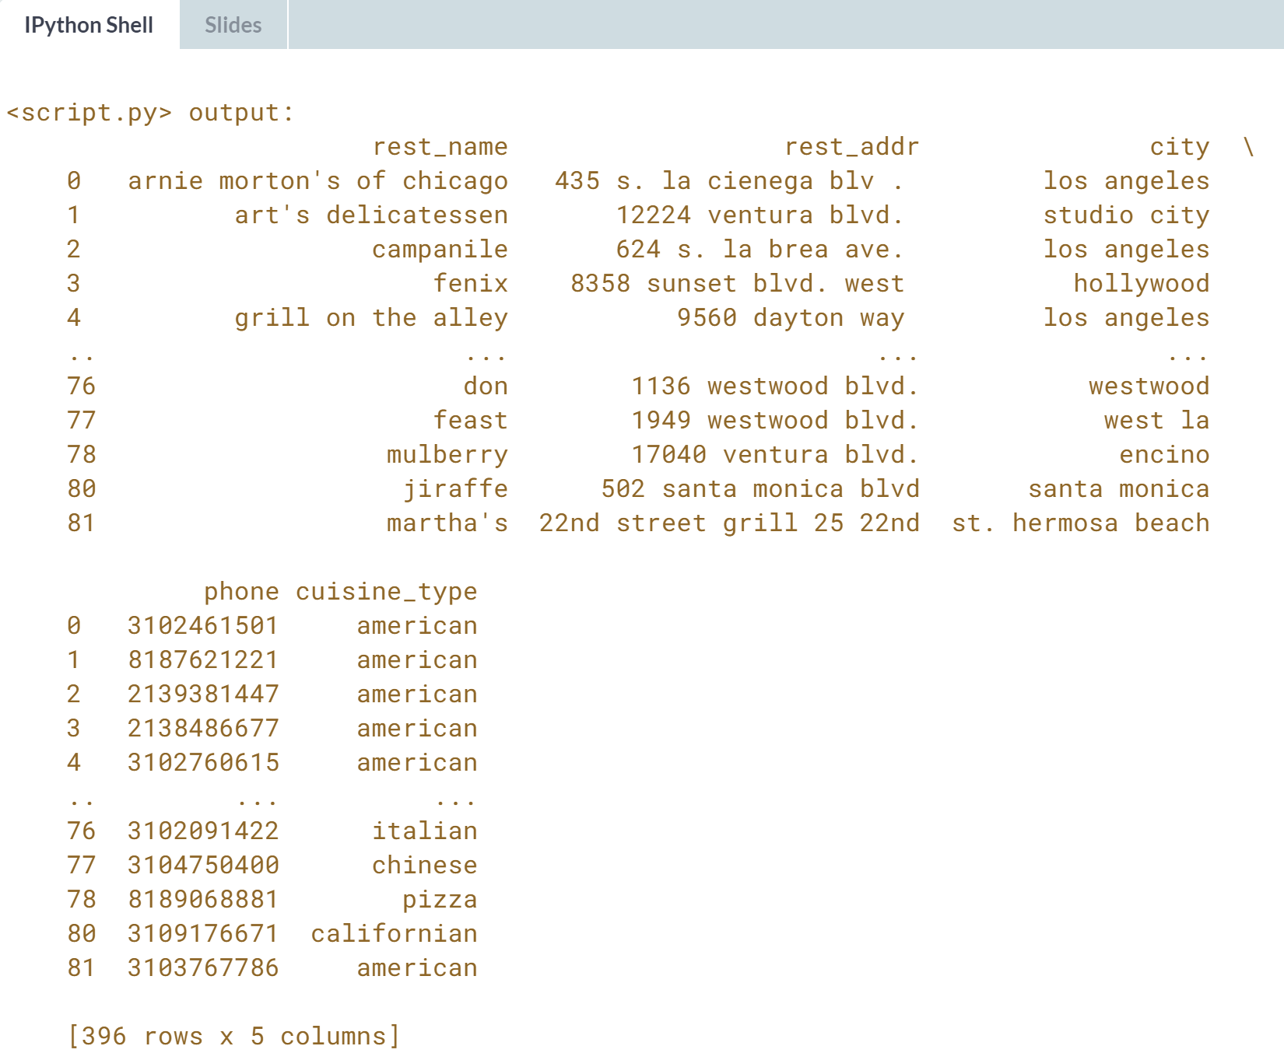 Awesome work! Linking the DataFrames is arguably the most straightforward step of record linkage. You are now ready to get started on that recommendation engine!



